Supplemental Materials for

##### A Course-Based Undergraduate Research Experience on the Evolution of Antibiotic Resistance and its Molecular Basis

Katie Dickinson1, Joya Mukerji1, 2, Stuart Graham1, Liz Warfield1, Ben Kerr1

1Department of Biology, Box 355320, University of Washington, Seattle WA 98195

2Present affiliation: Department of Biological Sciences, 6000 J Street, California State University – Sacramento, Sacramento CA 95819

**#Placeholder Table of Contents (Total pages 340)**



Part I.

Appendix 1: Student Lab Manual

Appendix 2: Student In-Class Worksheets

Part II.

Appendix 3: Instructor Lab Manual

Appendix 4: Prelab Quizzes

Appendix 5: Sample Clicker and Exam Questions

Appendix 6: Table of Learning Objectives: Vision and Change

Part III.

Appendix 7: Lab recipes and preparations

# to be removed/replaced upon submission

Table of Contents

APPENDIX 3: Instructor Lab Manual 5

Introduction 6

BIO1 9

Bio1 CURE: Evolution of Antibiotic Resistance Lab 1 9

Bio1 CURE: Evolution of Antibiotic Resistance Lab 2 15

Bio1 CURE: Evolution of Antibiotic Resistance Lab 3 19

Bio1 CURE: Evolution of Antibiotic Resistance Lab 4 23

Bio1 CURE: Evolution of Antibiotic Resistance Lab 5 28

Bio1 CURE: Evolution of Antibiotic Resistance Lab 6 33

Bio1 CURE: Evolution of Antibiotic Resistance Lab 7 41

BIO2 43

Bio2 CURE: Evolution of Antibiotic Resistance Lab 8 43

Bio2 CURE: Evolution of Antibiotic Resistance Lab 9 46

Bio2 CURE: Evolution of Antibiotic Resistance Lab 10 50

Bio2 CURE: Evolution of Antibiotic Resistance Lab 11 53

Bio2 CURE: Evolution of Antibiotic Resistance Lab 12 54

Appendices 56

Bacteria Daily Transfer Information and Tracking Sheet 56

Competition Drop-In Notes 63

Example Practice Data Sheets for Lab 3 & 4 65

R code for lab 3 66

Additional Functions 70

R code for lab 4 73

MIC maps for practice, Lab 4 76

Example Data Sheets for calculating competitive fitness 79

R code for lab 4 81

rpoB Sequence File 89

Pymol Cheat Sheet 93

CURE Peer Facilitator 94

APPENDIX 4: Prelab Quizzes 99

Prelab 1 100

Prelab 2 102

Prelab 3 104

Prelab 4 105

Prelab 5 107

Prelab 6 109

Prelab 7 111

Prelab 8 113

Prelab 9 115

Prelab 10 117

Prelab 11 122

APPENDIX 5: Example clicker and exam questions 125

APPENDIX 6: Learning Objectives 140

# APPENDIX 3: Instructor Lab Manual

# Introduction

**Introduction to a Course-based Undergraduate Research Experience (CURE)**

 Goals of our Course-based Undergrad Research Experience (CURE):

* **Producing preliminary data** on the fitness cost of resistance and cross-resistance interactions (or collateral effects) between different antibiotics
* **Generating student interest** in authentic research and a deeper understanding of science, improve student conceptions of scientific thinking and ability to interpret data
* **To give all students, rather than only a select few, the opportunity to engage in authentic research**. To make research more inclusive and lower (remove) the barriers to doing research and help students build the skills and confidence needed to complete a STEM major.

Each CURE is a bit different but in general there are "five elements that are reflective of authentic research: 1) engaging students in scientific practices; 2) emphasizing collaboration; 3) examining broadly relevant topics; 4) exploring questions with unknown answers to expose students to the process of scientific discovery; and 5) integrating iteration into the course, so students can see how science builds on itself” (Bangera & Brownell, 2014[1])

In this CURE, students first focused on evolution and ecology (Bio 180) to explore evolution of

antibiotic resistance by exposing *Escherichia coli* to specific drug regimes and assessing drug resistant levels, competitive fitness of isolates, as well as cross-drug resistance and sensitivity. The experience highlights evolutionary phenomena from a population level.

In the second set of labs (Bio 200), students trace genotype to phenotype at the cellular level, and connect evolution to molecular biology. Specifically, students will analyze their evolved bacterial isolates, focusing on the evolution of rifampicin resistance because rifampicin binds to the β-subunit of RNA polymerase. By studying mutations in central cellular machinery that confer drug resistance, students not only gain insight into fundamental cellular phenomena, but also recognize the molecular basis of a medically important form of evolutionary change.

Evolutionary principles are relevant to every field within biology. Yet, this connection remains

obscure for many students. In this CURE we seek to illustrate evolutionary concepts through hands-on discovery of the molecular underpinnings of adaptation. The series will allow students to explore the relationship between genotype, phenotype, and fitness, enabling a truly unifying perspective on evolution.

Additional instructor information

**Background information on the bacteria we are using:**

*Escherichia coli* is one of a number of microorganisms which inhabitant the colons of most mammals*. E. coli* belongs to the taxonomic family known as Enterobacteriaceae, which is one of the best-defined groups of bacteria. This strain of *E. coli* is a “debilitated strain” which means it does not normally colonize the human intestine. It has a history of safe commercial and laboratory use and is not known to have adverse effects on microorganisms or plants. Because of its wide use as a model organism *E. coli* is one of the most extensively studied microorganisms.

Other bacteria strain could be used but we two different *E. coli* K-12 strains. MG1655 is our focal strain and the common competitor strain *is E.coli* strain BW25113. The main difference between the two strains is deletion of araBAD and rhaDAB and the replacement of a section of lacZ in BW25133. As result BW25133 is: arabinose, rhamnose, lactose non-utilizing.

**Safety:**

**Review all safety procedures with your students (and any prep helpers)**

- All waste must be disposed of properly; your instructor will review the procedures in class

- Wear gloves anytime you are working with bacteria

- Do not open the agar plates unless instructed

- Wear goggles while handling microtiter plates during lab 6.

- Report any spillages or accidents immediately to a member of staff.

- DO NOT eat, drink, chew a gum, smoke or use a mobile phone in the lab.

- Long hair must be tied back.

- Wash your hands with soap and water when entering and leaving the lab

- Do not place anything in your mouth or near your eyes while in lab (pens, fingers, etc)

Review the location of:

* Biohazard waste bins (plus recycling and trash bins and clarify what goes in each)
* Sharps container
* Eyewash
* Emergency shower
* Exits
* First Aid kit
* Fire Extinguisher

If materials are transfer in the room (or to an incubator or storage area) make sure you use a secondary container.

**Note:**

You will likely notice changes in curriculum and format of the information as we move from Biology 180 to Biology 200, these modules were developed in collaboration but by different instructors. At the University of Washington, the labs were taught as part of an introductory biology series and the CURE spanned two consecutive quarters (as a result, students had some additional labs related to course content but don’t directly related to this CURE so they have been excluded.)

# BIO1

# Bio1 CURE: Evolution of Antibiotic Resistance Lab 1

We will be running an experiment that spans 12 lab sessions. Your results will contribute to a dataset on antibiotic resistance that is being used by Dr. Ben Kerr’s lab at the University of Washington.

We have two goals for you:

1. Work as a research scientist to generate data. You will be using established protocols, but the results students get are unknown and may help scientists respond to a looming public health crisis

2. Grow as a professional. Students will be learning practical lab and data analysis skills that could help open doors to other undergraduate research or career opportunities.

Science rarely runs smoothly -- we likely experience issues or failure when doing our experiment and assays, mistakes will be made. We WILL get unexpected results that lead to new questions. Sometimes these end up being the most interesting questions.

**Lab Set-up:**

**Today’s Learning Goals**

* Explain why the evolution of antibiotic resistance is a health concern.
* Instruct another student on proper sterile technique.
* Make a flow chart showing the experiment steps you performed, and add annotations explaining the rationale for each step.
* Diagram the week-to-week plan for this experiment over the course of the quarter.

**Sequence of events and timing:**

Introduction and getting to know your team 10 mins

Expectations 5mins

Safety 5 mins

Experimental evolution and antibiotic resistance 15 mins

Sterile technique demo 10 mins

Sterile technique practice 25 mins

Experiment “plating for mutants” demo 10 mins

Start the experiment by plating for mutants 15 mins

Wrap-up and Next Steps 10 mins

**Introductions**

1. Groups will work as a unit for at least 5 of the labs, so students should get to know each other a little.

Prompt: Have students introduce themselves to each other. Suggest (do NOT require) that they exchange contact information, as they will be working together, and do an icebreaker such as:

* What superpower would you like to have? Fly … breath underwater … turn invisible …
* If you could have any animal as a pet, what would it be?
* Name someone famous (real or fictional) that you would love to meet.
* What is your favorite plant?
* If you had a time machine, would you go forward or backward? How far?

Prompt: Introduce yourself.

* I’m a graduate student in …
* My research is on …
* My goals for this quarter are to …
* I decided to become a scientist because …

**Science Culture and Expectations**

This lab, just like a research laboratory, is a learning environment. In the beginning, you won’t necessarily be fluent in the language. That doesn’t mean you don’t belong! It will just take time and practice.

The key is to ask questions!

We expect you will…

* Learn and practice communicating about your science
  + In science, communication is key. Formal communication (for example, giving a presentation) and Informal communication (for example, participating in classroom discussions) are both critical to your success. Practice with both is important.
* Share ideas
* Practice team problem-solving and decision-making
* Foster critical thinking
* Celebrate individual and team achievements
* Forge new collaborations and develop comradery
* Both giving and receiving feedback

**Safety**

We will be working with a non-pathogenic laboratory strain of *Escherichia coli* (MG1655). Even though they aren’t disease-causing, these organisms must be treated as biohazardous waste--meaning, as an infectious or potentially infectious agent. Anything that comes into contact with the bacteria will be thrown away in the red biohazard bins. Pipet tips are exceptions—these can puncture the bag, so are collected and disposed of separately.

We will sterilize the benches with 70% ethanol and wear gloves when working with bacteria.

NO eating and drinking in lab. EVER.

**Experimental evolution and antibiotic resistance**

Experimental evolution uses manipulations in the lab or field to investigate evolutionary processes. Our goal is to investigate how *E. coli* evolves in an environment containing antibiotics.

Prompt: Why is *E. coli* a useful study organism? Ask students to brainstorm; write their suggestions on the whiteboard.

* Rapid generation times. Most mutations—the raw material of evolutionary change—occur when cells copy their genes and divide. With *E. coli*, many generations—and potentially an observable amount of evolutionary change—can occur in a relatively short time.
* “Ease of handling”

Small physical size—large populations can live in tiny volumes

Inexpensive to feed and grow; no disease if grown in sterile conditions

Can be frozen and revived

* Many/most genes have been sequenced and many genes are understood in terms of their function.
* Safe to work with, but a valuable model for disease-causing bacteria that have evolved resistance to antibiotics.

Prompt: How do antibiotics work?

Cells contain molecular machines that do the work critical for growth and reproduction. Antibiotics “gum up the works”—often jamming critical machinery inside the cell. Different drugs have different mechanisms of slowing bacterial growth or killing them outright.

Note: We are using two drugs. Rifampicin inhibits transcription and streptomycin interferes with translation. Both drugs are used to treat tuberculosis.

Prompt: Why is studying antibiotic resistance important?

1. Human health: Globally, over 700,000 deaths per year are due to drug-resistant diseases, including 230,000 from multidrug-resistant tuberculosis. These figures are expected to increase in coming decades. (WHO, <https://www.who.int/antimicrobial-resistance/interagency-coordination-group/IACG_final_summary_EN.pdf?ua=1>, 2019)

2. Food production: antibiotics are widely used in aquaculture, agriculture, and animal agriculture to reduce disease and increase growth.

**Sterile Technique**

Prompt: When working with bacteria, why is sterile technique important?

Bacteria and fungi are everywhere! But we want *E. coli* to be the only organism in our experiments, so we are confident that other species aren’t influencing our results.

Prompt: What are some common causes of contamination?

* Allowing a sterile implement to contact a non-sterile surface (table, clothing, skin …)
* Leaving flasks, petri dishes, microtiter plates, or tubes open to the air for too long.
* Talking or sneezing or coughing over your experiment when a container is open.

**Sterile Demo:** We will do this in TA meeting. Add your notes here:

INSTRUCTOR NOTE:

1. It is surprising hard to tip the microtiter titer plates and have the liquid spill out of the wells due to surface tension. However, it is fairly easy to bump the plate or put it down roughly on a surface and have the liquid jump up from a well to contaminate neighboring wells or the inside of the microtiter plate lid. You might want to demonstrate how this can happen to the students with a MT plate containing food coloring. Student will use MT plates for several weeks so proper handling is very important (to prevent contamination during their daily bacteria transfers and when the students do the assays in lab 5).

2. Student will practice the same steps next lab when they learn the Daily Transfer protocol. The focus here is getting comfortable pipetting and practicing sterile technique. The next lab the focus next week is building on these skills: proper pipetting, sterile technique PLUS learning how (& why) to do the bacteria transfers.

Give students time to review the “Sterile Technique: Guidelines and Skills Practice” and “Pipetting” sections in their lab manual.

When doing the demo, you may want to purposely do a few things “wrong” and ask your students to catch you if they see any issues with your technique.

Important tips:

* Check the volume your pipette is set to.
* After opening lids (petri dishes, microtiter plates, eppis, tip boxes), close them as soon as possible. Keep lids/caps face down, and do not place lids on the benchtop. Do not leave containers open to the air.
* If a pipette tip touches anything non-sterile (benchtop, sleeve, skin), eject it and get a new tip.

3. It is important for students to understand what “biohazardous” is and requires sterile technique and proper PPE and what is for “practices”. We recommend having two well marked areas in your lab room to keep **sterile items** (such as pipette tips, eppi tubes with saline and LB, extra microtiter plates, etc. **separate from the non-sterile practice items**.

**Sterile Practice:** See the student manual for details.

* + Have students work in pairs, so everyone gets a chance to practice.
  + Today students will work with water. Next week they’ll do the same steps with nutrient media and experimental cells.
  + Walk around the lab to make suggestions, focusing only on the most important issues first so students get comfortable.
    - Proper use of the pipette
      * Checking volumes before pipetting
    - Making sure the pipette tips is *in* the well (that students are not pipetting *above* the well)
    - 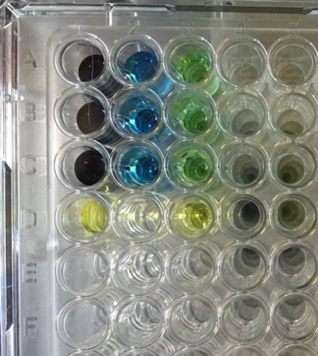Proper mixing (pipetting up and down) this is a skill that is essential for serial dilutions that occur in lab 5.
    - If food coloring has been used, you should see the blue “bacteria” become lighter blue as it is diluted in water and then turn green-ish as it is transferred into the yellow “LB”.

Clean up, so we can re-use these supplies for a practice session next quarter. Move the tips to the side bench’s “non-sterile tips” area; students will start the experiment with fresh *sterile* tips. Collect eppi tubes in a rack or tub and set them aside to be re-filled (time permitting students can rinse these items at the end of lab see “clean-up” note).

**Experimental-plating-for-mutants Demo:** We will do this in TA meeting. Add your notes here:

**Start the experiment**

Prior to the start of this lab, a researcher took a few *E.coli* cells from a population that had been stored in a -80 freezer, put them in a nutrient medium and let them grow overnight. After incubation the population of bacteria sample was add to the wells of your microtiter plate.

Prompt: We have ~200uL in column 1 of the microtiter plate. Approximately how many cells are we putting on each Petri dish?

From the lab manual, 1mL has ~ 10,000,000,000 (10 billion) cells.

Prompt: Are the bacteria populations for every group exactly the same?

As the cells grew and copied their genes and divided, mutations would have occurred. This creates heritable variation and makes evolution by natural selection possible.

Prompt: If your goal is to select for cells that are resistant to antibiotics, why were you asked to plate cells on the Petri dishes *not* containing antibiotic?

**Wrap-up and Next Steps**

Petri dishes will be moved to an incubator to grow overnight.

Have students complete the worksheet

Prompt: Next week you’ll start doing “serial transfers,” meaning that you’ll transfer your bacteria into fresh growth medium every day, so the population doesn’t run out of food and keeps growing. As more mutations occur each generation, the population will evolve. Later you will compare the characteristics of the ancestors and descendants in each population.

**Clean-up:**

Students should 1) wipe down their benches with ethanol, 2) empty the waste containers on their bench into the appropriate waste bin (biohazard or tip waste tub), and return petri dishes to the tray so they can be moved to the incubator. Time permitting, have students rinse their eppi tubes they used for practice and collect them in a container, 1 for “LB” and 1 for “Saline” tubes. **Be sure to emphasize we can only wash and reuse these eppis because they had no contact or chance of contact with bacteria!!**

**After lab:**

Move Petri dishes to the incubator to grow for 24 (or 48 hours).

## Bio1 CURE: Evolution of Antibiotic Resistance Lab 2

**Lab Set-up:**

**Today’s Learning Goals:**

* Using the terms heritable variation and differential reproductive success, explain why the evolution of resistance is a predictable consequence of natural selection in environments that contain antibiotics.
* Define mutation, and using the term allele, explain why changes in a genotype can alter a phenotype in terms of antibiotic resistance.
* Define the term fitness trade-off, and explain the prediction that resistance to RIF or STR will have a fitness cost.
* Instruct another student on how to do the transfer protocol, and predict what evolutionary changes are likely to occur in *E. coli* populations being transferred in different environments.

**Sequence of events and timing:**

Intro/Review Lab 1 15 mins

Petri dish observations, fitness costs 15 mins

Demo selecting a colony 5 mins

Pick colonies  10 mins

Why are we doing transfers? 5 mins

Demo: bacteria transfers  10 mins

Learn and Practice transfer protocol 20 mins

Transfer signup 10 mins

Worksheet 20 mins

Prompt: What are mutations?

Definition: Any permanent change in the hereditary material (DNA) of an organism

Mutations are the only source of new alleles in populations.

The fitness effects of mutations depend on the environment in which they occur.

Mutations that, by chance, result in drug resistance will not give cells any advantage in a drug free environment. In contrast, cells with these mutations have a huge advantage in an environment with drug present: they survive!

If your students struggled with the worksheet in lab you can review the questions together as a group.

**First Task**: Make observations about their Petri dishes

Prompt:

* Do you have colonies?
  + If so or if not, what does this mean?
* How many colonies, roughly, are on each dish?
  + Are the colonies the same size?
* Compare your Petri dishes with a neighbor group’s dishes
* What *might* the number of colonies and/or the size tell us?

Instructor notes:

If students have colonies on both of their RIF petri dishes (and/or on both of their STR dishes) they will pick one petri dish to use and set the other one aside.

If students don’t have colonies on one or both of their dishes, they may need to select a colony from a neighbor’s dish.

Instructor notes:

*E.coli* colonies are typically: whitish, round, opaque, raised, and smooth. Occasionally you will see a colony that is more yellow (often *staphylococcus aureus*) or fuzzy (fungus), these would be a contamination and we do not want the students to touch these colonies.

Often colonies are about the same size on the Petri dishes with the streptomycin resistance cells forming tiny colonies. Occasionally you might see a variety of sizes on a Petri dishes, colony size *may* be an indicator of fitness (larger colonies = more fit). If students pick an extra large or small colony off of a plate that has variation, they should make a note of it.

Evidence in the literature shows that there are more mutations available that confer resistance to rifampicin than streptomycin. It is not uncommon to get a lot of streptomycin plates that have 0 colonies (prepping a few extra plates with colonies may be helpful).

Prompt: From your reading…

* Why do we expect resistance cells to be rare in your ancestral population?

Ancestral population was initial grown in LB without drugs present. There is no benefit to being resistant in this environment. In addition, if there is a cost to being resistant (resistance = cellular machinery is mucked up in some way = less efficient) than the cell(s) could be in the population but at a low frequency and would potentially be outcompeted by sensitive cells.

* Do your Petri dish observations support the expectation that resistance is rare?
* Do your Petri dish observations support the idea that there is was genetic variation in a population?

**Second Task**: Your group will select one colony that is resistant to the drug rifampicin and one colony that is resistant to the drug streptomycin. Your TA/PF will select one sensitive colony from the LB plate.

Prompt: If we are interested in antibiotic resistance, why are we selecting a sensitive colony to grow and evolve alongside the resistant strains.

Before selecting a colony, review pipetting.

We will do this in TA meeting, add your notes here:

Bacteria divide by binary fission. After ~24 hours of growth, the bacteria have used up the available nutrients and stop growing.

If we are interested in how our populations of bacteria change over time. What do we have to do?

**Daily transfers**: a key technique in experimental evolution. Mutations occur during cell division. We want to provide lots of opportunities for mutations to occur. Allowing for many cycles of growth allows natural selection to potentially operate.

Antibiotic resistance is *usually* costly to the cell.

Here, we are transferring bacteria daily into *antibiotic-free* media. As the bacteria grow, additional mutations will arise, and some of these mutations could potentially **compensate** for (or lessen) the cost of resistance.

Every day, one person in your lab group will transfer cells first to saline and then into fresh medium. The cycles of dilution and growth that occur (due to our transferring bacteria daily for several weeks) will allow opportunities for mutations — including compensatory mutations — to occur and be passed on to the next generation.

When you added 20µL to 180µL, how much was the 20µL sample diluted?

Instructor notes:

The dilution step into saline is to thin the population. The diluted bacteria are then transferred into fresh media (nutrients) to grow. So there are two, 10-fold dilutions.

Students tend to get confused about the “media control”, be sure to check for understanding.

Often students want to transfer the media control each day, why is this not a good idea?

When students are practicing the daily transfer, make sure they understand when it is critical to change tips (and when it is considered “best practices” but not critical).

It is critical to change tips *between strains*.

Make sure students are mixing properly with the pipette (gently pipetting up and down to the first stop).

Have students sign-up to come in to do their daily bacteria transfers. Ideally, transfers should be done about the same time each day (give or take a couple of hours).

We suggest students document in a lab notebook their daily transfer notes to communicate that the transfer has been done that day. Students can also text or email each if they have exchange contact information or use a shared google document to communicate.

**Clean-up:** Students should 1) wipe down their benches with ethanol, 2) empty the waste containers on their bench into the appropriate waste bin (biohazard or tip waste tub), and move microtiter plates to the tray so they can be moved to the incubator.

Time permitting…

1) have students label the container (PCR tubes most likely) for their strains that will be frozen.

2) have students rinse their eppi tubes and microtiter plates they used for transfer practice and collect them in a container, 1 bin for “LB” and 1 bin for “Saline” tubes, 1 tray for MT plates. **Be sure to emphasize we can only wash and reuse these eppis and microtiter plates because they had no contact or chance of contact with bacteria!!**

**After lab:**

Move microtiter plates to the incubator to grow for 24.

Gather Petri dishes to be autoclaved for disposal, though we recommend you wait until you have confirmation that the students have cells/growth in their microtiter plates before disposing of the Petri dishes with colonies. (Occasionally, after 24 hours of incubator the wells of the microtiter plate do not look cloudy. If this happens, students will need to select a colony again and swirl it into fresh media to grow. This is more common with the streptomycin resistance stains this those colonies tend to be smaller).

Tomorrow students will begin the daily bacteria transfers. Once the first bacteria transfer is complete, instructors (or lab helpers) will take the remaining culture and freeze it down for future use. PCR tubes can be used for this step. For short-term storage, it is not necessary to add glycerol to the tubes. However, glycerol stabilizes the frozen bacteria, preventing damage to the cell membranes.

## Bio1 CURE: Evolution of Antibiotic Resistance Lab 3

**Today’s Learning Goals:**

* Explain why resistance is not all-or-none, but a phenotype with continuous variation from 0 to extremely high;
* Explain why resistance can be costly in the absence of an antibiotic, and analyze methods for measuring the cost of resistance;
* Understand why researchers perform statistical analyses;
* Choose appropriate statistical tests to analyze the experimental results that you will obtain;
* Navigate the interface of RStudio, load a practice data set, and run practice analyses.

**Sequence of events and timing:**

Recap: “You are here” in the

plan for the experiment 10 mins

Fitness 25 mins

Intro RStudio, *t*-test, worksheet: 55 mins

Daily transfer worksheet and signup: 5 mins

Complete the daily transfer 10-15 mins

Prompt: What happened in Lab 1, during selection?

Heritable variation

You started with a culture of bacteria that had ~109 cells. Not all were genetically identical—there was heritable variation in many traits.

Differential reproductive success

You plated the bacteria on Petri dishes with antibiotic. The bacteria that were resistant lived and grew; sensitive bacteria died.

Each lab group isolated a different mutant strain that showed resistance. We will be investigating…

* Do each of these resistant strains contain the same mutation?

It’s likely that no two mutants are exactly alike

* Will they all have the same level of resistance?

**No:** some will be more resistant than others, meaning that they grow better in presence of the drug

Prompts:

Why are you doing the daily transfers?

How do you properly “mix” with the pipette?

Why do you mix?

When gently pipetting up and down to mix, why do you need to do this slowly only going to the 1st stop of the pipette?

Why don’t you leave your tip boxes and eppi tubes open while you are using them?

What is the point of the media control?

Why don’t you transfer your “media control” but instead make a new media control each day?

If your media control is cloudy, what should you do?

What if a well in the microtiter plate that is supposed to have bacteria in it, isn’t cloudy?

What might this mean?

What would you do?

Instructor notes:

Prompt: During daily transfers, you are letting resistant strains evolve in an environment that lacks the drug. What might happen in your strains?

When you compare your progenitors and your descendants, will resistance

Increase?

Stay the same?

Decrease?

From your prelab:

Why would mutations that confer resistance have a fitness cost, in environments without the drug present?

If there is a **cost to resistance**, the prediction is that **resistance will DECREASE** during transfers (absence of drug).

If sensitive, the machine that the antibiotic binds to works better in its “normal” form—this is why resistance mutants were so rare in the original population (in Lab 1).

Instructor notes:

Prompt: Do you think that all resistant cells are resistant to the same level?

Key concept: Antibiotic resistance is NOT an all-or-none phenotype.

Up until today we have talked about resistance being all or nothing (either sensitive or resistant), but things are actually more complex! Different mutants can produce resistance, so there can be different levels of resistance, and there is more than one way that a cell can become resistant.

To find out how resistance impacts the cells we’re studying, we need to determine if there is a fitness cost to resistance.

Prompt: Brainstorm with your group: How can you determine if there is a fitness cost?

Recall that fitness is the ability of an organism to produce offspring that go on to reproduce. An individual’s fitness is always relative to other individuals in the population.

A well-known joke illustrates this point.

Two hikers are in the woods gathering berries. Suddenly they are confronted by a bear. They flee through the trees with the angry bear running after them. As the bear begins to gain on them, one hiker cries, “Oh no! We can’t outrun the bear!” The other hiker replies, “We don’t need to outrun the bear—I just need to run faster than you!”

To determine fitness, students will set up competitions. Each of our bacterial strains will compete for food and space against a “common competitor”—meaning, another strain of bacteria.

Think of it this way.

Say the UW husky football team beats Ohio State University (OSU). But we can’t say much about how good the Huskies are until we know what other teams played and beat OSU. What if OSU was undefeated until they played UW? What if OSU had lost every single game they played?

Have each group go to a section of the white board. We will give the students a few scenarios and have them draw graphs on the white board.

Details will be discussed in TA meeting, but briefly:

Scenario 1) Suppose a bacterial culture started at a low density and grew slowly. What would that graph look like?

Scenario 2) Suppose a bacterial culture started at a low density and the population stayed the same over time. What would that graph look like?

Scenario 3) Suppose a bacterial culture started at a low density and the population decreased. What would that graph look like?

Have the students note where the cultures started and where they end. After each scenario pause and select a team to describe what they drew and select a different team to comment. This will give each group a chance to present and for groups to interact. You can show the graphs on the ppt slide after the students have drawn their own, to recap.

If time allows, do a learning goals check-in with one question per lab group. Have each group discuss their goal briefly and report out.

* Why is resistance a phenotype with continuous variation, instead of being all-or-none?
* What does it mean to say that resistance can have a fitness cost?
* How will you be measuring fitness in your progenitors and descendants?
* Why can’t you tell if the means of two populations are different, just by comparing the numbers?
* Why is a *t*-test appropriate for your fitness data?
* What does it mean to “execute code” in RStudio?

Possible answers…

* Different mutations impact how well a drug binds to its target. Tighter binding = higher resistance.
* Resistant mutants don’t grow as well in environments that lack the drug.
* Competition assays: comparing how different populations grow when the compete against a common competitor (Focal Strains=RIF/STR-resistant progenitor, Common Competitor= descendant).
* There will be some variation in averages just by chance, even if the null hypothesis is correct.
* You are comparing the averages of two populations.
* You run certain commands, so that R does a specified action.

**Clean-up:** Students should 1) wipe down their benches with ethanol, 2) empty the waste containers on their bench into the appropriate waste bin (biohazard or tip waste tub).

**After lab:**

Move microtiter plates to the incubator to grow for 24.

## Bio1 CURE: Evolution of Antibiotic Resistance Lab 4

**Today’s Learning Goals:**

* Explain what collateral sensitivity and collateral resistance are and how to measure them;
* Discuss how investigating collateral effects could help slow the evolution of antibiotic resistance;
* Choose and conduct statistical tests that are appropriate for analyzing the experimental results you will obtain in future labs;
* Use RStudio to graph, interpret and analyze data

**Sequence of events and timing:**

MIC assay discussion 20 mins

Collateral effects discussion 40 mins

Lab 5 Assay Preview 5 mins

RStudio 30 mins

Worksheet 10 mins

Daily Bacteria Transfer: 10 mins

Last week students learned about relative fitness, how to do the competition assay, and how to do a *t*-test in Rstudio. This week they learn how to do an MIC assay and do a simple linear regression in RStudio.

NEXT LAB…

We will be doing two types of assays:

1. MIC assay
2. Competition assay

We will be collecting two types of data:

1. drug resistance levels
2. relative fitness

TODAY we will learn more about doing those assays.

Below is a table that contains the questions we are addressing with this experiment. See if the students can help you identify the data needed to answer each question.

|  |  |  |
| --- | --- | --- |
| **Question** | **Notes** | **Data needed** |
| Did all of the resistant cells that were selected (the ancestors) have the same level of resistance? | If resistance is binary (a yes/no trait) then yes.  If resistance is not binary, then no. Different mutations are responsible for resistance. | Level of resistance in ancestor cells |
| Did level of resistance change over time? | Possibilities are increase, decrease, or no change. | Compare level of resistance in ancestors and descendants |
| Did collateral effects occur? | Possibilities are collateral resistance, collateral sensitivity, or none | Compare level of resistance to STR in RIF-resistant cells vs. SEN cells; compare level of resistance to RIF in STR-resistant cells v. SEN cells |
| Is there a fitness cost to resistance? | If this is very common, then drug cycling may be a good approach. | Compare fitness of resistant and sensitive cells in media without drug present |
| Did fitness change over time? | If “compensatory mutations” occur, fitness may not decline over time. Drug cycling may not be a good approach. | Compare fitness of ancestors and descendants |

Prompt: What does MIC stand for? And why are we doing an MIC assay?

**Minimum Inhibitory Concentration (MIC)-** Quantifying level of resistance

MIC (minimum inhibitory concentration) testing allows for quantification of the concentration (in µg/mL) of the antibiotic needed to inhibit the bacterial growth. This information is most often used as a research tool to determine the in vitro activity of new antimicrobials and screen for the best candidates. Important tool for: drug development, design better treatment protocols (dose) using existing antibiotics, and is important to identify the correct drug to administer to the patient (too much drug can cause side effects and too little won’t stop the infection).

You will use MIC assays to measure the level of drug resistance in progenitors and descendants.

These data are crucial for understanding whether:

1. resistant cells isolated by different student teams varied in their degree of resistance;

2. resistance evolved in an environment that lacked drugs;

3. collateral effects occur between RIF and STR resistance

Using the microtiter plate image on the board…

Prompts:

Which row contains LB + the highest drug concentration?

Which row contains LB + the lowest drug concentration?

Which row has LB but no drug added?

If we are interested in level of drug resistance, why do we have this row?

How will we set up the assay?

At the end of the transfers, students will have 6 strains: 3 progenitors (sensitive, rifampicin-resistant strain, and streptomycin-resistant strain) plus the descendants for each.

Students will have two microtiter plates: One containing a gradient of the drug rifampicin and one containing a gradient of the drug streptomycin.

Students will inoculate each well in each column with cells, two columns per strain. They the microtiter plates will grow overnight.

Prompt: What does it mean if the well is clear the next day? What if it is cloudy?

Hand out the MIC plate diagrams. This example contains a gradient of rifampicin. Have students spend a few minutes deciding the MIC level for each strain. Note: The columns in the middle, where students will be putting the streptomycin-resistant ancestor and their descendants, are empty for now. So we will just focus on the rifampicin-resistant and the sensitive strains.

Why do we have 2 microtiter plates? And why do both plates get all 6 strains?

Our MIC plates will also be used for us to collect data about potential collateral effects.

Prompt: Who can tell me about collateral effects, from your prelab?

Using the MIC plate maps again, this time have 2 groups draw pattern of collateral sensitivity and 2 draw collateral resistance 2 draw no effect (filling in the blank STR area on the map, see image below).



No collateral effects: We would expect STR-resistant mutants would have the same MIC as the SEN strain. Collateral resistance: We would expect STR-resistant mutants would have a higher MIC than the SEN strain. Collateral sensitivity: We would expect STR-resistant mutants would have a lower MIC than SEN strain.

If a drug stops being effective in a patient, the provider may prescribe a new drug.

Prompt:

1) Would data on collateral resistance affect the doctor’s prescription?

2) Why might collateral sensitivity be a good thing?

The two assays we are doing next lab are a bit more complicated, so we are going to take a moment now to briefly review the steps.

(Note: you can move this review to the end of lab if you are worried about timing for the RStudio)

1. The prep team will…..

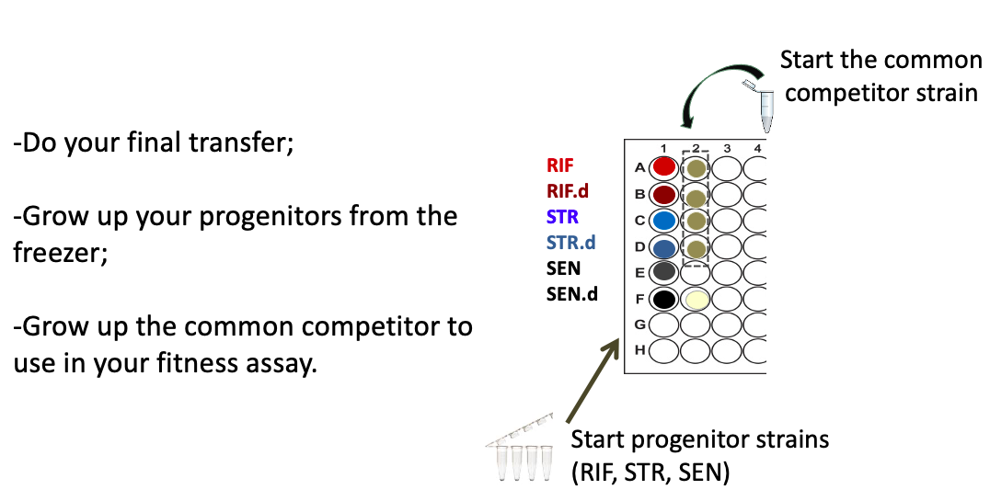

2. MIC ASSAY

* You will receive eppi tubes containing 990uL of saline
* You will label the tubes
* Dilute each strain (twice, making two copies)
* You will have two microtiter plates filled with growth media + antibiotic
* You will fill every well in a microtiter plate with the appropriate bacteria strain

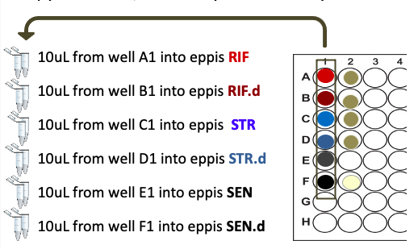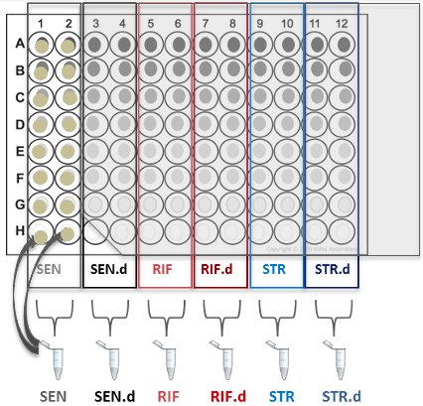

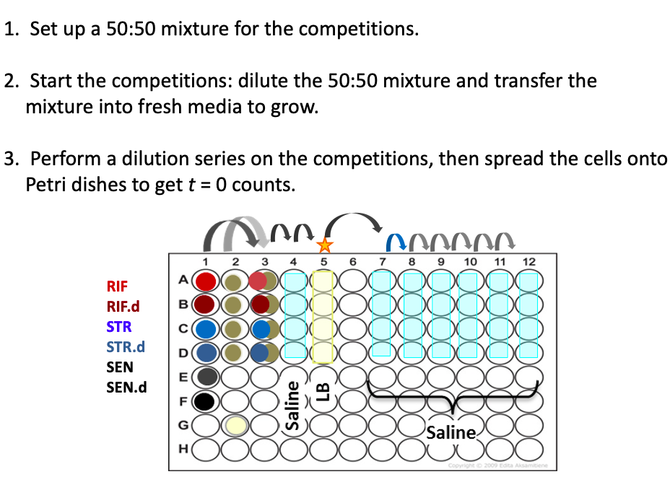3. FITNESS COMPETITION ASSAY

- Make a 50:50 mixture (of each strain + the common competitor)

- To start the competition, the mixtures need to be diluted and transferred into media to grow

- To determine the starting cell #s of each mixture you will: do a serial dilution, spread the diluted mixture onto Petri dishes, after growth you will count the colonies

After the mixtures have “competed” for ~24hrs, you will need to do another serial dilution to get your cell #s to determine which strain grew better.

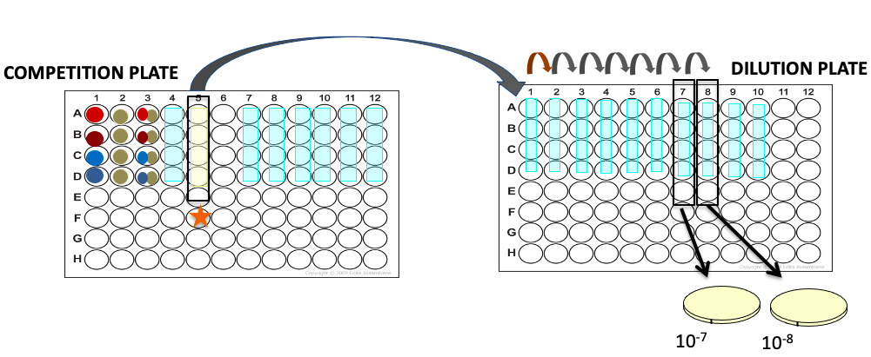

Instructor Notes: Prior to running this lab 5 you might want to test which serial dilution steps and plating dilutions work best for your class.

Make sure to remind your students to read their lab manual carefully before coming to lab.

* Many scientists follow Step-By-Step protocols however it is very important to know ahead of time what you are doing and why to prevent errors.

Now we will switch to using RStudio again, to review the importance of statistics and learn how to learn about linear regressions.

Make sure you leave time for students to complete the daily bacteria transfer

**Clean-up:** Students should 1) wipe down their benches with ethanol, 2) empty the waste containers on their bench into the appropriate waste bin (biohazard or tip waste tub).

**After lab:**

Move microtiter plates to the incubator to grow for 24.

## Bio1 CURE: Evolution of Antibiotic Resistance Lab 5

**Today’s Goals**

* Clarify the purpose of today’s assays
* Identify essential steps in the protocol
* Execute MIC assay
* Start Fitness Competition
* Do t = 0 dilution series and plating to get initial frequencies
* Explain how data from your MIC assays will allow you to assess changes in antibiotic resistance over time and whether collateral resistance or sensitivity occurs;
* Explain how data from your competition assays will allow you to assess the cost of resistance in progenitors and descendants of each of your strains.

**Sequence of events and timing**

MIC Intro 10 mins

Do the MIC assay 45 mins

Pairs get organized, do dilutions into eppis,

Fill drug gradient microtiter plates

Competition (fitness) assay intro 5 mins

Do the fitness assay 25 mins

Make 50:50 mixture, dilution, transfer to grow

Plate *t = 0*

Preview work for the *t = 1* drop-in tomorrow;

do sign-ups

Clean-up and worksheet 15 mins

**Safety**

The drugs rifampicin and streptomycin are toxic at high concentrations, so it is imperative to avoid contact with skin. Also, remember to keep the microtiter plates level, to avoid spilling.

We will sterilize the benches with 70% ethanol and wear gloves when working with bacteria.

NO eating and drinking in lab. EVER.

Instructor safety note:

Due to the surface tension in the MT plate wells, it is surprising hard to spill liquid out by tipping the microtiter plate. What is fairly easy to do is to bump the MT plate or bang it when moving it or putting it down on the lab bench which may cause the liquid to jump up from the well contamination other wells and/or getting on the inside of the lid of the plate. Please remind students to be careful when moving their microtiter plates.

**Lab notes:**

This week’s students do the MIC and Fitness assays. Carefully read the Student Manual so you understand the protocols step-by-step.

**MIC Assay Instructor Tips:**

Make sure students label their microtiter plates with their group #, lab section (if needed).

They can also strain names across the bottom of the plate so they know which strain is going into each column. For example:

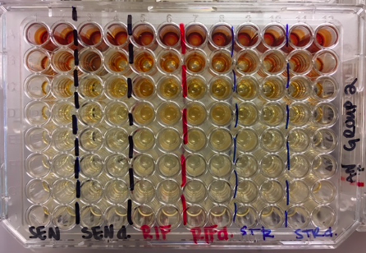

We dilute to each culture into an eppi. If the students are wondering why?

1. To have enough bacteria! We need more than is in each well.
2. Avoid the inoculum effect – if we add a dense, fully growth culture of bacteria we might have elevated/inaccurate MIC values. For a given concentration of an antibiotic, its ability to inhibit bacterial growth decreases with the size of the bacterial inoculum. (Inoculum or inoculation: putting bacteria or other agent into a culture medium)

Remind students that they will have a MT plate containing LB + rifampicin and a MT plate containing LB + streptomycin. Their strains: SEN, SEN.d, RIF, RIF.d, STR, STR.d will go into each of these plates so after growth, they know how resistant each strain is to each antibiotic (12 data points, each replicated)

First step is to prepare cells from each strain to serve as an inoculum in each well, by diluting each of the strains twice.

Column 2 in the microtiter plate has the common competitor for the competitions.

We are not using it in the MIC assay, it is for the competitions.

Groups will work at different paces, this is ok! It is not a race. It is important to work carefully because it is easy to lose track of where you are at in the microtiter plate.

* Have students move the lid over to the right as they work to help you keep track. This can be easier then opening and closing the MT lid each tip.
* It is ok to use your thumb to open and close the eppi tube between rows and not snap it all the way closed each time. Though students should not just leave the tube open the whole time they are working.
* If students make a mistake, they can note that on their tracking sheets. Most common mistake is to 1) add bacteria to a well twice 2) potentially miss a well and not add any bacteria.
* We recommend having one or two back up plates (per drug) for major mistakes (such as dropping a whole MT plate).

Pro tip: Use the tip box to help keep track of where you are at in the microtiter plate.

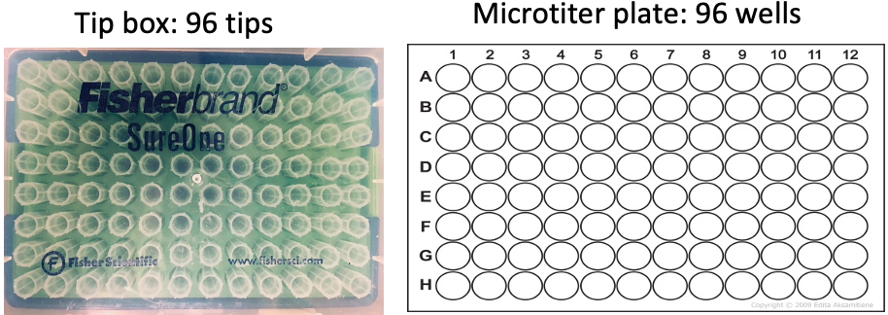

The tip box matches the layout of the microtiter plate.

As students work up the column adding bacteria, work up the tip box.

Students can also use the MIC tracking guide to mark once each well has been filled and to note if there are any errors or mistakes.

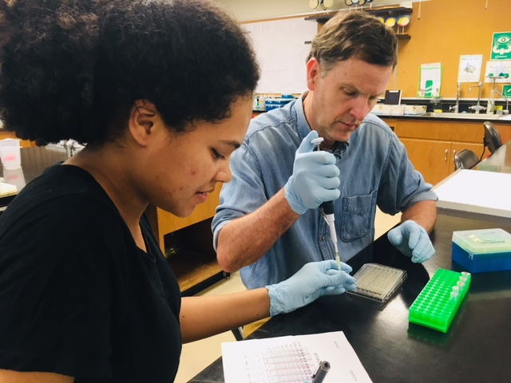

Here the student on the left is the “caller” who is calling which well to pipette into, while marking completed wells on the tracking sheet, and is holding the eppi with the appropriate bacteria strain.

The student on the right is the “pipetter”, filling up the microtiter containing antibiotic.

Students are encouraged to swap roles halfway through the plate.

As groups start to finish, have them review the competition protocol steps.

* When most groups are done with the MIC assay, we recommend you stop the whole class (having students who are still working on the MIC assay record where they are at & close lids/caps) review the competition steps with the whole class. Then groups can go back to finish their MIC assay while other groups start on the competitions.

**Fitness Competition Instructor Tips:**

Have students label their petri dishes, on the *side* of the dish that contains the agar (see student lab manual for image). If a stack of plates is accidentally bumped the lids can fall off and you will lose the label, so you won’t know which plate is which. If students label on the bottom of the plate it will be hard to count the colonies since the label will be in the way.

Relative fitness is calculated as the ratio of the growth rate of one strain relative to that of another strain. We need to know the *starting* ratio (which is why students spread a sample of their “competitions” onto petri dishes today). If we don’t have the starting ratio it would be like running a race where there is no starting line. Whomever crosses the finish line first isn’t necessarily the fastest if they started closer to the finish line than others.

Prompt: After we set up our competitions in column 5 we dilute the bacteria and spread the sample on petri dishes. Why do we dilute the bacteria?

The bacteria is diluted several times so that we can get count colonies, otherwise the petri dishes will have too many cells to count. We do two dilutions to make sure we don’t have too few or too many colonies.

Prompt: If we didn’t do the t=0 plating and only plated the competitions after 24 hours of growth, why would this be a problem?

We would know how many cells of each competitor we started with. It would be like having a race with only a finish line but not knowing where the runners started from!

Once students are done with their MIC assay and the start of the competition assay, students can label the Petri dishes for tomorrow’s drop-in t = 1 competition plating.

Instructor Notes:

The tip changing is a little tricky. Bacteria can sometimes be “sticky” so we want to change tips to get a proper dilution. In this lab we don’t have the students change tips between every dilution because:

1) it wastes plastic (we are trying to minimize plastic waste)

2) the more we change tips the easier it is for students to get confused where they are in the dilution series in the microtiter plate.

Feel free to adjust this as you see fit for your classroom. Note, we have seen that if students change tips between each dilution sometimes you need to adjust the dilutions that are plated (to 10-6 and 10-7) to make sure you don’t get too few colonies to count. However, if tips are not changed between any of the dilution, you might have to adjust in the other directions, so the petri dishes are not too dense.

**Prior to running this lab you might want to test which serial dilution steps and plating dilutions work best for your class.**

**Clean-up:** Students should 1) wipe down their benches with ethanol, 2) empty the waste containers on their bench into the appropriate waste bin (biohazard or tip waste tub).

Return the competition microtiter plates to the tray to be moved to the incubator.

Place stacks of Petri dishes in the tray to move to the incubator.

If they labeled Petri dishes for tomorrow, they should stack them to be stored until use.

**After lab:**

1. Carefully move competition microtiter plates and Petri dishes to the incubator to grow overnight.

2. Make a note to remove the t = 0 Petri dishes from the incubator after growth (this will make room to add the t = 1 Petri dishes tomorrow).

The t = 0 and t = 1 Petri dishes won’t be counted by students until the next lab session so store the dishes in a cold room or refrigerator so they don’t dry out (colonies from the rifampicin plates will be used in a later lab).

3. Make a note to move the MIC microtiter plates out of the incubator and store the MT plates until the next lab sections.

- If stored at room temperature, the liquid in the wells will slowly start to evaporate (especially around the edges of the plates), this shouldn’t interfere with the results but it might be best to bag them and/or store them in a cool location until the next lab sections. However, if the MT plates are stored in a refrigerator, condensation can develop on the lid. This can make it a little harder to tell if a well is cloudy or not so be sure to remove them from cold storage the night before lab to let the condensation evaporate off before lab. Alternatively, you can keep a few extra lids in the lab and groups can swap the lids. At this stage, we wouldn’t be too worried about contamination since there wouldn’t be enough time for any contaminate to grow and confuse the results.

## Bio1 CURE: Evolution of Antibiotic Resistance Lab 6

**Today’s Learning Goals**

* Explain how data from your MIC assays will allow you to assess changes in antibiotic resistance over time and whether collateral resistance or sensitivity occurs;
* Explain how data from your competition assays will allow you to assess the cost of resistance in progenitors and descendants of each of your strains.

**Sequence of events and timing**

Review the experiment so far 10 mins

Determine MIC values and fill out worksheet 20 mins

Petri dish observations, count colonies, complete

worksheet 30 mins

Calculate Relative Fitness as a class 15 mins

Finish worksheet 10 mins

Discussion/Future directions 20 mins

**Safety**

Remember, the MIC plates contain high concentrations of antibiotics which can be dangerous. When looking at MIC plates:

Wear goggles

Do not hold the plate directly over your head

Slightly tilt the plate to observe cloudiness in the wells

IF Students get antibiotic stock solution in their EYES: Rinse cautiously with water for 15 minutes. Remove contact lenses, if present and easy to do so. Continue rinsing.

If eye irritation persists: Get medical advice/attention

IF on skin: rinse with soap and water for 15 minutes.

**Experiment Review**

Prompt: What steps have we done each week and why?

Have students discuss with each other and report out.

Prompt: Why will it be interesting to compare results between groups?

Prompts: Why, do we believe the cycles of dilution and growth that occur (due to our transferring bacteria daily for several weeks) will allow opportunities for mutations?

Why are we interested in this?

What environment where the bacteria evolving in?

and what does this potentially mimic in a clinical setting?

Recall, after ~24 hours of growth, competitions were diluted and plated to get final counts (t=1). Why was this step needed?

* What does it mean to say that there is a cost of resistance?
* Why do the mutations that confer resistance come with costs?
* What data can you use to determine if there are fitness costs?

What is a collateral effect in terms of antibiotic resistance?

Why are collateral effects important?

What will we look at to gain evidence for the presence/absence of collateral effect?

Instructor Notes:

The cycles of dilution and growth that occur (due to our transferring bacteria daily for several weeks) will allow opportunities for mutations — including compensatory mutations and or reversion— to occur AND spread.

Cost = lower ability to grow in an environment lacking drug

Why = resistant machines don’t work as well as “normal” machines

Quantify fitness costs as growth rate of sensitive versus resistant strains, in medium lacking drug

Collateral effects = resistance to one drug impacts level of resistance to another drug (pleiotropy)

The mechanism isn’t well understood.

Collateral effects impact the design of drug cycling and drug cocktail protocols

**Today students will:**

1. Determine resistance levels by looking at your MIC plates
2. Count colonies on your Petri dishes from the start of each competition (*t* = 0) and the end of each competition (*t* = 1)

**MIC**

Review lab information from week 4 when students practiced getting MIC data.

Students will put on googles and take turns looking at their microtiter plates, examine the wells to see if the media is cloudy or clear. This will indicate growth or no growth.

Remember:

* Drug concentrations decrease as you go down the rows, from the highest concentration in Rows A at the top to the lowest concentration in Row G at the bottom of the plate.

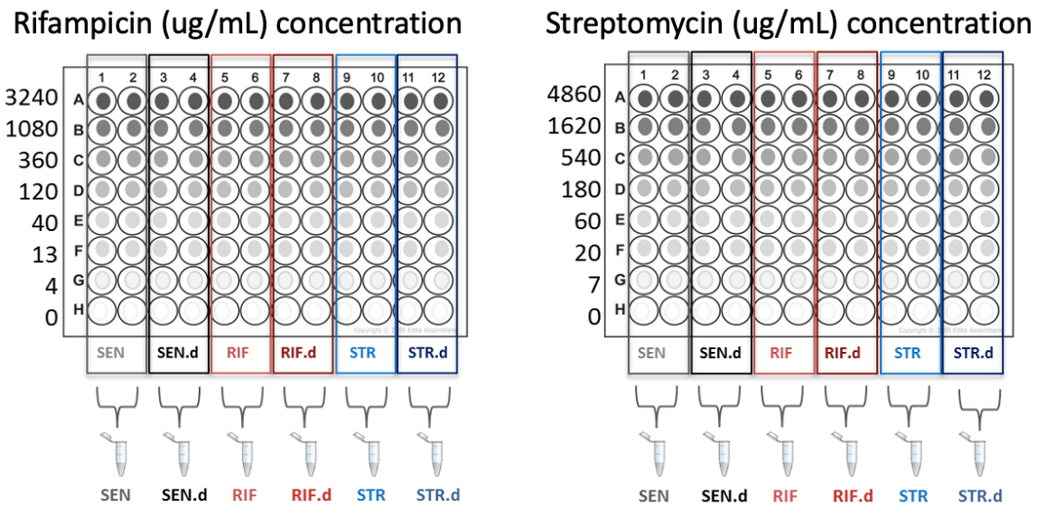

* The MIC is designated as the lowest drug concentration at which your strain failed to grow.
* Each strain has been inoculated in two neighboring columns, giving us two replicates to determine MIC for each strain. Consistency among replicates gives us more confidence in the results.
* It is often easiest for students to hold the microtiter plate up to the light and look from the bottom.
* Have students mark their MT plates, with a sharpie to indicate MIC and fill in the information on their worksheet.

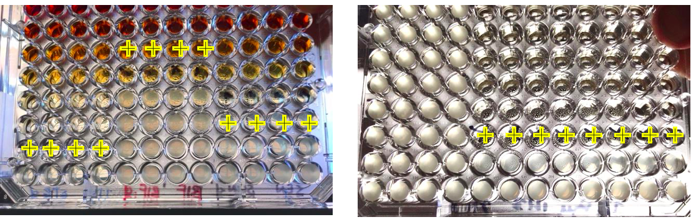

* Students can take turns and verify that they agree with the MIC call by their collaborators.

**Fitness Competition**

Fitness = reproductive success. It reflects how well an organism is adapted to its environment.

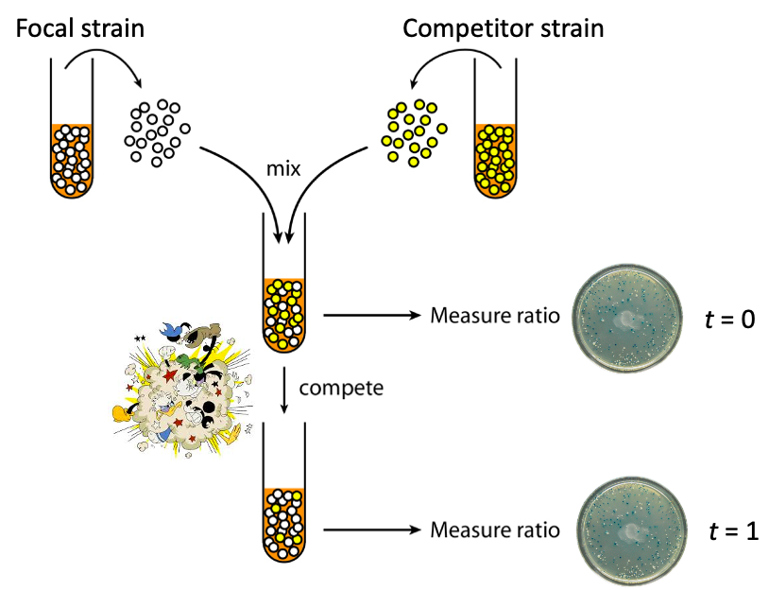

Relative fitness (W): measures differential reproductive success

* It is a dimensionless quantity

It is calculated as the ratio of the growth rate of one strain relative to that of another strain during their direct competition.

The equation for relative fitness is….



(Note: on our spreadsheet we use F and C (focal and competitor) instead of A and B).

**Counting Colonies**

Students will count the colonies on their petri dishes and record how many blue colonies there are and how many white colonies there are.

Each group (or group representative) will need:

* A clicker
* Two different colored sharpies (blue sharpie for focal strains and red for the common competitor)
* Their group’s petri dishes (t= 0 and t = 1 petri dishes)

For t = 0, students groups will have these plates:

RIF, dilution 10-4 and 10-5

RIF.d, dilution 10-4 and 10-5

STR, dilution 10-4 and 10-5

STR.d, dilution 10-4 and 10-5

Students will have a similar set of plates for t = 1, but the dilutions will be different.

[NOTE: t = 0 was sampled from the competition column 5 in the microtiter plate. Recall the bacteria mixture was first diluted in saline and then was diluted again as it was added to the LB. That is why the dilutes on the Petri dishes say 10-4 & 10-5 for t = 0.]

Each lab section will also have SEN and SEN.d Petri dishes (If you are only running a couple of lab sections you may opt to have each group plate their own SEN and SEN.d depending on your lab resources and time. For large scale CUREs, we do this per lab sections)

Prompt: Dilution series review.

If the 10-5 plate has 100 colonies, how many colonies would you expect to see on the 10-6 plate?

1. students make observations about their Petri dishes. First look at the *whole* plate (both dilutions) and make a quick judgement if you think it looks like, overall, there are more white or blue colonies or if they look relatively even in numbers. This will help you make some decisions when you have odd plates. See notes below on clumping.

2. If both dilutions have colonies that are distinct, students will then choose one of the two dilutions, to count.

* The ideal number of colonies per plate is 40-300 with the colonies well spread out so they are easy to distinguish. Students are encouraged to choose the “better” plate based upon this criterion.
* Make sure to reset the clicker to zero each time you start counting a new plate!

Students will only need to count colonies of **one** of these dilutions; however, they will need to have counted a plate of each strain.

If there is:

* More than 300 colonies in each plate
  + Although it is less than ideal, students can count ½ of the plate (using the paper petri dish diagrams that has been cut to the appropriate size to keep things consistent).

Students will need to multiply the fraction of the plate that they counted by an integer to emulate having counted one full plate. For example, if a student counted:

* ½ of a plate
  + # of colonies counted on ½ of plate * 2
* Use your whole plate observation to make sure you are not biasing the counts (by choosing a portion of the plate to count that isn’t reflective of the portion of each competitor on the whole plate. See below for more details).

Prompt:

If you see a clump of colonies, what could cause this?

* + 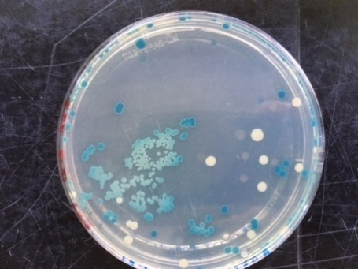Poor job spreading the bacteria (shaking the beads)
  + Forgot to change pipette tips
  + Some bacteria are “sticky” (due to adhesion proteins) and clump together (we do not usually see this in our strain)
  + Wet spot on the Petri dishes (as cells divide, instead of making one “colony” it spreads out (*E.coli* have flagella and can “swim”) and looks like lots of little small colonies.
* What would be the issue if we count each tiny colony in this case?

Instructor Notes: How you deal with “clumps” is a little tricky. They can mostly be avoided by making sure the Petri dishes are not wet and that students properly shake the beads in the dish to spread out the bacteria. If the dishes have been made ahead of time and stored, they can get extra condensation. However, these Petri dishes are also light and temperature sensitive so they should not be left out to dry for long extended periods. We have found pulling the Petri dishes out of the cold storage (and unbagging them) the night before lab helps.

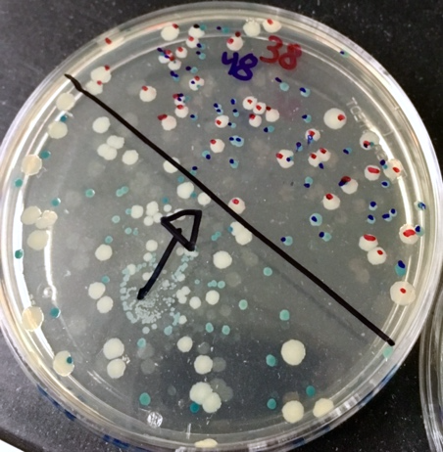

If colonies are inconsistently spread out (clumps or big clear spots without colonies), try and find a consistent looking 1/2 or 1/4 of the plate to count. But as mentioned above, try not to pick a spot that seems to favor one strain over the other if the overall plate seems to favor white cells but you pick a spot that is heavier in blue we could be basing the results.

Prompt: To calculate relative fitness, you counted colonies at two time points (getting initial frequencies and final frequencies). Why?

Student often get confused about the common competitor. We cannot compete the sensitive ancestor and the resistant strains directly because they are all directly related, so we can’t tell them apart on a Petri dish. The common competitor is also related but not directly and has been modified (a deletion) so it will look different on the Petri dishes.

We expect the common competitor will grow the same in all competitions, it is similar to a yard stick. By measure growth of the focal strains compared to the common competitor we can then make comparisons between our strains of interest, the sensitive strain and the resistant strains (both progenitor and descendant).

Instructor Notes:

When should a “problem be identified” for a line of data?

* *If data is missing*. If any field has not been entered, a problem should be identified on that line of data.
* *If you have a negative fitness value*. This occurs when one of the two competitors dropped in numbers over the course of the competition– the fitness metric is not informative in this case and a problem should be identified on that line of data.

 

If then

* If the colony counts for both competitors drop. This will occur extremely rarely, but the fitness measure will be positive in this case (why?) however, it will give the exact wrong answer about which competitor is dominant. In the event that both competitors’ colony counts drop from t=0 to t=24, a problem should definitely be identified.
* If you lack a colony count, which generated a fitness, a single colony count can be put in for a “conservative” measure of fitness. However, if this fitness data point ends up being extremely deviant (i.e., the strongest outlier), then you may choose to identify a problem on this line of data.

**Entering Competition Data**

Students should enter colony counts onto their worksheet and hand it in to the instructor (or a peer facilitator).

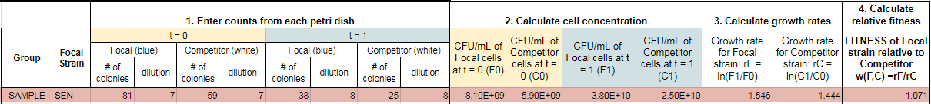

To get cell concentration from colony counts, you have to take the dilutions into account.

We will calculate relative fitness together, as a class.

1. enter cell counts from each petri dish and the dilution
2. calculate the cell concentration (CFU/mL)
3. calculate growth rate
4. calculate relative fitness

Lastly, once relative fitness has been calculate this data (along with MIC data) will be entered into the master data sheet to use in Lab 7 so we can analyze the results.

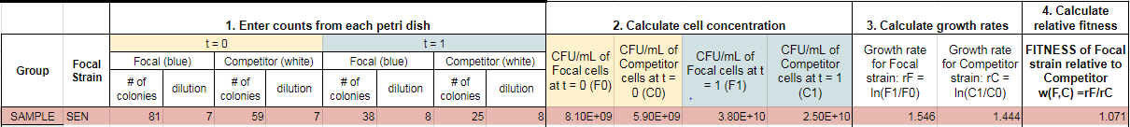

**Wrapping up and Looking Ahead:**

You now have had a glimpse of your own group’s data … what’s next?

It will be interesting to look at the class data. Why will the class data be of interest?

You will want to graph the data and run some statistical tests. Why?

What do we expect the data will show us?

Based off the data, we will want to think about follow-up experiments with your strains and other strains.

**Clean-up:** Students should 1) wipe down their benches with ethanol, 2) empty the waste containers on their bench into the appropriate waste bin (biohazard or tip waste tub).

Return the microtiter plates to the tray to be properly disposed of.

Return Petri dishes in the tray to be used in a future lab.

Wipe down your goggle (using ethanol on a kimwipe)

**After lab:**

Save one Petri dish with colonies of the RIF resistant progenitors and one Petri dish with colonies of RIF descendants from each lab group. The colonies on these plates will be used in a future lab. In Lab 8, students will select a colony from their RIF plates to use in a PCR. We aim to send the samples away for sequencing so we can identify the mutation that confers rifampicin resistance.

Make sure the plates are labeled, bag them up and store in the refrigerator until Lab 8.

Currently the STR colonies are not used again so they can be autoclaved for disposal once you have checked the data for any obvious errors.

## Bio1 CURE: Evolution of Antibiotic Resistance Lab 7

**Today’s Learning Goals**

* Use Rstudio to visualize and analyze results from the MIC assays and Fitness competitions.
* Discuss future directions for this research, including:
  + Identify potential questions to investigate (follow-up experiments)

**Sequence of events and timing**

Analyze fitness results 30 mins

Analyze MIC results 30 mins

Discuss future steps 45 mins

Prompt:

If you could repeat our experiment, what would you do differently (if anything)?

Are there any interesting patterns that you would like to investigate further?

If so, what kind of experiments might you set up?

What additional questions do your results raise?

If you were to propose a future experiment, what kinds of questions might you want to investigate? What variables would you manipulate?

Prompt:

How might your results change if you…

… continued the daily transfers for a longer time period?

…transferred strains in the presence of antibiotic?

… used a different strain of E. coli or a bacterial strain from a different genus/species than E. coli?

… had 2 or more strains of bacteria growing together for the duration of the experiment?

… changed the concentration of antibiotic (to be higher or lower) in the Petri dishes that we used as a selective pressure at the beginning of the experiment?

… used rifampicin and streptomycin together in a drug cocktail?

What if….

You used a different growth media (instead of using LB)?

Do you think media used might affects the evolutionary trajectories? Why or why not?

Prompt:

Imagine that the relative fitness of your STR strains started below one but by the end of serial transfers the relative fitness soared above one.

* If your MIC assay showed that the STR.d strain had the same MIC as the SEN strain, how would you explain these results, in terms of natural selection?
* How would you explain these results if the descendant maintained resistance?

Prompt:

In drug cycling programs, different antibiotics are applied in non-overlapping cycles. This means that one antibiotic (for example, Rifampicin) will be applied for a certain period of time and then removed for a period of time while a second drug is applied (for example, Streptomycin).

* From the results of your experiment, what are some of the possible outcomes of a drug cycling program?
* Is it possible that such a program might select for a bacterial strain both drug resistant and superior in growth to its ancestor?
  + How likely do you think this is to occur?
* If you wanted to test the effects of drug cycling, how would you adjust the protocol that we did?

Future directions:

For simplicity (and to ensure the labs are affordable), going forward we are going to focus on the rifampicin resistant strain.

Next lab, you will make many copies of the gene for RNA polymerase—the machine that rifampicin binds to. You will get sequence data for the RNA polymerase gene from both your RIF progenitor and descendant and compare this to the reference strain (the sensitive ancestor). This will allow you to identify mutations that occurred in this gene—that might be associated with resistance.

Using software called Pymol, will be able to visualize the structure of the RNA polymerase and evaluate how mutations potentially changed its structure.

# BIO2

## Bio2 CURE: Evolution of Antibiotic Resistance Lab 8

**Today’s Learning Goals**

* Predict the likely locations of mutations that confer antibiotic resistance
* Summarize the purpose of a PCR reaction
* Draw a figure explaining how gel electrophoresis works

**Sequence of events and timing**

|  |  |
| --- | --- |
| Activity | Duration |
| Instructor Lab Prep:   * Fill large ice bucket * Fill student ice buckets (Tupperware containers) * Get reagents   + 6 tubes of ladder (marked MR – in fridge)   + 6 tubes of loading dye (marked LD – in fridge)   + 6 tubes of “Cluster I master mix”/ “Cluster II master mix”     - In freezer   + 1 tube of enzyme     - In freezer – 1 tube per room per day   + 6 sets of 4 connected PCR tubes   + 1 tube of Sybr safe gel from the fridge * Take your Petri dishes from fridge |  |
| Start lab – Admin / Safety | 10 min |
| PCR Intro – brief! | 5 min |
| Colony transfer demo | 8 min |
| Students start PCR pipetting | 15 min |
| Students return PCR tubes w/out enzyme to TA | 2 min |
| Revisit previous CURE work. Instructor pipettes enzyme into all PCR tubes and starts cycles.   * Remember – you will need to cut CI and CII PCR tubes apart. * Run CI in one block using cluster 1 program, run CII in other block using CII program. * To complete PCR in time – please start thermocycler at this time! | 10 min |
| Hand-out previously PCR’d sample for gel electrophoresis   * These samples are in the thermocycler. | 0 |
| Intro to electrophoresis –   1. Purpose is to confirm product – did the reaction work? 2. You are sampling part of your sample for electrophoresis 3. The rest of the PCR products will go to outside lab for sequencing. | 10 min. |
| Start electrophoresis | 15 min |
| Start RNA Pol Activity | 50 min |
| View Gel | 10 min |
| Clean-up, confirm what to sequence, leave | 10 min |
| Tube clean-up:   * Used MR, LD, and CM – put back in fridge (put used tubes toward the back). * Enzyme – put back in freezer if not already done   Waste disposal:   * Pipette tips, gloves, gels, toothpicks: all to biohazard bin. |  |

**Background information**

Research has shown that resistance to rifampicin often arises from mutations in the *rpoB* gene, which encodes the β subunit of RNA polymerase. The goal of today’s lab is to set up a PCR reaction that will amplify segments of the *rpoB* gene known to be mutational hot spots: regions called Cluster I and Cluster II. We are using primers developed by Reynolds (2000)[2] that amplify two *rpoB* fragments. The first spans nucleotides 1-1342, including resistance cluster I. The second spans nucleotides 1240-2226, including resistance cluster II.

Petri dishes with colonies from the students’ competition assays have been stored in a cold room. Student will need their Rif-resistant progenitor Petri dish and the Rif-resistant descendant Petri dish.

We are doing a quick and dirty PCR protocol. Here are the steps:

- Using a sterile toothpick (or pipette tip), students will scrape a colony and swirl it into the appropriate tube. Ideally, it is best to use the same colony twice (for Cluster I and Cluster II). However, if the colonies are extremely small, you might have to select two different colonies. This is okay, because we don’t expect that enough evolution has occurred to create variation among colonies in the region we are sequencing.

- Make sure the PCR tubes are labelled properly on the cap and on the side of the tubes.

- The thermocycler settings have been pre-programmed for you. Note that there are settings for Cluster I and slightly different settings for Cluster II, so make sure tubes go into the right block. The settings can be found in the prep manual, if you are interested.

In this lab students will set up a PCR reaction and perform gel electrophoresis. In addition, students will discuss the structure of RNA polymerase, how it functions in transcription, and why it is impaired when rifampicin binds to it. Mutations in *rpoB* can lead to various levels of rifampicin resistance, as well as to a range of secondary effects. Our overall goal is for students to start making explicit connections between genotypes, phenotypes, and fitness as they explore the molecular basis of adaptation in drug-resistant bacteria.

*Two quick notes*

1) The term Clusters can be confusing with respect to *rpoB*. What Reynolds (2000) calls Cluster II includes what Campbell et al. (2001)[3] and other groups call Cluster I, II, and III. Instead of “Clusters,” you may also find references to the rifampicin resistance determining region (RRDR) of *rpoB*, which focuses on mutations at codons 516, 526 and 531.

2) The mutation rate for our strain of *E.coli* (MG1655) is ~1.0 × 10−3 mutations per genome per generation (reference: <https://www.pnas.org/content/109/41/E2774#sec-12>), or ~1.0 × 10−8 mutations per base per generation

## Bio2 CURE: Evolution of Antibiotic Resistance Lab 9

**Today’s Learning Goals**

* Create a sequence alignment
* Edit sequence data as needed
* Identify mutations in the DNA sequences of Rif-resistant progenitors and descendants
* Translate a DNA sequence
* Analyze whether mutations impact a protein’s primary structure

**Pre-lab prep**

Assign students’ strains & record in the TA strain log

**Sequence of events and timing**

|  |  |
| --- | --- |
| Intro   * Big picture: our contributions to science * Sequencing Clusters I and II and possible PCR/gel electrophoresis failures: frustrating but expected | 5 minutes |
| Poster Session (Part 1)   * Week 10, during lab time * Presenting findings to students, staff, faculty, and the public. * Invite your friends and family! | 5 minutes |
| *E. coli* mRNA and protein production (Part 2)   * RNA Pol structure and Rif mode of action * How would you expect resistant *E. coli* RNA Pol to be different from sensitive *E. coli* RNA Pol? | 15 min |
| Relative Fitness (Part 3) | 10 min |
| Bio1 experimental design (Part 4) | 10 min |
| MIC – Strep and Rif (Parts 5-7) | 15 min |
| Transition to computers | 1. min |
| Use laptop and projector to navigate to files; students follow on laptops | 1. min |
| Students download and complete Data Discussion: do the assignment on laptops, email completed documents to their group and TA | 10 min |
| Start TA Benchling tutorial   * Create alignments   + Check in with groups * “Task 1” Trim sequence –   + Check in with groups   + Complete page 3 of lab report * “Task 2” Sequence quality tutorial; misscall correction if needed.   + Check in w/ groups * “Task 3” Scan for mutations   + Check in w/ groups * Translation   + CAUTION: most likely for frame shift.   + Have groups check with their table peers. | 45 minutes |
| Students finish lab report discussion questions | 15 min |
| Student clean-up   * Take screen-shot images of DNA Sequences (ideally mutation) * Email image of mutation * Email data discussion * Delete files from laptop * Delete files from Benchling   + Archive files   + In archive - delete |  |
| Students turn in:   * Data discussion – via email 3 pts * Image of DNA sequences for progenitor and descendant – via email 1 pt * Lab report discussion –paper 4 pts | 5 min |

1. Poster Session: We will talk about poster requirements more in a future lab. Here the goal is to let students know about the poster presentations.
   1. We are excited for your contributions to one of the most ambitious undergraduate research experiments in ever. The work that we are doing in lab today will be used by you and your group.
   2. It will also contribute to a growing collection of work that will help us better understand antibiotic resistance.
   3. Over the next three weeks you and your peers will work to assemble your findings about the evolution of antibiotic resistance and the molecular explanation of resistance.
   4. Our lab reports and assignments will help guide you in the process of building a scientific poster to communicate your findings to other scientists within our department as well as non-scientists.
   5. Most scientific conferences hold poster sessions.
2. Revisit previous results
   1. Based on the POGIL from lab 8, we know that Rifampicin binds to RNA Pol.
   2. If a bacterial cell is resistant to Rif, it may have a mutation that causes the Rif binding site to be different in size, shape or charge—so the drug cannot bind.
   3. If the shape, size, or charge of amino acids near RNA pol’s active site change, would you expect transcription rates to change?
   4. (Complete Image 1)
   5. How would changes in transcription rates affect fitness?
3. Relative Fitness

Earlier we ran competition assays to estimate relative fitness. Recall that in this assay,

* 1. A culture plate lacking antibiotics was inoculated with two bacterial strains: one of the experimental strains and a common competitor.
  2. The two strains were left to grow.
  3. Colonies were counted at two time points, and growth rate calculated as the difference in colony density over time.
  4. Relative fitness was calculated as the growth rate of the experimental strain divided by the growth rate of the common competitor.

If the experimental strain is more fit, the value will be > (greater than) 1

If the experimental strain is less fit, the value will be < (less than) 1

If they are equally fit the value will be 1.

Please note: these fitness values are specific to an environment lacking antibiotics and relative to the competitor strain.

1. Reviewing the experimental design

All of the strains came from the same population but then evolved separately.

* 1. A sample from the common ancestor was exposed to an antibiotic: rifampicin or streptomycin.
  2. The colonies that survived the antibiotic and grew were collected.
  3. Resistant colonies were transferred to a medium WITHOUT antibiotic and grown for many generations, so evolution could occur.

1. MIC: a common clinical assay to estimate how resistant bacterial cells are to a drug. Earlier you ran an MIC assay for Rif and for Strep with each of your strains.
2. Hand-out Strain ID to students.
3. Our next task is to look at the data for your groups’ strain. Please open the web browser and go to:
   1. Canvas 🡪 Files 🡪 Lab Files
   2. Find the file for your lab section and open the data discussion file
   3. Open the excel sheet and find your strains’ data.
   4. In the next 10 minutes, use the data for your strain the answer the question in the data discussion file.
4. Next download your strain’s progenitor, descendant, and the SEN strain.
5. Benchling tutorial
6. Create an alignment
7. Analyze sequence quality tutorial
8. Trim sequence tutorial
9. Misscall tutorial
10. Scan for mutations.
11. Perform translation (Caution: frameshift mutations are COMMON!)

## Bio2 CURE: Evolution of Antibiotic Resistance Lab 10

**Today’s Learning Goals**

* Analyze the quaternary structure of RNA Polymerase
* Identify the binding pocket where rifampicin binds to the β subunit of RNA Polymerase (the protein coded by the *rpoB* gene)
* Model and view rifampicin and how it binds to β subunit of RNA Polymerase
* Use software to alter a *rpoB* sequence

**Sequence of events and timing**

Protein Structure and Function 15 mins

R-group chemistry and mutations 5 mins

Model RNA Polymerase (quaternary structure) 15 mins

Model rpoB protein alone 20 mins

Model Rifampicin Pocket 15 mins

Model Rifampicin in the Rif. Pocket of rpoB protein 10 mins

Mode Mutation 20 mins

Discussion and questions 15 mins

Poster Details 10 mins

Poster work 35 mins

Instructor Note:

The student manual tells students to download/open files:

* Codon Table & Sidechain Chemistry sheets can be found in a text book or online
* Pymol Cheat Sheet (found in the appendix in this manual)

Protein Structure / function refresher:

* 1o Structure : amino acid sequence

Bonds: Peptide (covalent bonds)

* 2o Structure: α helices and β pleated sheets

Bonds: Backbone–to–backbone hydrogen bonding.

* 3o Structure: Folding

Bonds: many! E.g. ionic; R-group-to-backbone hydrogen bonds; R-group to R-group hydrogen bonds

**Part 1** Student Prep

**Goal**: prepare all needed files / information to ensure a smooth experience.

* Canvas:
  + Group DNA Sequences results
  + Pymol Cheat Sheet PDF (appendix)
* Benchling
  + Create an alignment of the cluster with a mutation.
  + Create a translation for the template.
  + Create a translation for the mutation.
    - If no mutation is found in cluster I OR cluster II (this should be rare), ask students to create a random mutation in Benchling.
    - Because they are making an edit to their data, please have them document where this mutation was created.

**Required work for this section**: If students did not take screen shots of mutations last week, they should do so NOW! We will be using these next lab.

**Part 2 Model quaternary structure of RNA Polymerase**

Goals: Practice using Pymol; get a feeling for how the controls work and what the model means.

**Required work for this section**: None – just experience

**Part 3 Model rpoB subunit alone**

Goals: Understand rpoB’s role within a multi-unit protein.

**Required work for this section**: screen shot image of the rpoB protein in the preset “publication” visualization. This image will have the best resolution.

**Part 4 Model rifampicin-binding pocket**

Goals: Visualize residues that create an area where the antibiotic rifampicin binds to RNA Polymerase. Understand that the primary, secondary, and tertiary structure of rpoB are create this feature.

**Required work for this section**: screen shot image of the rifampicin-binding pocket, also called the “ligand binding site,” in the mesh surface mode.

**Part 5 Model rifampicin bound to the rpoB protein**

Goals: Visualize Rifampicin interacting with amino acids in the RpoB protein in the Rifampicin-binding pocket (ligand binding site). Understand why changes in the amino acids found in the binding pocket might affects Rifampicin’s ability to disrupt the enzyme.

**Required work for this section**: Screen shot image of Rifampicin sitting in the Rifampicin-binding pocket in the mesh surface mode.

**Part 6 Analyzing how a mutation affects rpoB**

Goals: Visualize how the mutation documented by each group has caused a structural and chemical change in rpoB that increases fitness in an environment containing Rifampicin.

**Required work for this section**: screen shot image of mutation in Pymol

**Part 7 Discussion question**

**Part 8 Poster work**

Poster Details:

Our final lab class will give us a chance to celebrate and share our research with each other and the greater community. Each group will create and present a scientific poster. We will go over more details later, but your poster will be a mix of brief text mixed with tables, graphs, and pictures. Most scientific conferences have a combination of talks and poster sessions.

In a poster session, researchers stand by their poster while other conference participants come and view the presentation and interact with the author. We will do something similar!

General Poster Tips:

Academic posters are a summary of what you did, how you did it, and what you learned.

Most posters are divided into four parts:

– Introduction (motivation for what you did)

– Design or methods (how you did it)

– Results

– Conclusion (what you learned)

Layout tips:

Space is limited. Choose your words and graphics carefully. A poster should be visually simple,

yet highly informative.

* Present information the way you would normally read — left to right, top to bottom.
* Use columns and line breaks to divide the poster into smaller sections.
* Use bullets instead of long paragraphs to summarize information.

## Bio2 CURE: Evolution of Antibiotic Resistance Lab 11

**Today’s Learning Goals**

* Connect changes in the molecular structure of RNA Polymerase in the progenitor and descendant strains to changes in MIC
* Propose a hypothesis to explain the molecular basis of fitness trade-offs
* Explain why changes in the molecular structure of RNA Polymerase in the progenitor and descendant strains can lead to changes in relative fitness
* Explain why changes in the molecular structure of RNA Polymerase in RIF-resistant strains could impact resistance to a second antibiotic, meaning that collateral effects occur.

This lab is largely small group discussions based on the questions in the student manual.

The aim is to revisit the data and each major concept in this CURE. By the end of today, students should be able to understand evolution as changes in allele frequencies and explain evolution by natural selection as an outcome of heritable variation associated with differential reproductive success. In addition, students should be able to recognize the molecular basis of heritable variation and then make explicit connections between genotypes, phenotypes, and fitness.

Another important goal for today is for students to look critically at their data. Are the results what we predicted?

* + If not, why? Is it more likely to be due to experimental errors (from the students or the prep team), lack of data, or because our predictions were wrong?
  + What is needed to feel more confident in the data and the results?

Make sure you are listening in on groups as they discuss the questions in their manual to clear up any misinterpretations. For example, if the class data shows no initial fitness cost of antibiotic resistance, why were there not typically lawns of bacteria growth on the Petri dishes that contained antibiotics but lawns of bacteria on the Petri dishes that did not contain antibiotics back in Lab 2? The data from Lab 2 (# of colonies on the Petri dishes) would support the idea that resistant cells were rare in the population if the cells had been grown in an environment without drug.

If fitness decreased over the time, as the bacteria were transferred in the absence of media, why might you want to confirm the accuracy of this data?

Time permitting, students can work on their poster presentations that they started last week.

## Bio2 CURE: Evolution of Antibiotic Resistance Lab 12

**Today’s Learning Goals**

* Use evidence to make a scientific argument.
* Use oral, graphical, and writing skills to communicate effectively with both scientific and lay audiences.
* Evaluate data collected by your peers, recognizing excellence and contributing constructive feedback on how to strengthen ongoing studies.

**Poster presentations**

The main goals of the poster session are for students to celebrate their work, share results with others, and practice communications skills in a supportive setting that should help decrease feelings of intimidation and increase confidence.

Scientific communication includes a diverse array of written and verbal modes that vary from formal to informal and are important to the successful practice of science in academia, industry, and other organizations. Communication can also reinforce the acquisition of new knowledge, development of expertise, and strengthening of other scientific competencies. One of the aims of this poster presentation session is for students to build professional identity, competence, and confidence. This will be one of the first times that students get to explore results from other groups.

The poster sessions will be an important time for students to solidify their knowledge and identify where they are confused.

**Examples of questions you might ask at the poster sessions.**

Protein structure

How do differences in protein structure observed in sensitive strains versus Rif-resistant progenitors and ancestors relate to fitness and MIC?

Fitness

1. Often you hear that resistance comes with a fitness cost. Why is this logical, and do your data indicate a cost of resistance? If not, what do you think is happening?
2. Did other groups have the same mutations (AA change) that you had? If so, did they have similar results?

Collateral Effect:

1. Why did you collect data on streptomycin-resistance? How is this relevant? What did you find?
2. If you were to do this again and wanted to test other drugs, what would you pick? (Ideas include drugs used for common infections in human, drugs that are often used together, or drugs that come from similar or dissimilar chemical families.

MIC:

Why do we suspect that the mutation you saw in Benchling (if you saw one) was the change that conferred resistance to RIF?

In General:

* Why is your work important?
* Please explain what data are presented in this graph. What did you conclude from the data?
* How could we explain what we observed, in terms of evolution?
* What did you propose for your future experiment(s)? What do you hope to learn from performing it?

Example email invitation to send to the department to advertise the poster sessions.

*Dear Biology Department,*

*During the past two quarters, our students in our Course-Based Undergraduate Research Experience (CURE) have been studying evolution of antibiotic resistance in E. coli. We cordially invite you to join this year’s CURE students as they present posters describing their research.*

*Poster Sessions: We will have multiple poster presentations with different student groups presenting each time. Students will be presenting their work in Room ___ at the following times:*

*Tuesday, May 29th from 4:00 - 5:30 pm*

*Wednesday, May 30th from 9:00 - 10:30 am*

*Thursday, May 31st from 11:30 - 1:00 pm*

*We would love for a strong turn-out of faculty, staff, and students to come support our hard-working student-scientists and help celebrate their progress this quarter.*

*We hope to see you there!*

*Sincerely,*

## Appendices

### Bacteria Daily Transfer Information and Tracking Sheet

**Instructor Notes:**

This CURE was run in a large introductory biology class that had 25 lab sessions. The notes below are for the student bacteria transfers that students did outside of normal lab time. Students would sign up using a Google spreadsheet and then come by the lab room during their time slot to do their transfer. Because we had a large number of students, we had a “transfer supervisor” who had help from peer facilitators.

If you have fewer lab sections, you will likely not need to have so much structure and supervision. Once students are properly trained, if your institution will allow it, students can “drop-in” to do their daily transfers independently. We recommend having a trained peer facilitator available to help the students in case an issue arises. We have found these “drop-in” transfers can facilitate informal conversations and discussions that students have found to be rewarding

**Supplies**

Each student will need:

* 1 box of sterile pipette tips
* 1 P20 pipette
* 1 P200 pipette
* 1 eppi of sterile saline (stored in the fridge)
* 1 eppi of sterile LB (stored in the fridge)
* Kimwipes
* 1 bottle of ethanol
* Pens/Sharpies

**Plus**

1. 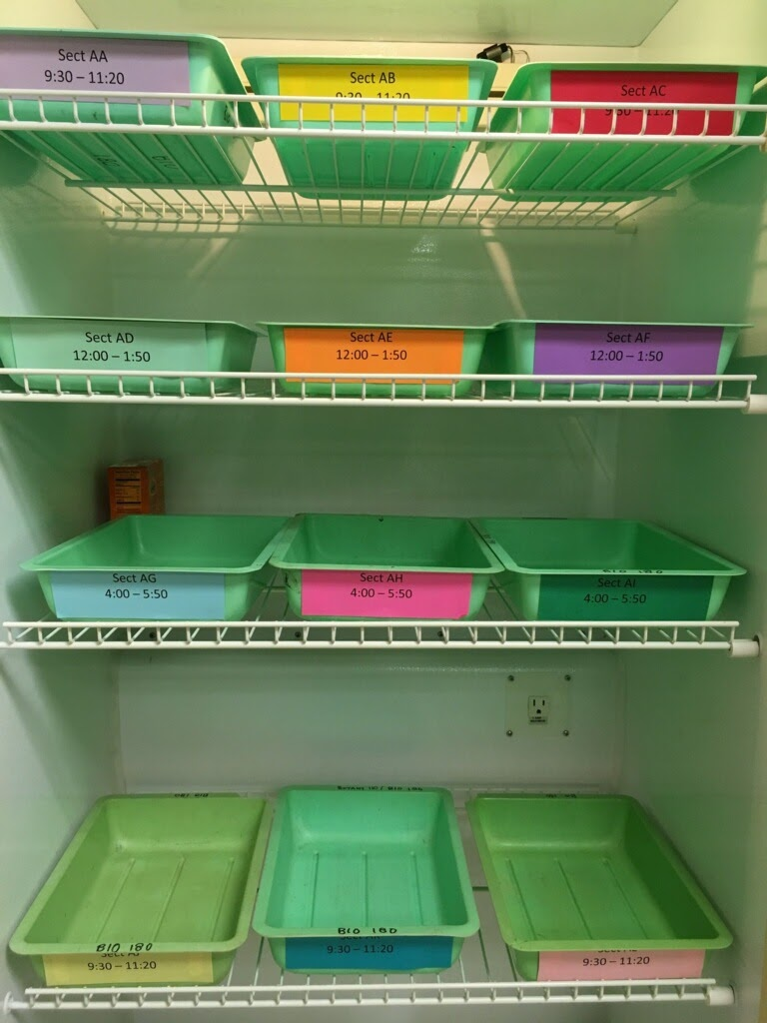Backup bacteria petri dishes or Backup microtiter plates
2. Extra Blank Transfer Sheet
3. Extra Sterile Microtiter Plates
4. Group microtiter plates in trays labeled by lab section (Incubator).
5. Folders labeled by Lab Section containing Transfer Sheets.

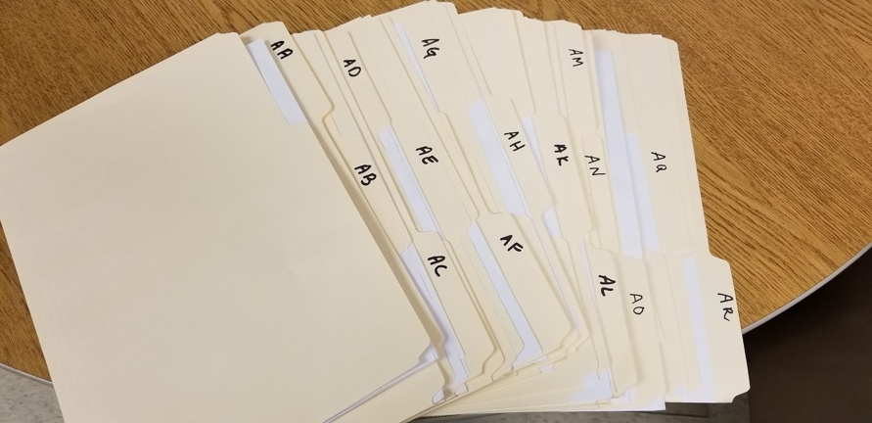

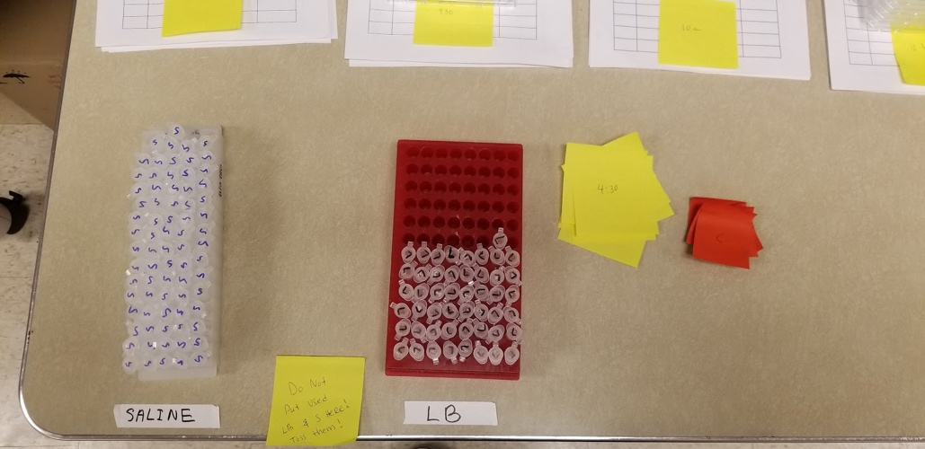**Before Student Drop-In Preparations**

1. Grab a rack of LB and Saline and place it in front of the room.
2. Transfer Sheets

* Using the Student Sign-up Spreadsheet, grab each session’s Transfer sheets and mark it with the time period the group is coming in, using a post-it.

1. Microtiter Plate

* Relocate trays from incubator to back counter in alphabetical order to make grabbing student’s plates easier.
* Grab each session’s Microtiter Plates and place them with the session’s Transfer Sheet.

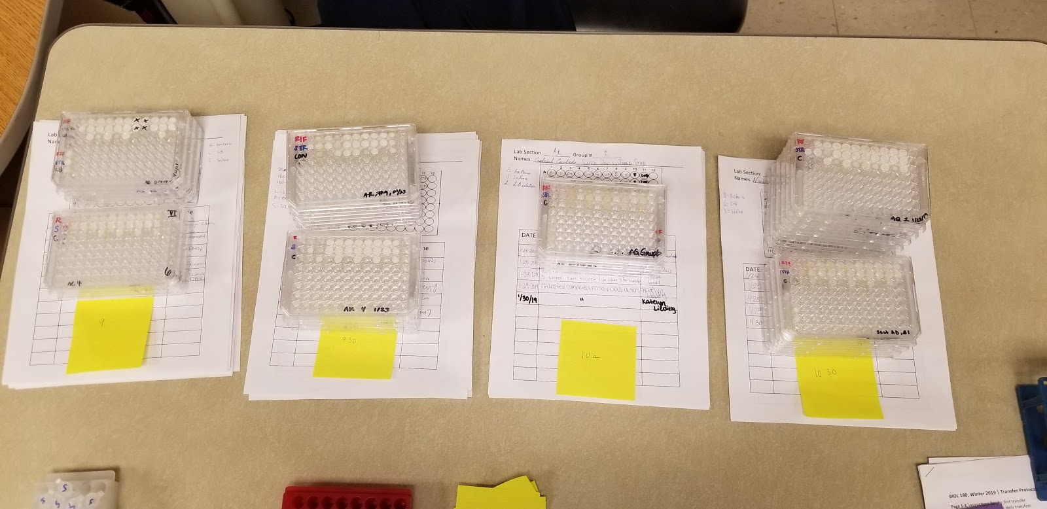

**Student Transfers**

1. Place the current session’s plates and paper on a designated seat.
2. Using the Google Tracking Spreadsheet
   1. Mark cells YELLOW if they are coming in to do their transfers
   2. Mark cells BLUE and write notes if they are either (1) missing their papers or (2) missing their plates.
      1. Missing papers can indicate (1) someone has already transferred and they double booked, (2) they missed their last session and requested a different time, or (3) they signed up twice a day.
      2. You would want to note down what times they were expected and confirm with the student when they come in.
   3. Mark cells GREEN if you notice the plate has something to discuss with the student. Ex. Contamination, no growth, etc.
   4. Mark cells RED  and write “LAB” if they have lab that day.
      * 1. Let the student know that they will transfer their bacteria during their lab.
3. No-Show Plates and Paper are placed in the back counter. It is easier to grab when they do show up.
4. After checking-in students can grab gloves, supplies, and do their bacteria transfer, filling in their tracking sheet as they work.

Students will become more comfortable with the daily transfers overtime. When the protocol is still new, you may opt to do brief overview of the protocol using the whiteboard. Students that have already completed a daily transfer and therefore have listened to and participated in this introduction are not required to listen to this introduction again.

Students are encouraged to write any notes (e.g. deviations from protocol) from these transfers in their group’s lab notebooks and/or tracking sheets.

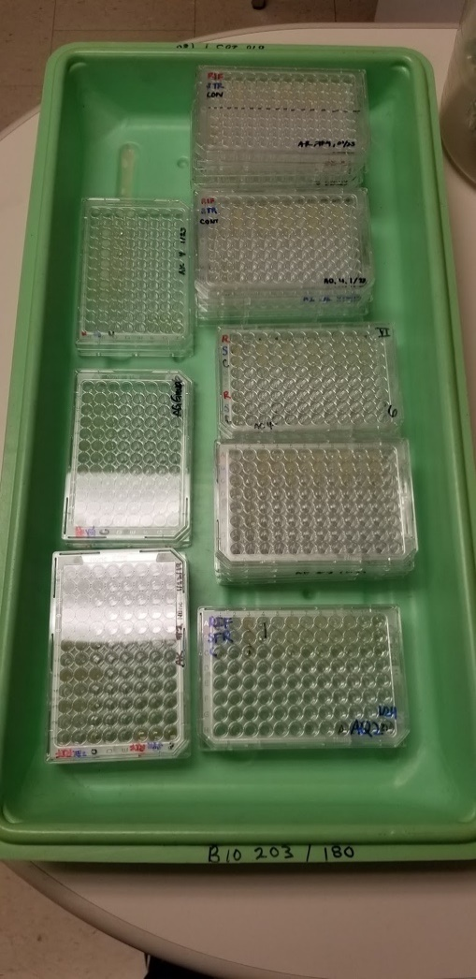**Student Clean-up**

1. Discard waste in respective areas
2. Move their microtiter plate to the “Completed” tray to go back into the incubator

3. Turn in their filled in Tracking Sheet

4. Wipe down their bench

5. Dispose of gloves

6. Wash hands

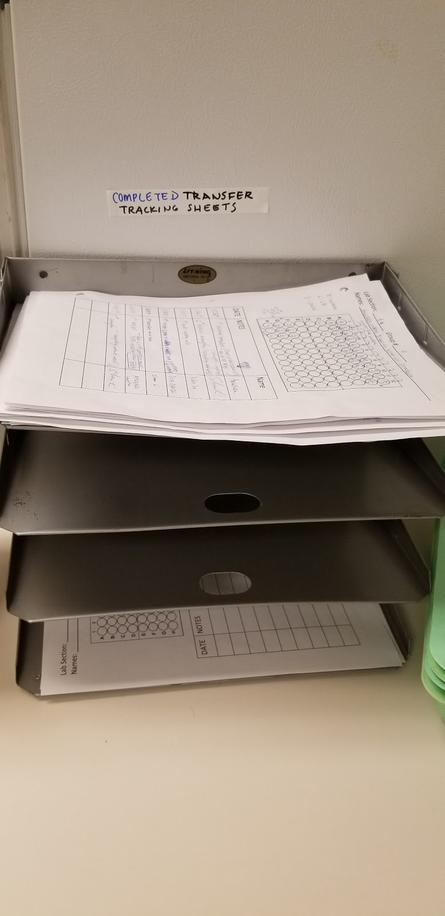

**Supervisor/Peer Facilitator Clean-up**

1. Tracking Sheets

* Throughout the day, roughly put completed sheets in alphabetical order of Lab Section along the back counter.
* At the end of the day, put the sheets in numerical order in their respective lab section folders, including incomplete sheets.

1. Microtiter Plates

* Throughout the day, try to organize completed plates by lab sections and start putting the plates in their trays and back into the incubator.

1. Clear out used pipette tip boxes and grab new autoclaved ones per work area.
2. Put unused LB and Saline back into refrigerator.

**Potential Issues**

If an issue arises, make sure students note their observations, hypothesize about what happened, and come up with a plan to move forward and add notes so their lab group and understand what happened. This is all part of science!

* No growth:
  + If this is the very first transfer, students will need to select a new colony from the appropriate petri dish and swirl into microtiter plate well with LB (following the steps in their lab manual from Lab 2).
  + For all other transfers, if there is no growth, students can “go back” a transfer, and transfer from the previous day’s culture to new LB broth (checking that their LB control is not contaminated that day)
    - What does this mean for their experiment?
    - That population will have less cell divisions which means less evolution, which might mean that we will see less variation between their progenitors and the descendants at the end of the transfers. As cells grow and divide, mutations can occur and be passed down to their daughter cells.
* Media Control is contaminated:
  + If first transfer, students will need to select a new colony from the appropriate petri dish and swirl into microtiter plate well with LB (following the steps in their lab manual from Lab 2).
    - Why? The LB media control is to confirm that the media itself isn’t contaminated, giving us confidence that the growth we see in the well is because of the bacteria we purposely put into those wells.
  + If possible, students can “go back” a transfer, and transfer from the previous day’s culture to new LB broth.
    - What does this mean for their experiment?
    - That population will have less cell divisions which means less evolution, which might mean that we will see less variation between their progenitors and the descendants at the end of the transfers.
  + If whole plate is contaminated, request for backup/pre-cultured plate.
* Accidentally pipette 20uL for Saline/LB instead of 180uL
  + Re-adjust P200 to 160uL and insert respective Saline and LB into wells.
  + Make sure the student changes the pipette back to 180uL to prevent other students from making an error (though students should ALWAYS check what volume their pipette is set to.
  + Proceed with transferring 20uL of Bacteria into Saline and then into the LB
* Accidently use the pipette set to 180uL to transfer the bacteria instead of 20uL
  + The well can overflow if a student doesn’t catch the error in time (each well can hold 300uL) –
  + IF the student catches the issue while pipetting expect the well to be very full, be careful but gently use the pipette to remove the volume into the waste bin and start again with new wells.
* Mixed Saline with the LB in a well.
  + Grab a new set of Saline and LB and have them redo their Saline and LB in the next two wells. Transfer bacteria into the new set of solutions.
* Not having enough LB
  + Student most likely grabbed an eppi tube of LB that had been used by a previous student (each eppi tube has a little extra LB in case there is an error).
  + Proceed by giving the student a new LB and have them fill 3 new LB wells in the next column. Have the student transfer Bacteria to the new LB.
    - If two different LBs are used, media control will be inaccurate, reduce ambiguity by  grabbing fresh LB and doing 3 new wells.
* Mixed their RIF and STR strains
  + If two different bacteria are placed into one well, start over with fresh Saline and LB
  + If the two bacteria are misplaced/swapped, the best option is to restart with fresh Saline and LB.
    - Alternatively, students can label carefully which bacteria is where on the Transfer sheets AND plate however this isn’t not recommend because it can cause mistakes in the future.
* Transferred Bacteria before placing solutions
  + It will be visibly apparent that there is 20uL of bacteria in a well.
  + If 20uL of bacteria is in Saline well, simply put 180uL of saline and mix and continue as normal.
  + If 20uL of bacteria was pipetted straight into the LB well, why can’t you just add 180uL of LB? You can but then the bacteria will have not been diluted in saline first so it will stop growing earlier than we want because the well will quickly because saturated. Diluting the bacteria in Saline first thins the culture.
    - The bacteria goes through two 10x dilutions, first it is diluted in saline and the second dilution is when you add the diluted culture into the LB
* Student came in to do their transfer at an unscheduled time (either by sign-up error or walk in)
  + Have the student wait for available seating.
  + If room has available space, let them in.
  + If students are getting used to transfers and they are able to finish within 15 minutes without supervision, the walk-in can take their seats.
* Students did the wrong plate, doing the transfer for another group
  + Remind students to check if the plate they are doing is theirs next time.
  + Have student do their respective plate and make a note for the other lab group

Other notes:

Transfer to a new microtiter plate once the first plate is full

* + After students transfer to a new plate, we recommend you keep both plates together and for at least 2 successful transfers.

Lab Section: _________ Group #__________

Group Members: ___________________________________________________

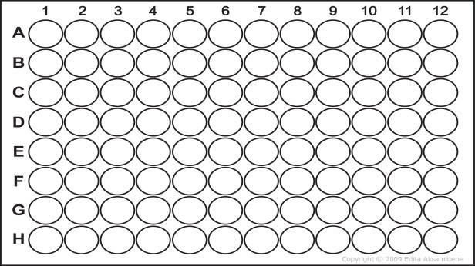

L = LB

S= Saline

L+B = LB + bacteria

|  |  |  |  |
| --- | --- | --- | --- |
| Transfer # | Date & Time | Observations/Notes/Protocol deviations | Name |
|  |  |  |  |
|  |  |  |  |
|  |  |  |  |
|  |  |  |  |
|  |  |  |  |
|  |  |  |  |
|  |  |  |  |
|  |  |  |  |
|  |  |  |  |
|  |  |  |  |

### Competition Drop-In Notes

Note:

Many items are pre-labeled to make the drop-in time less demanding for students. If timing is not an issue for your students, students can do some of the prep and labeling themselves.

You will need:

* Student microtiter plates from the previous lab day when they started the competition. In Column 5 the focal strain has competed for space and nutrients with the “common competitor” strain. For ~24hrs.
* For each group a “dilution” microtiter plate that has 180uL of sterile saline in the wells so students can do a dilution series (thinning the population in order to get countable colonies on a Petri dishes)
* Sterile LB Petri dishes that have been beaded.

Make sure to remind the students, when doing their dilution series to gently pipette up and down to mix as they move from well-to-well, so they get a proper dilution.

Student can review the steps they did yesterday to plate their competitions as a reminder. Once students are done have them do their standard clean up procedures and place their Petri dishes in a tray to be moved to the incubator to grow overnight.

Instructors note: Don’t forget to do the t = 1 plating for the sensitive strain as well.

### Example Practice Data Sheets for Lab 3 & 4

**Important note**: this data needs to be in a .cvs format and needs to be titled “ClassData” in order to work with the R code as it is written. Data below is sample data from one of the pilot classes that we ran. (This will be the same layout for the master data sheet for your results).

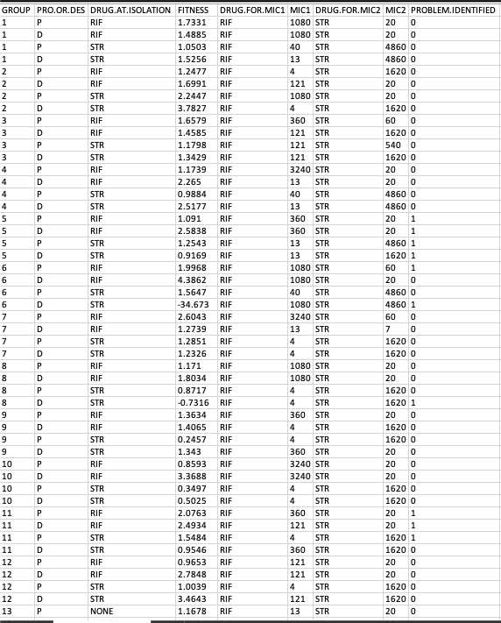

### R code for lab 3

BIO 180 Lab 3: Intro to Statistics

Welcome to RStudio! For many of you, this will be one of your first experiences with coding and you may be feeling a little apprehensive. However, with the instructions in this R script, and your TA and peer facilitator on hand, we are confident you will quickly realize how simple and powerful coding is. This is important because the number of careers that require coding skills (e.g. researchers, data analysts) is growing rapidly, and if you can gain some coding skills now, you will be highly competitive candidates for these types of jobs when you graduate from UW!

In today’s lab you will get to practice using t-tests and interpreting the results, which will be useful for your next exam and for when you analyze your lab data later this quarter. By the end of this lab, you will be able to: 1) Recognize data that can be analyzed with a t-test 2) Deploy a t-test in RStudio 3) Interpret the results of a t-test 4) Explain why statistics are important in Biology

Part 1: Loading and exploring data

To start practicing t-tests you are going to need some data. But before that, there are a few R commands that the BIO 180 teaching staff have edited to make them more useful for your needs. Load these edited commands by running the following line of code

source("AdditionalFunctions.R")

The data you will use today are fitness data collected by students in previous quarters of BIO 180 (the same type of data you will be collecting in lab 6). Load this data into RStudio and save it under the name “class_data” by running the following line of code

class_data <- read.csv("ClassData.csv")

Whenever you are analyzing data, your first task should be to look at the data. To look at the dataset you just loaded, click on the name “class_data” in your Environment (see top-right panel of the screen). Each row in the data represents a single strain of E. coli. As you move across the columns, you will see that for each strain you have information on: whether it is a progenitor (PRO = frozen at the end of lab 1) or a descendent (DES = underwent serial transfer), the drug that was used at its isolation (NONE = sensitive strain), and its fitness measured through the competition assay. The final column “PROBLEM.IDENTIFIED” contains 0 or 1, with 1s indicating that a problem was found with that data and therefore the strain should not be included in the analyses

Use the code below to remove these problem strains from your data so you don’t accidentally include them in your analysis

class_data <- subset(class_data, class_data$PROBLEM.IDENTIFIED == 0)

Great work! Your data are now ready for statistical analysis! Before moving onto the next section, be sure to complete Part 1 of your worksheet

Part 2: T-test

Recall that t-tests are used to ask questions of the form “Is A different from B?” To use a t-test, you need a categorical independent/explanatory variable and a continuous dependent/response variable. To practice the t-test, you are going to ask whether there is a fitness cost to RIF resistance. To do this you will compare fitness between RIF resistant progenitors and SEN progenitors.

Before continuing, work with your lab group to complete questions 4-6 on your worksheet by writing out your hypothesis and corresponding null hypothesis for this t-test, and drawing a graph of your expected results under both your hypothesis and null hypothesis.

Next, restrict your dataset to only the RIF resistant progenitors and SEN progenitors (the only strains you need to test your hypothesis), and call this new dataset “rif_vs_sen_fitness”

rif_vs_sen_fitness <- subset(class_data, class_data$PRO.OR.DES == "P" &   
 class_data$DRUG.AT.ISOLATION %in% c("RIF", "NONE"))

Now you can deploy your t-test by running the next line of code. When you do this, the output of your t-test will appear below. Make sure you can find your p-value in this output

t.test(FITNESS ~ DRUG.AT.ISOLATION, data = rif_vs_sen_fitness)

##   
## Welch Two Sample t-test  
##   
## data: FITNESS by DRUG.AT.ISOLATION  
## t = -3.4495, df = 41.978, p-value = 0.001291  
## alternative hypothesis: true difference in means is not equal to 0  
## 95 percent confidence interval:  
## -0.6915844 -0.1810548  
## sample estimates:  
## mean in group NONE mean in group RIF   
## 1.246273 1.682592

Now plot your data by running the next line of code

bar_graph(dependent <- rif_vs_sen_fitness$FITNESS,  
 independent <- rif_vs_sen_fitness$DRUG.AT.ISOLATION,  
 ylab <- "Fitness",  
 xlab <- "Drug at isolation",  
 main <- "Fitness cost of RIF resistance")

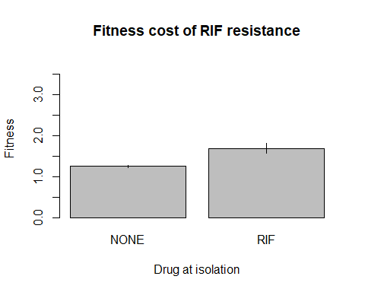

Now that you have deployed your t-test and plotted your data, return to your worksheet to describe and interpret your results (questions 7 and 8)

Part 3: T-test with paired data

In this section you will practice using a special kind of t-test called a paired t-test. The best way to explain when a paired t-test is required is through an example. Imagine you are asking the question of whether a new medicine decreases blood pressure. You get a group of volunteers, and measure each volunteer’s blood pressure before taking the medicine, and then measure their blood pressure again after they have been taking the medicine for 5 weeks. To determine whether the medicine works, you could use a regular t-test (like the one you used earlier) to determine whether blood pressure differs between the “before medicine” group and the “after medicine” group. However, this test could return a significant result even if most volunteers’ blood pressure did not change, but a few volunteers’ blood pressure decreased A LOT. A better way to test if the medicine works is to calculate the change in blood pressure for each volunteer and then test if these changes were, on average, decreases. This is what a paired t-test does.

In your experiment this quarter, you will be generating your own before-and-after data. Specifically, because you will have progenitor (= before serial transfer) and descendent (= after serial transfer) strains of E. coli. To practice the paired t-test, we would like to to test whether serial transfer changed the fitness of your RIF strains. In other words, did fitness differ between the RIF progenitors and the RIF descendents?

Before continuing, work with your lab group to complete questions 9-11 of your worksheet by writing out your hypothesis and corresponding null hypothesis for this paired t-test, and drawing a graph of your expected results under both your hypothesis and null hypothesis.

Now make another new dataset that contains only the RIF strains (progenitors and descendents) and call it “rif_strains”

rif_strains <- subset(class_data, class_data$DRUG.AT.ISOLATION == "RIF")

Remove from your dataset any strains for which there isn’t both a progenitor and a descendent - these strains are not paired, so can’t be used in the paired t-test

rif_strains <- rmv_unpaired(data = rif_strains, pair_id = rif_strains$GROUP)

Now create another new dataset where the progenitor and descendent fitness data are in separate columns, where each row contains a pair (one progenitor and its descendent), and call it “rif_paired”. After running this code, be sure to look at the new dataset by clicking on its name in your Environment (top-right panel of RStudio)

rif_paired <- pair_format(rif_strains, "FITNESS")

Great! Now your data are ready for the paired t-test, so go ahead and deploy it! Be sure to find the p-value in the output that will appear below

t.test(rif_paired$DES, rif_paired$PRO, paired = T)

##   
## Paired t-test  
##   
## data: rif_paired$DES and rif_paired$PRO  
## t = 2.4351, df = 15, p-value = 0.02784  
## alternative hypothesis: true difference in means is not equal to 0  
## 95 percent confidence interval:  
## 0.04758091 0.71551909  
## sample estimates:  
## mean of the differences   
## 0.38155

Now plot your data using the next section of code. Note that the lines on the plot connect the paired progenitors and descendents (from the same lab group)

paired_plot(before = rif_paired$PRO, after = rif_paired$DES, ylab = "Fitness",  
 main = "Change in RIF fitness over time")

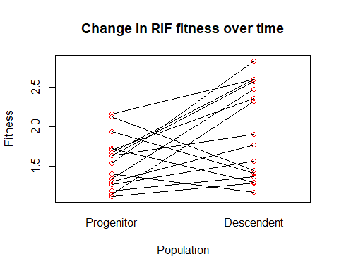

Congratulations! You have loaded data into RStudio, reorganized your data, and conducted both a t-test and a paired t-test! To finish off lab 3, get back together with your lab group and interpret the results of your paired t-test to answer the final questions (12-14) on your worksheet. And remember, if you want to keep a copy of your analysis in RStudio, you can create an html file from this script (hit the “Knit” button at the top) and email it to yourself.

### Additional Functions

Additional Functions

This script contains functions that are called in the script for lab 7. The functions reduce the amount of code that appears in the scripts that students will view, while allowing them to perform complex data reorganization and plotting

Restrict dataset to strains resistant to your drug of interest and sensitive

focal_drug <- function(data){  
 output <- data[data$DRUG.AT.ISOLATION %in% c(drug, "NONE"), ]  
}

Separate MICs corresponding to different drugs into distinct columns

reformat_mic <- function(data){  
 output <- data[, c("GROUP", "PRO.OR.DES", "DRUG.AT.ISOLATION", "FITNESS")]  
 output$MIC.ON.RIF <- NA  
 output$MIC.ON.RIF[which(data$DRUG.FOR.MIC1 == "RIF")] <-   
 data$MIC1[which(data$DRUG.FOR.MIC1 == "RIF")]  
 output$MIC.ON.RIF[which(data$DRUG.FOR.MIC2 == "RIF")] <-   
 data$MIC2[which(data$DRUG.FOR.MIC2 == "RIF")]  
 output$MIC.ON.STR <- NA  
 output$MIC.ON.STR[which(data$DRUG.FOR.MIC1 == "STR")] <-   
 data$MIC1[which(data$DRUG.FOR.MIC1 == "STR")]  
 output$MIC.ON.STR[which(data$DRUG.FOR.MIC2 == "STR")] <-   
 data$MIC2[which(data$DRUG.FOR.MIC2 == "STR")]  
 output  
}

Calculate standard error of a numeric vector

se <- function(x){sd(x, na.rm = T)/sqrt(length(na.omit(x)))}

Create a bar graph with standard error bars

bar_graph <- function(dependent, independent, ylab, xlab, main,  
 include_points = F, log_scale = F){  
 means <- tapply(dependent, independent, FUN = mean, na.rm = T)  
 ses <- tapply(dependent, independent, FUN = se)  
 if(log_scale == T){  
 my_plot <- barplot(height = means,  
 ylim = c(1, max(dependent, na.rm = T) * 1.5),  
 ylab = ylab, xlab = xlab, main = main, log = "y")  
 } else {  
 my_plot <- barplot(height = means,  
 ylim = c(0, max(dependent, na.rm = T) * 1.05),  
 ylab = ylab, xlab = xlab, main = main)  
 }  
 segments(my_plot, means - ses, my_plot, means + ses, lwd = 1.5)  
 if(include_points == T){  
 points(x = rep(my_plot[2],  
 times = length(dependent[which(independent == drug)])),  
 y = dependent[which(independent == drug)], col = "red")  
 }  
}

Remove unpaired observations from a paired dataset

rmv_unpaired <- function(data, pair_id){  
 complete_pairs <- as.numeric(names(which(table(pair_id) == 2)))  
 output <- subset(data, pair_id %in% complete_pairs)  
 output  
}

Format paired data for a paired t-test

pair_format <- function(data, dependent){  
 output <- data[data$PRO.OR.DES == "P", c("GROUP", dependent)]  
 output$DES <- data[data$PRO.OR.DES == "D", dependent]  
 colnames(output)[2] <- "PRO"  
 output  
}

Plot paired data with lines linking paired points

paired_plot <- function(before, after, ylab, main, log_scale = F){  
 plot_data <- data.frame(x = rep(c(0.2,0.8), each = length(after)),  
 dependent = c(before, after),  
 treatment = rep(c("Progenitor", "Descendent"),   
 each = length(after)))  
 if(log_scale == T){  
 plot(x = plot_data$x, y = plot_data$dependent, col = "red", xlim = c(0, 1),  
 xaxt = "n", xlab = "Population", ylab = ylab, main = main, log = "y")  
 } else {  
 plot(x = plot_data$x, y = plot_data$dependent, col = "red", xlim = c(0, 1),  
 xaxt = "n", xlab = "Population", ylab = ylab, main = main)  
 }  
 axis(side = 1, at = unique(plot_data$x), labels = unique(plot_data$treatment))  
 segments(x0 = plot_data$x[1:length(after)],  
 y0 = plot_data$dependent[1:length(after)],  
 x1 = plot_data$x[(length(after) + 1):nrow(plot_data)],  
 y1 = plot_data$dependent[(length(after) + 1):nrow(plot_data)])  
}

### R code for lab 4

(plus you will still use the “Additional Functions” file)

BIO 180 Lab 4: MIC and Collateral Effects

Welcome back, experienced RStudio users! As you all know how to use RStudio, let’s get straight to it with today’s learning goals. By the end of this lab, you will be able to: 1) Recognize data that can be analyzed with a linear regression 2) Deploy a linear regression in RStudio 3) Interpret the results of a linear regression 4) Explain why we expect a relationship between MIC and fitness

Part 1: Loading and exploring data

To practice using linear regression, you will be using fitness and MIC data collected by students in previous quarters of BIO 180 (the same data you will be collecting in lab 6). Load this data into RStudio and save it under the name “class_data” by running the following line of code

class_data <- read.csv("ClassData.csv")

Remember to look at this data again to remind yourself what it looks like (hint: look at your data by clicking on its name in the Environment panel). When looking at your data you will see that the last column is called “PROBLEM.IDENTIFIED” and contains 0s and 1s. The 1s indicate that a problem was found with the data in that row, so remove those rows from your data by running the following line of code

class_data <- subset(class_data, class_data$PROBLEM.IDENTIFIED == 0)

Part 2: Linear regression

Recall that linear regression is used to answer questions of the form “is there a relationship between A and B?” To use linear regression we need both our dependent and independent variables to be continuous. To practice linear regression, you will be testing whether there is a relationship between MIC and fitness. The theory behind why there might be a relationship between MIC and fitness is a little tricky, so let’s work through it together.

Antibiotics kill bacteria by breaking essential machinery of the bacterial cell. When this machinery is broken, the bacterium cannot survive. The antibiotic can only break the machinery if it is a particular shape. When a bacteria becomes resistant to an antiobiotic, it has usually changed the shape of its machinery (through mutation) so that the antibiotic can no longer break it. Unfortunately for the bacteria, this new shape usually means that the machine can’t do its job as well as it did before it changed shape. This is the cost of resistance that you learned about in previous labs.

In today’s lab, you went one step further and learned that bacteria can have different levels of resistance (measured by MIC). A bacteria that has only weak resistance probably only changed the shape of its machinery a little bit, so the antibiotic is still able to bind to it sometimes. However, this small change in shape also means that the machine can still do its normal job quite well, so this bacteria experiences a low cost of resistance. Bacteria with very strong resistance have machinery of a very different shape, so the antibiotic almost never breaks it, but it also can’t do its job very well (big cost of resistance).

Using this information, you should be able to make a prediction about the relationship between MIC and fitness. Be sure to ask your TA and/or peer facilitator about this if you are unsure - this is a tricky concept!

Now that you have a prediction, you can create a new dataset for analysis that only contains the RIF progenitors, and call it “fit_vs_MIC”

fit_vs_MIC <- subset(class_data, class_data$PRO.OR.DES == "P" &   
 class_data$DRUG.AT.ISOLATION == "RIF")

Now deploy your linear regression and save the output under the name “fit_vs_MIC_model”

fit_vs_MIC_model <- lm(FITNESS ~ MIC1, data = fit_vs_MIC)

The next line of code will print a summary of your linear regression. Make sure you can find your p-value (fourth column, second row of the coefficients table) and R squared (Multiple R-squared - second row from the bottom of the output)

summary(fit_vs_MIC_model)

##   
## Call:  
## lm(formula = FITNESS ~ MIC1, data = fit_vs_MIC)  
##   
## Residuals:  
## Min 1Q Median 3Q Max   
## -1.5879 -0.4103 -0.1509 0.2920 1.6844   
##   
## Coefficients:  
## Estimate Std. Error t value Pr(>|t|)   
## (Intercept) 1.999e+00 1.880e-01 10.637 8.29e-13 ***  
## MIC1 -1.805e-04 8.361e-05 -2.159 0.0374 *   
## ---  
## Signif. codes: 0 '***' 0.001 '**' 0.01 '*' 0.05 '.' 0.1 ' ' 1  
##   
## Residual standard error: 0.7336 on 37 degrees of freedom  
## Multiple R-squared: 0.1118, Adjusted R-squared: 0.08784   
## F-statistic: 4.659 on 1 and 37 DF, p-value: 0.03744

And finally, make a scatterplot of your data

plot(fit_vs_MIC$FITNESS ~ fit_vs_MIC$MIC1, ylab = "Fitness", xlab = "MIC",  
 main = "Fitness vs. resistance to RIF")  
abline(fit_vs_MIC_model)

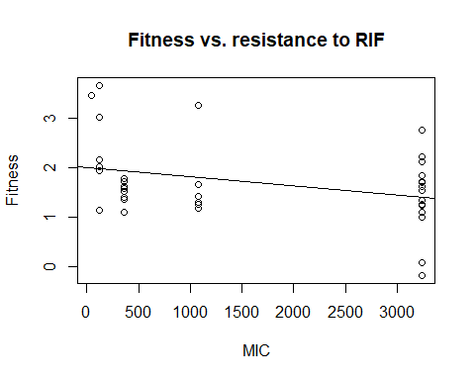

Nice work! You have now deployed a linear regression in RStudio! To finish off this lab, get back together with your lab group and interpret the results of your linear regression to answer the final questions on your worksheet. And remember, if you want to keep a copy of your linear regression analysis, you can create an html file from this script (hit the “Knit” button at the top) and email it to yourself.

### MIC maps for practice, Lab 4













### Example Data Sheets for calculating competitive fitness

We suggest making a shareable spreadsheet so student can enter their data or hand the data in for a Peer Facilitator to enter.

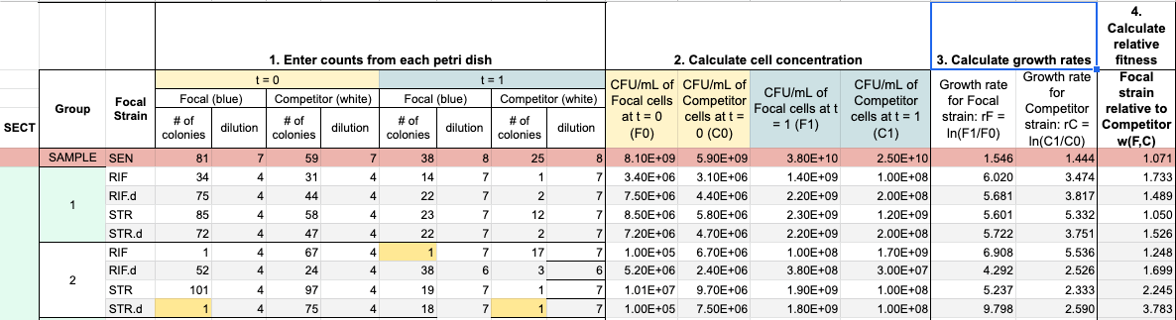

(The table above has been enlarged in parts below, so it is easier to read).

Part 1. Enter colony counts and dilutes from the petri dishes

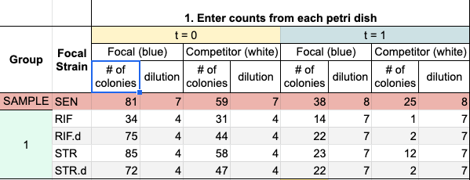

Part 2. Using the information entered in Part 1, calculate cell concentrations

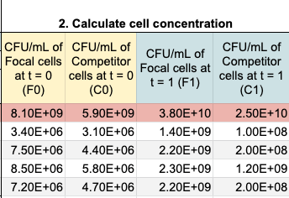

Part 3 and 4. Calculate growth rate and relative fitness

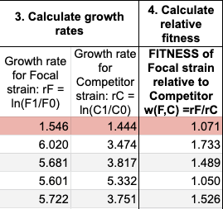

Once relative fitness has been calculated this information will need to be transferred to the master data sheet (that will also have the MIC data) to be used in R/RStudio for data analysis.

The master data spreadsheet will need to be set up like this:

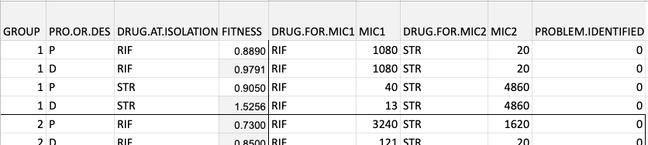

### R code for lab 4

(You will also use the “Additional Functions” code)

BIO 180 Lab 7: Data Analysis

Welcome to your BIO 180 Data Analysis lab! So far this quarter, you have all been working hard to create strains of E. coli with different drug resistance traits and you then collected data on the fitness and MIC of these strains. Now you finally have all your data and can start your analysis. We’re sure you’re all excited to see how your strains performed in the fitness and MIC trials and how they evolved during the daily transfers, so let’s get started!

As each group has collected so much data, we are going to use a divide and conquer strategy to complete all our analyses. In your labgroup of 3 or 4 people, we would like half of the group to analyze the RIF-resistant strains on one laptop, and the other half to analyze the STR-resistant strains on the other laptop. However, be sure to confer with your colleagues working at the other laptop as you will need information from both analyses to complete your worksheet

IMPORTANT! First, identify which type of resistance you will be analyzing be removing the hash tag from the beginning of ONLY ONE of the following two lines of code, then run this section of code

drug <- "RIF"  
#drug <- "STR"

Now, as in labs 3 and 4, load the set of functions created by the BIO 180 teaching team

source("AdditionalFunctions.R")

Load your data

class_data <- read.csv("ClassData.csv")

Exclude any data that was identified by the teaching team as problematic

class_data <- subset(class_data, class_data$PROBLEM.IDENTIFIED == 0)

Next, remove the data for strains resistant to the other drug i.e. not the drug you are interested in. Remember to check the data to see what it looks like!

class_data <- focal_drug(class_data)

The next line of code will rearrange the MIC columns in your dataset so that the column names are more meaningful. View the dataset after this step to see what has changed

class_data <- reformat_mic(class_data)

Great, your data are now formatted for analysis, so let’s begin!

Question 1: Is there a fitness cost to resistance?

To answer this question you will need to compare fitness between your resistant progenitors and your sensitive progenitors. Your dependent variable is fitness, which is continuous, but your independent variable is bacterial strain, which is categorical, so we will use a t-test

First subset your data to only the progenitors

progenitors <- subset(class_data, class_data$PRO.OR.DES == "P")

Implement your t-test (and be sure to look for the p-value in the output!)

t.test(FITNESS ~ DRUG.AT.ISOLATION, data = progenitors)

##   
## Welch Two Sample t-test  
##   
## data: FITNESS by DRUG.AT.ISOLATION  
## t = -3.4495, df = 41.978, p-value = 0.001291  
## alternative hypothesis: true difference in means is not equal to 0  
## 95 percent confidence interval:  
## -0.6915844 -0.1810548  
## sample estimates:  
## mean in group NONE mean in group RIF   
## 1.246273 1.682592

Create a bar graph of the data with the individual values of the resistant strains shown as red circles. These red circles are needed to answer one of the questions on your worksheet

bar_graph(dependent <- progenitors$FITNESS,  
 independent <- progenitors$DRUG.AT.ISOLATION,  
 ylab <- "Fitness",  
 xlab <- "Drug at isolation",  
 main <- paste("Fitness cost of", drug, "resistance", sep = " "),  
 include_points = T)

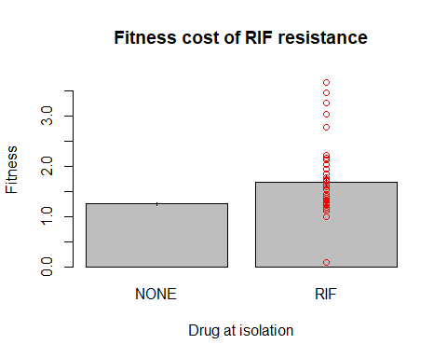

Question 2: Did fitness change over time?

To answer this you will need to compare fitness between your resistant progenitors and your resistant descendants. You are still comparing two groups of data, but now each progenitor is paired with a single descendant, so you will need to use a paired t-test

Subset your data to only the resistant strains

resistant_strains <- subset(class_data, class_data$DRUG.AT.ISOLATION == drug)

Remove any strains that do not have both a progenitor and descendant version

resistant_strains <- rmv_unpaired(resistant_strains,  
 pair_id = resistant_strains$GROUP)

Reformat your data for a paired test (go ahead and look at the new dataset to see what the new format looks like)

fitness_paired <- pair_format(resistant_strains, "FITNESS")

Implement the paired t-test

t.test(fitness_paired$DES, fitness_paired$PRO, paired = T)

##   
## Paired t-test  
##   
## data: fitness_paired$DES and fitness_paired$PRO  
## t = 2.4351, df = 15, p-value = 0.02784  
## alternative hypothesis: true difference in means is not equal to 0  
## 95 percent confidence interval:  
## 0.04758091 0.71551909  
## sample estimates:  
## mean of the differences   
## 0.38155

Plot the data

paired_plot(before = fitness_paired$PRO, after = fitness_paired$DES,  
 ylab = "Fitness",  
 main = paste("Change in", drug, "fitness over time", sep = " "))



Question 3: Did resistance change over time?

In the last section, you may have noticed that fitness of your resistant strains increased over time (through evolution during the daily transfers). However, you cannot determine if this is due to compensatory mutations or a loss of resistance. To distinguish between these two scenarios, you need to compare resistance (measured as MIC) between your resistant progenitors and resistant descendants. This is still paired data, so you will use another paired t-test

Reformat the MIC data for the paired t-test

mic_paired <- pair_format(resistant_strains, paste("MIC.ON.", drug, sep = ""))

Implement the paired t-test on log-transformed MIC data

t.test(log(mic_paired$DES), log(mic_paired$PRO), paired = T)

##   
## Paired t-test  
##   
## data: log(mic_paired$DES) and log(mic_paired$PRO)  
## t = -1.7281, df = 15, p-value = 0.1045  
## alternative hypothesis: true difference in means is not equal to 0  
## 95 percent confidence interval:  
## -0.61695350 0.06448263  
## sample estimates:  
## mean of the differences   
## -0.2762354

Plot the data (NOTE: the y-axis in this plot is on a log scale!)

paired_plot(before = mic_paired$PRO, after = mic_paired$DES,  
 ylab = "MIC",   
 main = paste("Change in", drug, "resistance over time", sep = " "),  
 log_scale = T)

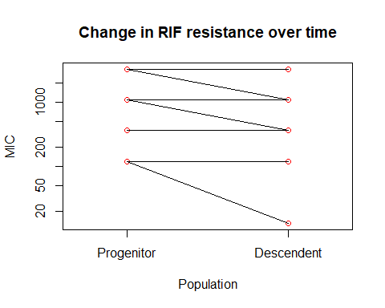

Question 4: Did we observe any collateral effects?

We finally made it! This is the big question that your experiment set out to test, so let’s see what we found. Remember that to determine if resistance to your drug of interest had a collateral effect on resistance to the other drug, we would expect MIC of your resistant strains growing on the other drug would differ from MIC of the SEN strain growing on that other drug. Make sure you understand this expectation before doing this analysis and ask your TA or peer-facilitator if you are unsure

For this analysis you only need to compare the resistant progenitors and the sensitive progenitors so you can use the progenitors dataset you created when answering question 1. These data are not paired so you can use a regular t-test.

First, use the next line of code to identify the MIC data you need i.e. MIC.ON.“other drug name”

mic_on_other_drug <- if(drug == "RIF"){"MIC.ON.STR"} else {"MIC.ON.RIF"}

Implement the t-test on log-transformed MIC data

t.test(progenitors[, mic_on_other_drug] ~ progenitors[, "DRUG.AT.ISOLATION"])

##   
## Welch Two Sample t-test  
##   
## data: progenitors[, mic_on_other_drug] by progenitors[, "DRUG.AT.ISOLATION"]  
## t = -1.4237, df = 38.235, p-value = 0.1626  
## alternative hypothesis: true difference in means is not equal to 0  
## 95 percent confidence interval:  
## -148.14422 25.79257  
## sample estimates:  
## mean in group NONE mean in group RIF   
## 16.28571 77.46154

Plot the data. The individual points for the resistant strains are again plotted as red circles and the y-axis is on a log scale. Remember it is very unlikely that the same collateral effect would be seen in all strains, so use the red circles to think about whether collateral effects were seen in SOME strains. And were these collateral resistance or collateral sensitivity?

bar_graph(dependent <- progenitors[, mic_on_other_drug],  
 independent <- progenitors$DRUG.AT.ISOLATION,  
 ylab <- "MIC",  
 xlab <- "Drug at isolation",  
 main <- paste("Collateral effects of", drug, "resistance", sep = " "),  
 include_points = T,  
 log_scale = T)

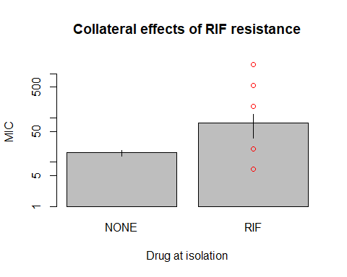

### rpoB Sequence File

LOCUS rpoB_flanking_regions 4029 bp ds-DNA linear

11-APR-2018 DEFINITION .

FEATURES Location/Qualifiers

gene 1..4029

/label="rpoB gene"

/ApEinfo_revcolor=#85dae9

/ApEinfo_fwdcolor=#85dae9

ORIGIN

1 atggtttact cctataccga gaaaaaacgt attcgtaagg attttggtaa

acgtccacaa

61 gttctggatg taccttatct cctttctatc cagcttgact cgtttcagaa

atttatcgag

121 caagatcctg aagggcagta tggtctggaa gctgctttcc gttccgtatt

cccgattcag

181 agctacagcg gtaattccga gctgcaatac gtcagctacc gccttggcga

accggtgttt

241 gacgtccagg aatgtcaaat ccgtggcgtg acctattccg caccgctgcg

cgttaaactg

301 cgtctggtga tctatgagcg cgaagcgccg gaaggcaccg taaaagacat

taaagaacaa

361 gaagtctaca tgggcgaaat tccgctcatg acagacaacg gtacctttgt

tatcaacggt

421 actgagcgtg ttatcgtttc ccagctgcac cgtagtccgg gcgtcttctt

tgactccgac

481 aaaggtaaaa cccactcttc gggtaaagtg ctgtataacg cgcgtatcat

cccttaccgt

541 ggttcctggc tggacttcga attcgatccg aaggacaacc tgttcgtacg

tatcgaccgt

601 cgccgtaaac tgcctgcgac catcattctg cgcgccctga actacaccac

agagcagatc

661 ctcgacctgt tctttgaaaa agttatcttt gaaatccgtg ataacaagct

gcagatggaa

721 ctggtgccgg aacgcctgcg tggtgaaacc gcatcttttg acatcgaagc

taacggtaaa

781 gtgtacgtag aaaaaggccg ccgtatcact gcgcgccaca ttcgccagct

ggaaaaagac

841 gacgtcaaac tgatcgaagt cccggttgag tacatcgcag gtaaagtggt

tgctaaagac

901 tatattgatg agtctaccgg cgagctgatc tgcgcagcga acatggagct

gagcctggat

961 ctgctggcta agctgagcca gtctggtcac aagcgtatcg aaacgctgtt

caccaacgat

1021 ctggatcacg gcccatatat ctctgaaacc ttacgtgtcg acccaactaa

cgaccgtctg

1081 agcgcactgg tagaaatcta ccgcatgatg cgccctggcg agccgccgac

tcgtgaagca

1141 gcggaaagcc tgttcgagaa cctgttcttc tccgaagacc gttatgacct

gtctgcggtt

1201 ggtcgtatga agttcaaccg ttctctgctg cgcgaagaaa tcgaaggttc cggtatcctg

1261 agcaaagacg acatcattga tgttatgaaa aagctcatcg atatccgtaa

cggtaaaggc

1321 gaagtcgatg atatcgacca cctcggcaac cgtcgtatcc gttccgttgg

cgaaatggcg

1381 gaaaaccagt tccgcgttgg cctggtacgt gtagagcgtg cggtgaaaga

gcgtctgtct

1441 ctgggcgatc tggataccct gatgccacag gatatgatca acgccaagcc

gatttccgca

1501 gcagtgaaag agttcttcgg ttccagccag ctgtctcagt ttatggacca

gaacaacccg

1561 ctgtctgaga ttacgcacaa acgtcgtatc tccgcactcg gcccaggcgg

tctgacccgt

1621 gaacgtgcag gcttcgaagt tcgagacgta cacccgactc actacggtcg

cgtatgtcca

1681 atcgaaaccc ctgaaggtcc gaacatcggt ctgatcaact ctctgtccgt

gtacgcacag

1741 actaacgaat acggcttcct tgagactccg tatcgtaaag tgaccgacgg

tgttgtaact

1801 gacgaaattc actacctgtc tgctatcgaa gaaggcaact acgttatcgc

ccaggcgaac

1861 tccaacttgg atgaagaagg ccacttcgta gaagacctgg taacttgccg

tagcaaaggc

1921 gaatccagct tgttcagccg cgaccaggtt gactacatgg acgtatccac

ccagcaggtg

1981 gtatccgtcg gtgcgtccct gatcccgttc ctggaacacg atgacgccaa

ccgtgcattg

2041 atgggtgcga acatgcaacg tcaggccgtt ccgactctgc gcgctgataa

gccgctggtt

2101 ggtactggta tggaacgtgc tgttgccgtt gactccggtg taactgcggt

agctaaacgt

2161 ggtggtgtcg ttcagtacgt ggatgcttcc cgtatcgtta tcaaagttaa

cgaagacgag

2221 atgtatccgg gtgaagcagg tatcgacatc tacaacctga ccaaatacac

ccgttctaac

2281 cagaacacct gtatcaacca gatgccgtgt gtgtctctgg gtgaaccggt

tgaacgtggc

2341 gacgtgctgg cagacggtcc gtccaccgac ctcggtgaac tggcgcttgg

tcagaacatg

2401 cgcgtagcgt tcatgccgtg gaatggttac aacttcgaag actccatcct

cgtatccgag

2461 cgtgttgttc aggaagaccg tttcaccacc atccacattc aggaactggc

gtgtgtgtcc

2521 cgtgacacca agctggggcc agaagagatc accgctgaca tcccgaacgt

gggtgaagct

2581 gcgctctcca aactggatga atccggtatc gtttatattg gtgcggaagt

gaccggtggc

2641 gacattctgg ttggtaaggt tacgccgaaa ggtgaaactc agctgacccc

agaagaaaaa

2701 ctgctgcgtg cgatcttcgg tgagaaagcc tctgacgtta aagactcttc tctgcgcgta

2761 ccaaacggtg tatccggtac ggttatcgac gttcaggtct ttactcgcga

tggcgtagaa

2821 aaagacaaac gtgcgctgga aatcgaagaa atgcagctca aacaggcgaa

gaaagacctg

2881 tctgaagaac tgcagatcct cgaagcgggt ctgttcagcc gtatccgtgc

tgtgctggta

2941 gccggtggcg ttgaagctga gaagctcgac aaactgccgc gcgatcgctg

gctggagctg

3001 ggcctgaccg acgaagagaa acaaaatcag ctggaacagc tggctgagca

gtatgacgaa

3061 ctgaaacacg agttcgagaa gaaactcgaa gcgaaacgcc gcaaaatcac

ccagggcgac

3121 gatctggcac cgggcgtgct gaagattgtt aaggtatatc tggcggttaa

acgccgtatc

3181 cagcctggtg acaagatggc aggtcgtcac ggtaacaagg gtgtaatttc

taagatcaac

3241 ccgatcgaag atatgcctta cgatgaaaac ggtacgccgg tagacatcgt

actgaacccg

3301 ctgggcgtac cgtctcgtat gaacatcggt cagatcctcg aaacccacct

gggtatggct

3361 gcgaaaggta tcggcgacaa gatcaacgcc atgctgaaac agcagcaaga

agtcgcgaaa

3421 ctgcgcgaat tcatccagcg tgcgtacgat ctgggcgctg acgttcgtca

gaaagttgac

3481 ctgagtacct tcagcgatga agaagttatg cgtctggctg aaaacctgcg

caaaggtatg

3541 ccaatcgcaa cgccggtgtt cgacggtgcg aaagaagcag aaattaaaga

gctgctgaaa

3601 cttggcgacc tgccgacttc cggtcagatc cgcctgtacg atggtcgcac

tggtgaacag

3661 ttcgagcgtc cggtaaccgt tggttacatg tacatgctga aactgaacca

cctggtcgac

3721 gacaagatgc acgcgcgttc caccggttct tacagcctgg ttactcagca

gccgctgggt

3781 ggtaaggcac agttcggtgg tcagcgtttc ggggagatgg aagtgtgggc

gctggaagca

3841 tacggcgcag catacaccct gcaggaaatg ctcaccgtta agtctgatga

cgtgaacggt

3901 cgtaccaaga tgtataaaaa catcgtggac ggcaaccatc agatggagcc

gggcatgcca

3961 gaatccttca acgtattgtt gaaagagatt cgttcgctgg gtatcaacat

cgaactggaa 4021 gacgagtaa

//

### Pymol Cheat Sheet

**Parts of the PyMOL viewer_________________________________________________________**

1. **3D screen** (left-center of big window) - the molecules appear here.[4]

1. **Object list** (top right of big window) - loaded molecules and user-defined selections appear here.

* 1. To make an object disappear from your 3D screen, click on its name. (Click again to make it reappear.) NOTE: The shading around the object’s name will change from *light gray* to *dark gray* when the item associated with that name is *NOT* displayed on the 3D screen.

* 1. To the right of each object name, are buttons labeled A, S, H, L and C. We use these to set individual display modes for each object. Clicking on each button opens a menu from which you can select options. These buttons are:
     1. [A]ction
     2. [S]how,
     3. [H]ide,
     4. [L]abel and
     5. [C]olor buttons.

1. **Display** menu (top of window) – We will use this to display the protein sequence, and to zoom to view specific regions of interest in our protein.
2. **Wizard** menu (top of window) - contains advanced tools and some demos. We will use this during Lab, in-class to visualize your mutations, and measure distances between atoms.

1. **Mouse controls** are summarized in the bottom right of the window (functions of the mouse buttons in combination with the keyboard).

* 1. You can adjust mouse settings in the **Mouse** menu at the top of the window.

* 1. Clicking in this control box toggles between two modes for selecting and modeling atoms

### CURE Peer Facilitator

We ran the CURE lab series with alumni students as peer facilitators in the classroom.

The role of the peer facilitator (PFs) depended on their interests, the class needs, and their availability. Several students volunteered to help out with laboratory prep or with the daily bacteria drop-in transfers. Other PFs had a more structured role and received course credit by assisting the TA in the lab sections.

Who could be a PF?

These are students who have previously been enrolled in the CURE class.

First, Students first filled out a survey expressing their interest.

Questions included:

* Contact information
* In 1-2 sentences, please share your reason(s) for wanting to join the Peer Facilitation Team of the UW Intro Bio CURE.
* If selected to peer facilitate, would you be available to attend a weekly 2 hour PF on _______?

Second, we completed a quick reference check with the student’s TA/instructor for any red flags.

Third, students complete a scheduling poll with their availability (we aimed to have one PF in each lab section).

Lastly, students added their information to a google spreadsheet clarifying if they wanted to:

* volunteer or register for credits,
* PF in lab sections, or proctor bacteria transfers, or both

Once students filled out the poll with their availability and completed the spreadsheet, we finish the scheduling and contacted students to confirm: if they had been selected, their schedule, and the number of credit hours to register for (if they were PFing for credit)

•At our institution, each credit hours = ~3hrs of work per week (Ex. If a student was a PF for 1 lab section they would register for 2 credits to cover their time in lab time and the weekly PF training meeting).

If students volunteered, they needed to sign a volunteer form.

**Role of PFs**

1. Since peer facilitators have already completed the CURE labs they can help instructors and TAs in the lab sections.

2. PFs can gain confidence, leadership, and communications skills

3. PFs can help to build an undergraduate mentoring ladder (and hopefully increase students sense of belonging in STEM)

Below is an example of CURE Peer Facilitator Guidelines and Expectations

PFs’ roles in labs will include:

1. Attending lab sessions to assist the grad TAs
2. *Facilitating* learning

(e.g., circulating during Think Tank breakout discussions and asking students questions about their thoughts, helping students with sterile technique),

1. Potentially demo in-lab protocols for the students
2. Help with lab set-up and/or clean-up
3. Ensure classroom safety protocols are adhered to
4. Proctoring bacteria daily transfers, if available.
5. Attending a weekly team meeting

Expectations and Guidelines:

* PFs will be given the instructor’s cell phone number and we are asked to keep the phone number confidential.
* PFs will be asked to share their availability (i.e., their work / course schedules) with the instructor/TA and phone number.
* PFs are urged to ask students questions, to teach without giving away the answer(s) whenever possible, and to consider students’ contributions with respectful, encouraging open-mindedness.
* PFs are encouraged to provide feedback to their instructor/TA about:
  + Areas where students might be finding the material to be difficult
  + Group dynamics that might challenging
* PFs are encouraged to provide feedback or ask questions at weekly meetings about:
* How to make course activities and the PF experience more effective,
* Recap the previous lab session
* Ask questions about the coming up lab session (material and/or techniques)
* Strategies for effective teaching / evidence-based instruction, or
* Future career goals, or
* Any other matters that may arise.

PFs may be asked to assist with lab prep. If help is requested outside of regularly scheduled times this will be scheduled and agreed upon between the lab technician and the PF.

PF are not expected to teach! This is the role of the instructor/TA.

PFs are asked to:

• Attend a weekly 2 hour team meeting

• Arrive 5-10 min before the start of your assigned lab sessions or drop-ins. If your schedule allows it would be ideal if you have ~15 minutes before and after lab to help with set up and clean.

• Contact the instructor as far in advance as possible if they will not be able to attend a planned session, especially if it is a drop-in session.

Example of a Peer Facilitator Meeting Agenda

Our first meeting will be informal to get to know our team and discuss expectations.

* Meet other peer facilitators
* Meet the instructors/TAs
  + Coordinate with the instructor. For example, will you have ~15 minutes before and/or after lab sections to help with set-up or clean-up?
* Review PF roles and expectations
* Hand out lab manuals
* Review lab safety
* Answer any questions

Going forward, 1 (or 2) peer facilitator will help lead the PF weekly meeting. Details can be found below.

As leads you will…

1) Leads will take the first 10 minutes of the meeting to recap the previous lab, making a list on the whiteboard.

- What went well this week?

- What didn’t work?

- Suggestions for future PFs

2) Make sure the learning goals of each lab are clear

3) Practice the lab protocol

- Touch base on lab set-up and clean-up

4) Work through the in-lab worksheets so you are familiar with concepts being cover that week.

- You can discuss with student groups what they think the answers are if they are struggling but please do not give them the answer. Note: Your role is to help facilitate discussions but not to teach the students (that is the instructor/TAs role) and not to tell students the answer. Students should be able to get most of the information from their lab manual or from the lab discussions.

5) Highlight any tips and suggestions

Being a Peer facilitator does not mean that you know everything. In addition to you mentoring peers in the classroom, we aim to establish mentoring relationships between peer facilitators and with your supervisor/instructor.

In a sentence, I would like for you to state what you are working towards. (Basically, I want to hear a little bit about you and what your goals are so you can be best supported.) It can be a bigger picture goal such as "I am working towards a degree in nursing" or something such as "I want to learn better communication skills" or even "I don't know what I am doing, I am just trying to figure it out".

If your role is to help proctor student bacteria transfers you will see a variety of students each day. A few tips:

* Introduce yourself to the students!
* For the first few transfers, check in with the students to make sure they know what steps they are doing today *before* they start pipetting (feel free to use the whiteboard as a visual aid)
  + Try not to hover too obviously or stare too much as students are working: it can make them nervous and distract them.
  + *Please* do not correct every little mistake students make. They are still learning, and building confidence is important. (It is not essential that the students learn to be perfect microbiologists). However, if a student is making a big mistake* that will wreck the experiment or if they are unsafe, then step in to offer a suggestion.
* Write down any questions students have and pass them along to the TA
* If you are seeing lots of errors, make a note in the Staff Only Lab Notebook so the TA can give gentle reminders the next class and other PFs can look out for the issue.
  + *Experimentally: the most important thing is for students to not mix up their strains and do not pipette *above* the well (which can cause contamination).
  + *Sterility: the most important things are to keep the microtiter plate covered and to not touch the sterile tip to any surface. Many of the other sterile guidelines are less critical.

Although we are not going to go into the Peer Facilitator role more here, we highlight recommend you thinking of adding peer mentoring or peer facilitators to the classroom. As this CURE changes overtime, based on the data, alumni students will be critical to troubleshooting new protocols before they are used in a classroom. In addition, our peer facilitators gained a lot of out of the experience. For example, some peer facilitator quotes can be found below.

“The peer facilitating experience allowed me to understand better the teaching process and scientific research process. I grew in my accountability, attention to detail, communication skills, and teamwork.”

“After being involved with PFing, I feel more confident and am further motivated to apply for other lab/research positions.”

“Being a PF is a cool thing. It is an opportunity, a challenge and a learning process.”

“I greatly enjoy being a part of a small and supportive community of students and faculty. The faculty's mentorship and guidance are invaluable as I continue to pursue my future endeavors”.

# APPENDIX 4: Prelab Quizzes

## Prelab 1

**Question 1**

When may food or drink be present or consumed in lab?

* **Present - only in your pack. Consumed in lab - never.**

**Question 2**

What is the maximum volume that this pipette, pictured below, can dispense?

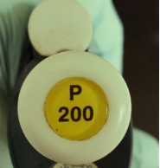

* 200 mL
* **200 μL**
* 1000 μL
* 2 mL
* 20mL
* 20 μL

**Question 3**

You need to measure 0.18 mL, which of the following micropipette would you use? Hint - look at the units!

* P-100
* P-10
* **P-200**
* P-20
* P-1000

**Question 4**

You are using a P-200 pipette and the view window looks like this image below:

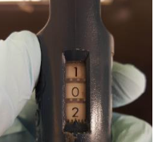

How much fluid will this dispense?

* 10.2 μL
* 10.2 mL
* **102 μL**
* 102 mL
* 1.02 μL

**Question 5**

You are using a P-20 pipette and the view window looks like this picture below:

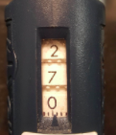

What is the problem with this?

* **P-20's can only dispense up to 20 μL. This could break the micropipette!**
* There is no problem.

**Question 6**

When using a pipette in this lab, you will always go to the second stop on the pipette.

* True
* **False**

**Question 7**

In an environment containing an antibiotic, cells that are resistant to that antibiotic will leave more offspring than the cells that are sensitive to the antibiotic.

* **True**
* False

**Question 8**

What is a mutant?

* An individual that has something wrong with it.
* **A population of organisms that has a novel trait. An individual with a novel, heritable (genetic) trait.**
* An individual that is missing certain genes.

**Question 9**

If you are growing bacteria on a plate and find a colony, what does the colony represent?

* Drug-resistant cells
* Drug-sensitive cells
* **A population of cells descended from a single progenitor**.
* A continuous sheet of cells, so dense that you can't pick out individual groups descended from the same progenitor.

**Question 10**

What is saline?

* A growth medium that contains an antibiotic. Will select for resistant cells (only they can grow).
* The growth medium (nutrient recipe) that is commonly used to grow E. coli in the lab.
* Seawater
* **A solution containing salts but no nutrients. Cells put into saline don't die, but they don't grow.**

## Prelab 2

**Question 1**

When pipetting, if your sterile pipette tip touches the benchtop, it is still considered sterile.

True

**False**

In Lab 1, you were given a population of bacteria. You spread a sample of that population on solid food (growth medium) in petri dishes. Individual bacteria cells are too small to see without a microscope, but the cell(s) divided many times overnight on the petri dish, which resulted in visible growth.

The next two questions ask you to predict “bacterial growth in each petri dish” given the conditions described.

**Question 2**

If the bacteria had not been diluted and the solid growth media did not contain an antibiotic, then you expect to see:

• No growth or little bacterial growth (0 to a few colonies)

• **Full growth (a lawn of bacteria)**

• Some bacterial growth (hundreds of colonies)

**Question 3**

If the bacteria had not been diluted and the solid growth media contained an antibiotic, then you expect to see:

• Full growth (a lawn of bacteria)

• **No growth or little bacterial growth (0 to a few colonies)**

• Some bacterial growth (hundreds of colonies)

**Question 4**

In lab 1, you also spread bacteria onto two LB Petri dishes that did *not* contain an antibiotic. True or false: You expect these two Petri dishes to have the same level of bacterial growth on them.

True

**False**

**Question 5**

Mutations can occur during DNA replication. The chance of a mutation occurring is greater in a...

• small population of bacteria

• **large population of bacteria**

**Question 6**

A large bacterial population contains extensive heritable variation. Exposing this population to an antibiotic selects for resistant bacteria in the population, if they exist.

In your experiment, you will isolate resistant colonies from Petri dishes containing antibiotic and give them time and food to grow. By performing daily transfers, you will be propagating your bacterial strains over many generations.

If you compared the progenitors (bacteria from the beginning of the experiment) to their descendants (from the end of our serial transfers), would you expect them to be different?

• **Yes**

• No

**Question 7**

Different antibiotics target different cell processes that are essential for cell division and growth--processes such as DNA replication, cell wall synthesis, or protein synthesis.

In an environment containing drug, resistant cells can grow while the sensitive cells die.

However, in a drug-free environment, drug resistance usually is associated with a fitness cost. This means that in a drug-free environment resistant cells tend to grow ________ than the sensitive cells.

• **Worse**

• Better

**Question 8**

True or false: If you did not come in to transfer our bacteria, the bacteria would continue to divide and grow without limits.

True

**False**

**Question 9**

What is a compensatory mutation?

* An advantageous mutation--one that increases fitness in an environment that contains an antibiotic.
* **A mutation that reduces the fitness cost of drug resistance--it "compensates" and allows resistant cells to grow better in the absence of the drug.**
* A deleterious mutation--one that reduces fitness in an environment that does not contain an antibiotic.
* A mutation that makes a cell even more resistant to a particular drug--it increases the degree of resistance (cells can grow when the drug is present at high concentration).

**Question 10**

Predict what the nature of your cells will be at the end of the transfers--when the experimental evolution step in your experiment is complete.

* The cells will be more resistant to RIF, but not to STR.
* The cells will have compensatory mutations that reduce the cost of resistance--probably to almost nothing.
* The cells will be less resistant to RIF, it's not clear how resistance will change with respect to STR.
* **No one knows--this is an experiment!**

## Prelab 3

**Question 1**

When you plated a population of *E. coli* in Lab 1 and exposed them to RIF or STR, only a few or no cells were resistant to each drug. What does this observation tell you?

* **Resistant cells were rare because they tend to have low fitness in environments that lack drugs.**
* The resistance mutations occurred because the drugs were present.
* Resistant cells will eventually take over the entire population (they will increase to high frequency).
* More than one gene can be involved in the trait we call drug resistance.

**Question 2**

Select the statement or statements that best completes the following: “By measuring relative fitness, we hope to determine..."

* whether antibiotic resistance incurs a fitness cost.
* whether fitness changes over time.
* how different resistance-conferring mutations affect fitness.
* **All of the above**

**Question 3**

Why does rifampicin kill cells?

* **It binds to a machine that is essential for cells to survive and grow, and keeps the machine from working properly.**
* It overwhelms their defenses, meaning that the affected cells can no longer respond to viruses that kill bacteria.
* It prevents cells from dividing, after their DNA has been replicated.
* It prevents DNA from being replicated, before the cell divides.

**Question 4**

What is the molecular basis of resistance to rifampicin?

* **It can vary, but often the binding site for rifampicin is altered so it doesn't bind as well**.
* Bacterial cells have several defense systems against viruses; RIF interferes with each by binding to key molecules inside the cell.
* RIF is at a lower concentration.
* RIF is at a higher concentration.

**Question 5**

In many cases, variation in the phenotype called “rifampicin resistance” is due to variation in the gene for what?

* **RNA polymerase (the rifampicin target)**
* Streptomycin resistance
* DNA polymerase (crucial to DNA replication)
* Rifampicin

**Question 6**

If a statistical test tells you that the p-value is less than 0.044 (p < 0.044), would you reject or fail to reject the null hypothesis?

* **Reject**
* Fail to reject

**Question 7**

If a statistical test tells you that the p-value is 0.06, would you reject or fail to reject the null hypothesis?

* **Fail to reject**
* Reject

**Question 8**

To compare two average values, an appropriate statistical test would be:

* **A t-test**
* A linear regression

**Question 9**

What do the bars on a bar chart usually represent?

* **The mean value from a population**.
* The standard error of the mean.
* The standard deviation of the sample.
* The maximum value observed in a population.

**Question 10**

What do the vertical lines on a bar chart usually represent?

* **The standard error of the mean.**
* The standard deviation of the sample.
* The maximum value observed in a population.
* The mean value from a population.

## Prelab 4

**Question 1**

Collateral effects are said to occur when an evolutionary response to one antibiotic causes increased resistance or increased sensitivity to a second antibiotic.

* **True**
* False

**Question 2**

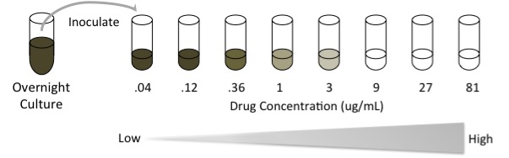

In the image above, test tubes contain LB growth media plus an antibiotic. Note that the antibiotic drug concentrations increase from the left to the right. Each test tube has been inoculated with bacteria from the same population and allowed to grow overnight.  Tubes that are cloudy (grey) have bacteria growth. What is the MIC (minimum inhibitory concentration)?

* 1ug/mL
* **9ug/mL**
* 3ug/mL
* .36ug/mL

**Question 3**

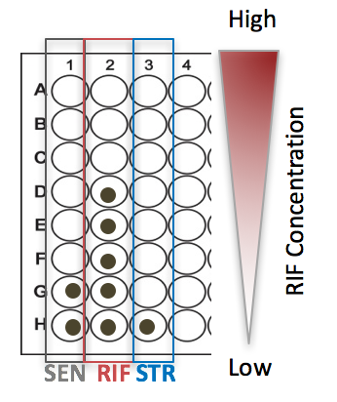You have a microtiter plate filled with growth media plus rifampicin. Row A has the highest drug concentration; drug concentration decreases as you go down each row in the plate until you reach Row H, which has no drug.

You inoculated every well of each column in the microtiter plate with a different strain of bacteria, as shown: Sensitive ancestor in Column 1, RIF-resistant isolate in Column 2, and STR-resistant isolate in Column 3. After 24 hours of growth, you see the following growth pattern (dots in the wells indicate bacterial growth).

Select the interpretation that is consistent with the data you see:

* **Collateral sensitivity**
* No collateral effects
* Collateral resistance

**Question 4**

A linear regression analysis calculates a line of best fit for the data in which type of graph?

* Pie chart
* Bar chart
* Histogram (a frequency distribution)
* **Scatterplot**

**Question 5**

In your MIC assays, you will be using two microtiter plates. Each plate contains a gradient of something. What type of gradient is it?

* Increasing number of bacteria cells, from no cells (bottom of plate, row H) to high concentration of cells (top, row A).
* Increasing concentration of growth medium (LB), from no LB (bottom of plate) to high concentration of LB (top).
* Increasing time in terms of exposure to the drug.
* **Increasing drug concentration, from no drug (bottom of plate, row H) to high concentration (top, row A).**

**Question 6**

If the well in an MIC plate is cloudy, what does it mean?

* High concentration of antibiotic
* **Bacterial growth has occurred (no inhibition, so resistant)**
* No bacterial growth has occurred (inhibition, so not resistant)

**Question 7**

Collateral sensitivity occurs when resistance to one drug induces (leads to) susceptibility to a second drug.

* **True**
* False

**Question 8**

If you were a doctor treating a patient for tuberculosis (TB), you might decide to prescribe the drugs RIF and STR together. Treatment with two or more drugs makes resistance less likely to evolve, but not all drug pairs interact in the same why. For this “cocktail” to be effective, you want RIF and STR to exhibit...

* Collateral resistance
* **Collateral sensitivity**
* Extra side effects

## Prelab 5

The following 4 questions each refer to setting up your MIC Assay.

Reminders

* You will set up your MIC assays in two microtiter plates.
* Each of these microtiter plates contains LB growth media plus an antibiotic (here, "drug").
* Row A of the microtiter plate has the highest drug concentration, drug concentration decreases as you go down the plate until you get to Row H which contains no drug

**Question 1**

[When setting up your MIC assay microtiter plates, ...] you will place bacteria into:

* only the wells that contain the highest concentration of drug.
* only the wells that contain no drug.
* **all of the wells of the microtiter plate.**

**Question 2**

[When setting up your MIC assay microtiter plates, ...] you will inoculate each strain into two adjacent columns, creating replicates.

* **True**
* False

**Question 3**

[When setting up your MIC assay microtiter plates, ...] you will inoculate strains into wells starting at Row H and working up to Row A.

* **True**
* False

**Question 4**

[When setting up your MIC assay microtiter plates, ...] you will change tips between strains (when you change eppis) AND between rows.

* **True**
* False

**Question 5**

Why is the research team asking you to replicate each MIC treatment? (Two columns per strain)

* It is a more efficient way to use the available wells in the plate
* **This will increase confidence in your results.**
* It is the only way you can look at both RIF and STR resistance, to test for collateral effects.
* It is the only way you can look at both sensitive and resistant strains.

**Question 6**

This week you will set up a Competition assay with the resistant and sensitive ancestors and descendants.

What does the competition assay measure?

* **Growth rate (a measure of relative fitness)**
* Gene expression
* Level of drug resistance
* Colony size

**Question 7**

Column 5 of your microtiter plate will be your "competition column" where strains will compete for space and resources overnight. Samples from this column will be taken at the start (t = 0) and end (t = 1) of the competition to get cell counts.

* **True**
* False

**Question 8**

In the competition assay, you will do a dilution series and then will grow cells on a solid medium (Petri dish). Why?

* It is a 50:50 mix, by volume.
* The t = 0 sample will tell you how resistant the common competitor is to the focal drug.
* **If you don't know how many cells of each type you started with, you can't tell how much increase occurred**
* The t = 0 sample will tell you whether the progenitors and descendants are the same or different, in terms of fitness (cost of resistance).

**Question 9**

The day after your next lab, one member of your group will need to come into lab to do a key step. What is it?

* Plate the cells that grew overnight in the competitions (creating the t = 0 plates) Count the number of cells that grew on the t = 1 plates in the competitions.
* **Dilute and spread cells that grew overnight in the competitions wells on to Petri dishes (creating the t = 1 plates)**

**Question 10**

When doing the dilution series, as you go across the microtiter plate transferring cells between wells, you do *not* need to pipette up and down to gently mix the cells with saline before transfer the cells to the next well.

* True
* **False**

## Prelab 6

Several weeks ago, each lab group picked a streptomycin resistant colony off of Petri dishes containing the drug streptomycin and a rifampicin resistant colony off of Petri dishes containing the drug rifampicin.

**Question 1**

True or False: We expect all of these streptomycin resistant mutants to have the *same* level of initial drug resistance.

* True
* **False**

**Question 2**

In Lab 5 we set up an **MIC assay** to measure the progenitors and their descendants of our resistant strains and the sensitive ancestor.

What are we measuring?

* **Level of drug resistance**
* Colony size
* Speed of growth
* Mutation rate

**Question 3**

In Lab 5 we set up a **Competition assay** to measure these mutants and their sensitive ancestor (plus their descendants).

What are we measuring?

* Gene expression
* Level of drug resistance
* **Relative fitness**
* Colony color

**Question 4**

*Select the correct response(s).*

By analyzing our MIC assay results, we will be able to tell whether our strains’ levels of resistance did which of the following things over time?

* Increased over time
* Decreased over time
* Stayed the same over time
* **All of the above**

**Question 5**

In our MIC assay, we did several steps. One step was to put your rifampicin resistant mutant into a microtiter plate containing a concentration gradient of the drug **rifampicin**.

After 24 hours of growth, we will look at this microtiter plate (described above) and we will have evidence to indicate that the rifampicin resistant mutant is *also* resistant to the drug **streptomycin**.

* True
* **False** (Placing the rifampicin resistant mutant in a microtiter plate containing rifampicin does *not* tell us anything about the mutant’s ability to grow in the drug streptomycin. We have to also look at the rifampicin resistant mutant in the microtiter plate containing the concentration gradient of the drug streptomycin.)

**Question 6**

True or False: If cells that are rifampicin-resistant are **also** more resistant to streptomycin (compared to sensitive cells that were NOT exposed to rifampicin), this is called collateral resistance.

* **True**
* False

**Question 7**

How do you know if a strain has a higher MIC than the sensitive ancestor?

* If the strain has a higher relative fitness
* **If the first well with clear media / no bacterial growth occurs at a higher drug concentration**
* If the first well with clear media / no bacterial growth occurs at a lower drug concentration

**Question 8**

Recall your competition assay...

True or False: If the two strains start the competition with equal numbers of cells, then the strain with more numerous cells at the end of 24 hours must have a higher growth rate, meaning that this strain is better-adapted to the experimental environment.

* **True**
* False

## Prelab 7

*This element is a more accessible alternative to drag & drop reordering. Press Enter or Space to move this question.*

**Question 1***.*

How can you evaluate the cost of resistance, when assessing data on relative fitness (growth rate) in an environment lacking drugs?

* **Compare the fitness of sensitive cells to resistant cells. If they are the same, there is no cost.**
* This is the wrong approach. You need to measure fitness (growth rate) in an environment where the drug is present.
* Compare the fitness of RIF-resistant cells to STR-resistant cells. If they are correlated, there is a cost to resistance.
* Compare the fitness of progenitors to descendants in each strain. If fitness increases or stays the same, there is no cost to resistance.*is*

**Question 2**

If collateral sensitivity is occurring, what should you see?

* RIF-resistant progenitors have higher resistance to rifampicin than RIF-resistant descendants.
* RIF-resistant descendants have higher resistance to rifampicin than RIF-resistant progenitors.
* **RIF-resistant cells have lower resistance to streptomycin than sensitive cells.**
* RIF-resistant cells have higher resistance to streptomycin than sensitive cells.

*element is a more accessible alternative to drag & drop reordering. Press Enter or Space to move this question.*

**Question 3**

If MICs for RIF-resistant progenitors and descendants go down (or if MICs for STR-resistant progenitors and descendants go down), what do the data suggest?

* Compensatory mutations occurred.
* Resistance is not an all-or-none phenomenon.
* Additional mutations occurred that increased the level of resistance, even though selection was not occurring.
* **Natural selection favored new mutations that reduced the level of resistance.**

*e to move this question.*

**Question 4**

If MICs for RIF-resistant progenitors and descendants go up (or if MICs for STR-resistant progenitors and descendants go up), what do the data suggest?

* **Additional mutations occurred that increased the level of resistance, even though selection was not occurring.**
* Natural selection favored new mutations that reduced the level of resistance.
* Compensatory mutations occurred.
* Resistance is not an all-or-none phenomenon.

*element is a more accessible alternative to drag & drop reordering.*

**Question 5**

Each lab group this quarter may see different patterns in terms of MIC values and changes in fitness over time. Why is this interesting?

* It implies that some or many groups did the experiment wrong.
* **It should mimic variation in mutations that confer resistance in clinical and other settings.**
* It implies that every group is studying the same resistance mutations this quarter.

*drag & drop reordering. Press Enter or Space to move this question.*

**Question 6**

Why are compensatory mutations of deep concern for researchers and clinicians who are tasked with managing antibiotic resistance?

* **They allow resistant strains to persist, even when a drug is NOT being used.**
* They allow resistant strains to persist, even if a drug is used at high dosage.
* They increase the level of resistance over time.
* They make resistant strains more likely to evolve collateral resistance.

*to move this question.*

**Question 7**

What type of resistance mutations would cause the most concern for research and clinicians?

* A low level of resistance that increases over time, as drug therapy continues.
* **High level of resistance, low cost of resistance, collateral resistance to other drugs**
* High level of resistance, high cost of resistance, collateral sensitivity to other drugs.

## Prelab 8

**Question 1**

What molecule is the source of information for transcription?

* RNA polymerase
* **DNA**
* Proteins (enzymes)
* DNA polymerase

**Question 2**

What is the main enzyme for making a polymer of RNA?

* RNA polymerase
* **DNA**
* Proteins (enzymes)
* DNA polymerase

**Question 3**

Rifampicin is an antibiotic that works on / inhibits which of the following in bacteria?

* **RNA Polymerase**
* DNA Polymerase
* Ribosomes
* Plasma membrane formation

**Question 4**

In a bacterial cell, which 4 of the following events need to happen in order to recognize where the information for a gene is? [Choose all correct answers.]

* **Template DNA must be present.**
* **Sigma protein must recognize the promoter sequence in the DNA**.
* **The promoter region must include a -10 sequence and a -35 sequence.**
* The promoter region must include a TATA-box
* **Core RNA polymerase enzyme must bind to sigma.**
* The promoter region must include a -45 sequence.
* The gene must include information for multiple genes.
* The operator must be bound to the DNA.

**NOTE**

Polymerase Chain Reaction (PCR) Video: 1.5 minute

Please view this [video](https://www.biointeractive.org/classroom-resources/polymerase-chain-reaction-pcr) (note: Links to an external site) and answer the questions below.

**Question 5**

What does PCR do?

* **Amplifies DNA - makes many copies of a specific section of DNA**
* Amplifies DNA - makes many copies the whole genome
* Amplifies DNA - makes many copies of a single chromosome
* Degrades all DNA from a sample

**Question 6**

What is the purpose of 'primers' in the PCR process?

* They bind with a specific region of DNA and bracket the section to prevent replication
* **They bind with a specific region of DNA and bracket the section that will be replicated**
* Catalyze the formation of a complementary strand
* Clean the bacterial sample and remove any contaminants

**Question 7**

What does Taq polymerase, the blue molecules in the video, do?

* **Bind to the primer sequences and elongate the new DNA strand**
* Bind to the primer to purify the sample
* Prevent primers from annealing
* Align primers to the target sequence so they bind efficiently

**Question 8**

In part two of this lab you will be using a small amount of your PCR products to run a gel electrophoresis. What is the purpose of doing this?

* To confirm the base sequence of our DNA sample
* To indicate whether our PCR products are clean or contaminated
* **To confirm that the PCR products conform to the length of cluster I and II**
* Electrophoresis is not useful in this setting.

**Question 9**

The agarose gel should be inserted so that the wells are nearest which electrode?

* Positive electrode (Red wires)
* Negative electrode (Red wires)
* Positive electrode (Black wires)
* **Negative electrode (Black wires)**

**Question 10**

DNA has a negative charge and will therefore be attracted to the positive electrode (red wires) electrode.

* **True**
* False

## Prelab 9

Today in lab, you will compare a small section of the *rpoB* gene from your resistant bacteria (progenitor and its descendant) to a sensitive reference strain. We want to know what mutations were selected in the progenitor, whether these mutations were retained in the descendant, and if any new mutations occurred. Information from our experiments may help future doctors and scientists predict patterns of evolution, as observed in our experiments. This may contribute to the body of scientific literature about antibiotic resistance and best practices for prescribing antibiotics.

**Question 1**

What makes the RNA polymerase from a sensitive bacterial strain different from the RNA polymerase from a resistant strain? (Please select all correct.)

* **primary structure of the beta subunit**
* **mRNA for the *rpoB* gene**
* tRNA
* sigma
* *rpoB* promoter
* ***rpoB* DNA sequence**

**Question 2**

The DNA of the *rpoB* gene in the sensitive strain is ________ the DNA of the *rpoB* gene in the resistant strain.

Select the answer that correctly completes this statement.

* the same as
* complimentary to
* **different than**
* anti-parallel to

**Question 3**

Why are resistant bacteria resistant to rifampicin?

* the *rpoB* gene codes for a protein that breaks down rifampicin
* **rifampicin no longer binds at the typical binding site**
* another gene makes a protein that protects RNA polymerase
* a transport protein removes rifampicin from the cell

**NOTE**

The next group of questions will ask you questions about Sanger sequencing. If you get stuck, review appendix III in your student lab manual.

**Question 4**

What can you tell about the quality of information based on the provided chromatogram?

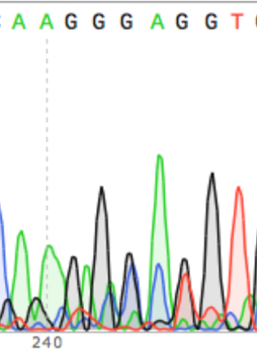

* **Unreliable—lots of "noise"**
* Reliable—good peaks
* Reliable—little “noise”

**Question 5**

Sequence information at the ends of the sequenced DNA is often unreliable and should not be read.

* **True**
* False

**Question 6**

In general, how much of a sequenced DNA strand is accurate?

* only the first and last 25 base pairs
* **500-800 base pairs in the middle of the sequence**
* the whole sequence

**Question 7**

In our experiment, what is the "template" strand?

* **a reference strain of the complete *rpoB* gene from a sensitive strain**
* What you sampled in lab earlier this week
* what we use to make mRNA

## Prelab 10

In lab last week, you looked at two small regions for making the RpoB protein (Cluster I and Cluster II of the *rpoB* gene). You may have identified a single base change (point mutation) that was present in the DNA of your progenitor and/or descendant strains, compared to the Rif-sensitive ancestor strain.

In this week’s protein structure analysis lab, you will:

1. Determine how changes in the DNA in this region would affect the sequence of the RpoB protein,
2. Locate the affected site in a computer model of the protein structure,
3. Substitute the amino acid side chain (protein building block) as specified by your strains' DNA sequence, and
4. View how your strain's mutation affects interaction of the RpoB protein with the antibiotic rifampicin.

Modeling the effect of the resistance-conferring mutation on the RpoB protein's structure will help us make predictions about differences in the shape and function of the RNA polymerase protein, compared to the same protein from sensitive bacteria.

These changes in DNA and protein are the basis for differences in antibiotic resistance level and fitness level. Therefore, you will be able to use the observations that you collect today to explain differences in fitness and resistance levels.

*Instructor note: Edit suggested questions as needed, some of the question as about information that was discussed in lecture and not as explicitly in the CURE student lab manual.*

**Question 1**

Why are we spending so much time looking at the *rpoB* gene?

* It is easy to find.
* It has a localizing signal that will cause this protein to be in a predictable location in the cell.
* **It is where rifampicin binds, and where many resistance mutations occur**
* Resistance mutations can occur anywhere; we are starting with *rpoB* because it is as good as any.

*alternative to drag & drop reordering. Press Enter or Space to move this question.*

**Question 2**

Review: Please match each structure with the description

Primary (protein) structure **c**

Secondary structure **a**

Tertiary structure **d**

Quaternary structure **b**

a) includes alpha helix and beta pleated sheets

b) polypeptides form a multi-unit peptide molecule

c) amino acid sequence

d) protein folding

e) the N terminus of one protein binds with the C terminus of a different protein

**Question 3**

What type of chemical bonds hold a protein’s primary structure together? (select all correct answers)

* phosphodiester bond
* **covalent bonds - specifically peptide bonds**
* hydrogen bonds - specifically R-group to R group or R-group to backbone
* hydrogen bonds - specifically back-bone to back-bone
* ionic bonds
* hydrophobic interactions
* covalent bonds - specifically disulfide bridges

*s question.*

**Question 4**

What type of chemical bonds hold a protein’s secondary structure together? (select all correct answers)

* phosphodiester bond
* covalent bonds - specifically peptide bonds
* hydrogen bonds - specifically R-group to R group or R-group to back bone hydrogen bonding
* **hydrogen bonds - specifically back-bone to back-bone hydrogen bonding**
* ionic bonds
* hydrophobic interactions
* covalent bonds - specifically disulfide bridges

*more accessible alternative to drag & drop reordering. Press Enter or Space to move this question.*

**Question 5**

What type of chemical bonds can be used to hold tertiary protein structure together? (select all correct answers)

* phosphodiester bond
* **covalent bonds - specifically peptide bonds**
* **hydrogen bonds - specifically R-group to R group or R-group to back bone hydrogen bonding**
* **hydrogen bonds - specifically back-bone to back-bone hydrogen bonding**
* **ionic bonds**
* **hydrophobic interactions**
* **covalent bonds - specifically disulfide bridges**

*question.*

**NOTE**

Below is an image of an alignment taken from Benchling. Please answer the following questions about this image.

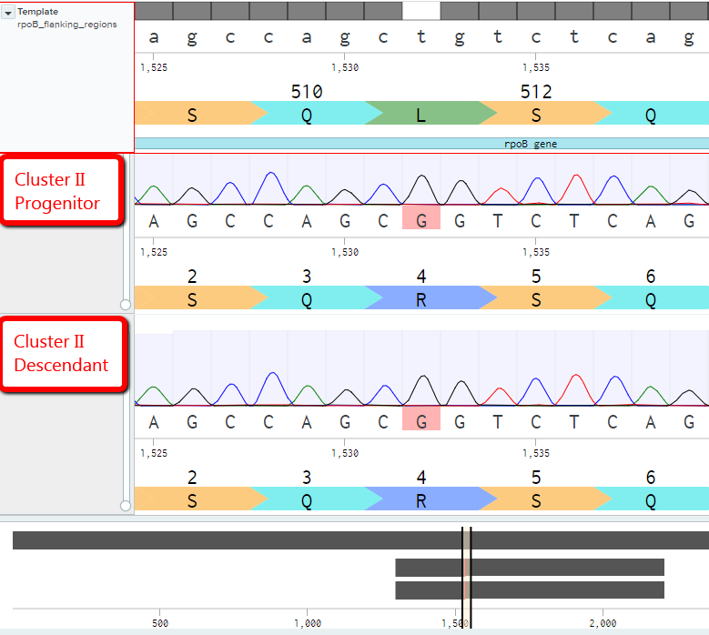

*this question.*

Please answer the following questions about this alignment and the provided translation.

**Question 6**

A mutation has occurred in the template

* True
* **False**

**Question 7**

A mutation has occurred in the Cluster I region of the progenitor

* True
* **False** (cannot tell with the information in this image)

**Question 8**

A mutation has occurred in Cluster II of the descendant

* **True**
* False

**Question 9**

The sequence shown is poor quality and therefore the mutation cannot be trusted

* True
* **False**

*this question.*

In the image below, a mutation has occurred at some point in the alignment shown. The next set of questions are about this mutation.



**Question 10**

10a) The DNA **codon** sequence in the template that is associated with the mutation is: [**CTG**]

10b) The DNA **codon** sequence in the progenitor that is associated with the mutation is: [**CGG**]

**Question 11**

*Using a codon table or this R-group chemistry reference might help answering the next few questions. The resources can be found in the Appendix of your lab manual.*

11a) The codon from the template codes for which amino acid? [**Leucine**]

11b) The codon from the progenitor codes for which amino acid? [**Arginine**]

**Question 12**

Imagine a situation where a codon in a bacterium has the sequence 5' CGA '3

12a) The above DNA would code for [**GCU**]

12b) The selected amino acid has the following chemical characteristics [**hydrophobic**]

*his question.*

**Question 13**

Next imagine that the bacteria from before acquires a mutation and the codon now has the sequence 5' CTA '3

13a) The above DNA would code for [**GAU**]

13b) The selected amino acid has the following chemical characteristics [**negatively charged**]

*element is a more accessible alternative to drag & drop reordering. Press Enter or Space to move this question.*

**Question 14**

Next imagine that you have a mutation where a change in the DNA results in a change in amino acids. Specifically, at one location, an alanine is replaced with a glutamine.

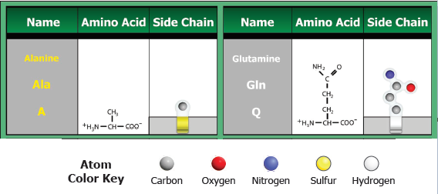

14a) Does this change represent a change in the primary sequence? [**yes**]

14b) Could the amino acid replacement mentioned above cause a change at the secondary protein structure level? [**yes]**

14c) Could the amino acid replacement mentioned above cause a change at the tertiary protein structure level [**yes**]

14d) If yes - which bonds / interactions could be disrupted based on the specific case listed above? [**The new amino acid is charged and may form a new ionic bond resulting in a change in protein folding]**

In lab this week, you will be viewing the structure of RNA polymerase using software. X-ray crystallography was used to capture electron dispersal patterns and these data were used to generate a 3-D structure. More details about X-ray crystallography can be found [here: "Crystallography: An Animated adventure"](https://vimeo.com/76689612).

Using a program called Pymol we will:

* View the quaternary structure of RNA Polymerase
* Edit the sequence to view only the protein coded by the *rpoB* gene (the beta sub-unit of RNA polymerase)
* Model and view the pocket where rifampicin binds to the beta sub-unit of RNA polymerase (the protein coded by the *rpoB* gene).
* Model and view rifampicin and how it binds to the beta sub-unit of RNA Polymerase.
* Analyze the consequences of the mutation that you found in your alignment last week.

## Prelab 11

**NOTES on MIC**

Minimum Inhibitory Concentration - Text below is from [this peer reviewed publication](https://www.ncbi.nlm.nih.gov/pubmed/11420333) (Links to an external site).

Minimum inhibitory concentrations (MICs) are defined as the lowest concentration of an antibiotic that will inhibit the visible growth of a microorganism after overnight incubation. MICs are used by diagnostic laboratories mainly to confirm antibiotic resistance, but most often MIC measurements are used as a research tool.

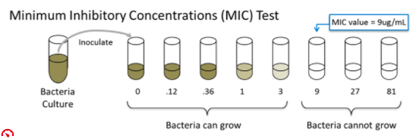

If a strain of bacteria has a high MIC when grown in rifampicin, that would mean that a large dose of rifampicin is needed to inhibit growth or kill.

If a strain of bacteria has a low MIC when grown in rifampicin, a much lower dose of rifampicin is needed to inhibit growth or kill.

Another lab is measuring the Minimum Inhibitory Concentration (MIC) for the bacterium S. typhi grown in ampicillin (a common antibiotic). The data from their experiment is in the following table.

Use this data to answer the questions below.

|  |  |  |  |  |  |
| --- | --- | --- | --- | --- | --- |
| Bacterial Strain | Strain X | Strain Z | Strain W | Strain V | Strain U |
| MIC (ug/mL) | 360 | 120 | 13 | 40 | 1080 |

**Question 1**

1a) Bacteria with [**High MIC value**] are said to be ampicillin resistant.

1b) Which strain is the most sensitive to ampicillin? [**Strain W**]

1c) Which strain is the most resistant to ampicillin? [**Strain U**]

1d) If a human had an infection with S. typhi, which strain would be most likely to respond (die) after treatment with ampicillin? [**Strain W**]

**Question 2**

A human is sick with typhoid fever. This illness is caused by the bacterium *S. typhi*. Imagine that this human has bacteria from strains X, Z, W, V, and U infecting their body causing their illness. (see data above)

The medical team decides to treat this person with ampicillin at a dose that reaches a concentration of 900 mg/L. What would you expect to happen?

2a) Strain X would: [**Die because the antibiotic concentration of the environment (the sick person’s body) is higher than the minimum inhibitory concentration (MIC) of strain X**]

2b) Strain U would: [**Survive because the environmental (hosts) ampicillin concentration is lower than the Minimum inhibitory concentration (MIC) for Strain U**]

2c) As a result of antibiotic therapy the patient (the person) would [**Not get better because Strain U will still be in the person's body**]

**Background**

In 2015, a forest fire produced ash and soot that darkened the forest environment. Populations of Brilliant Belligerent Beetles live in all parts of this forest, including the area where the fire happened (the "sooty woods"). Varieties of this beetle are one of three colors: brown, green, or purple. Researchers collected data about the populations of each beetle variety after the fire (2016) and 2 years later (2018).  The graphs show the number of beetles that the researchers counted in the forest.

**Question 3**

Use the graph below to answer the following question:

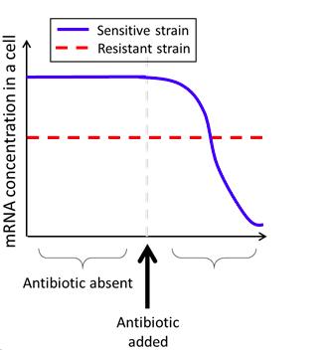

These data tell us that rifampicin-resistant bacteria [**Have RNA Polymerase enzymes that are mostly likely less efficient.]**

The “antibiotic absent” data imply that there is [**a fitness cost**] associated with rifampicin resistance.

# APPENDIX 5: Example clicker and exam questions

**Question 1. Apply Darwin’s postulates of natural selection**



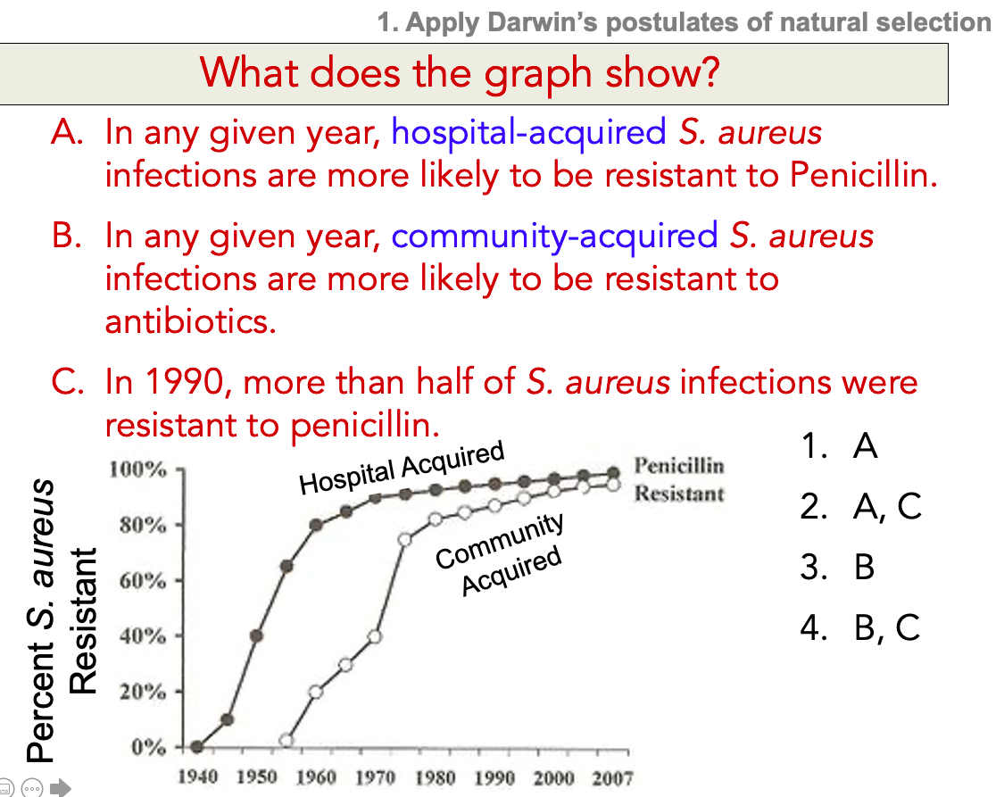

(answer: 2) Antibiotic resistance is an important topic for public health and it is a good example of evolution by natural selection! Our CURE is all about experimenting with natural selection and antibiotic resistance! (S. aureus is staph)

**Question 2.**

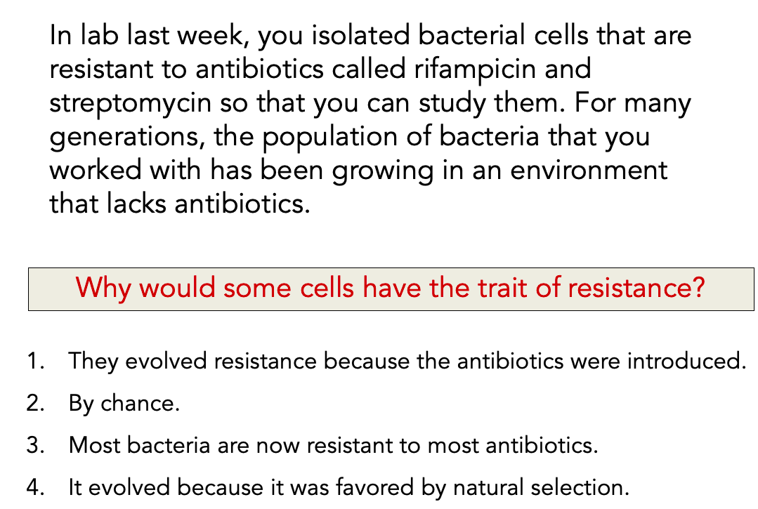

(answer: 2)

**Question 3.**

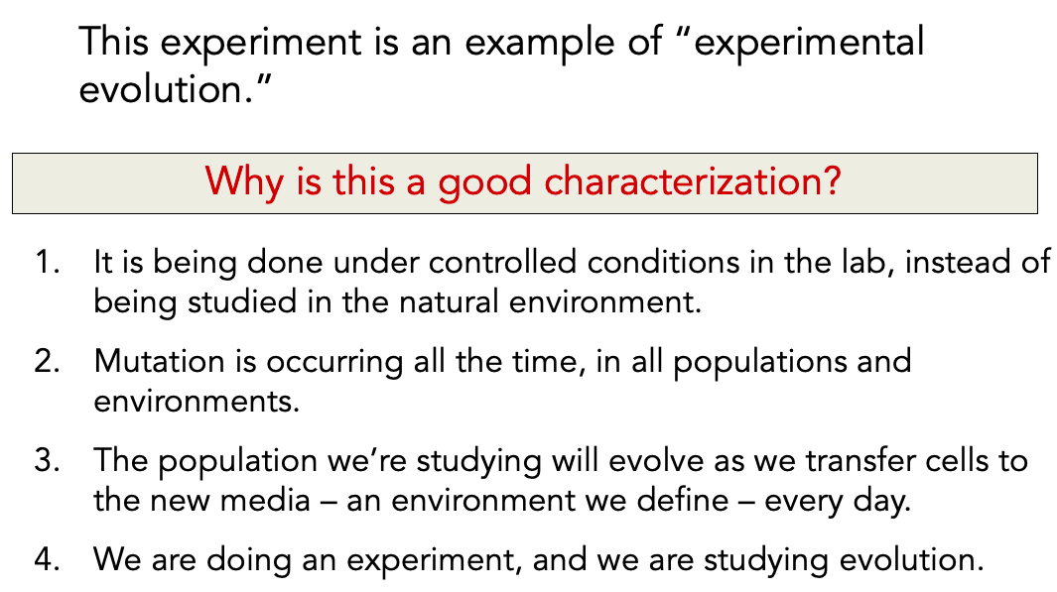

(answer: 3) We control the environment, studying evolution in real time

**Question 4.**

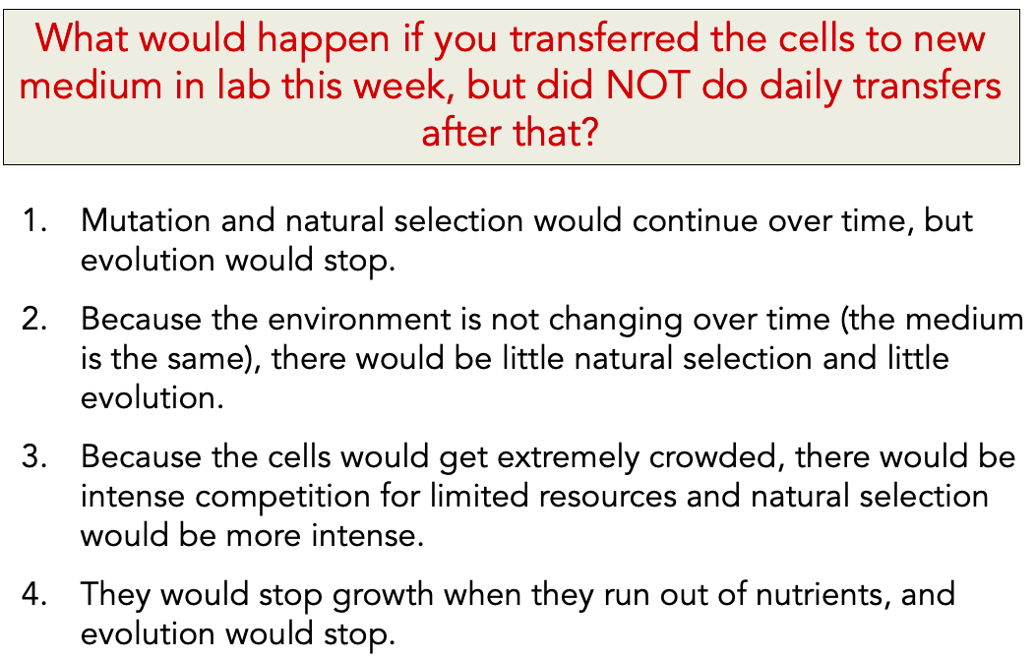

(answer: 4) - Eventually the cells would die but first they would just stop growing and go quiet

#2 – is not correct because if the population continues to grow, you could still have evolution (drift, mutation, etc.)

**Question** **5**.

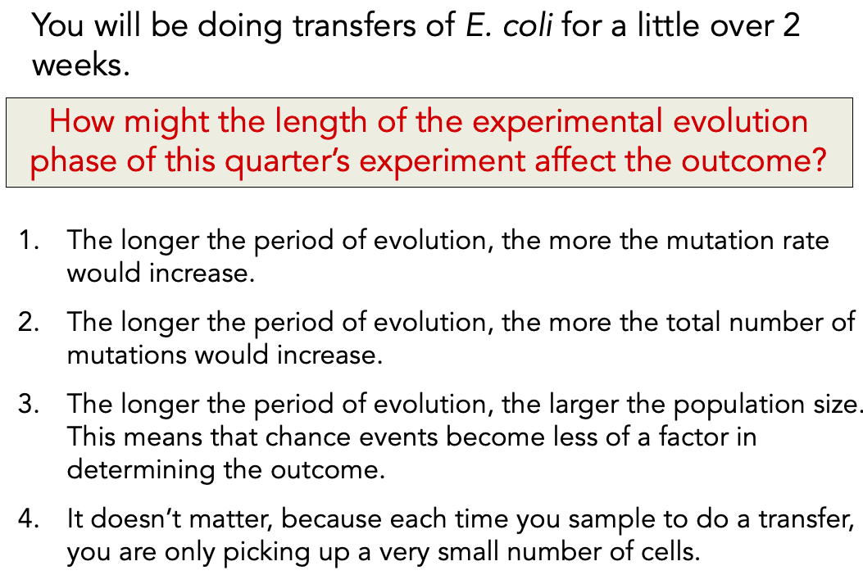

(answer: 2)

1-mutation rate does not change; n mutations does

3-larger population but you are discarding individuals.

4-you are taking a small number of cells but the ones you take are surviving.

**Question** **6**. Identify the best way to visualize and analyze particular types of data



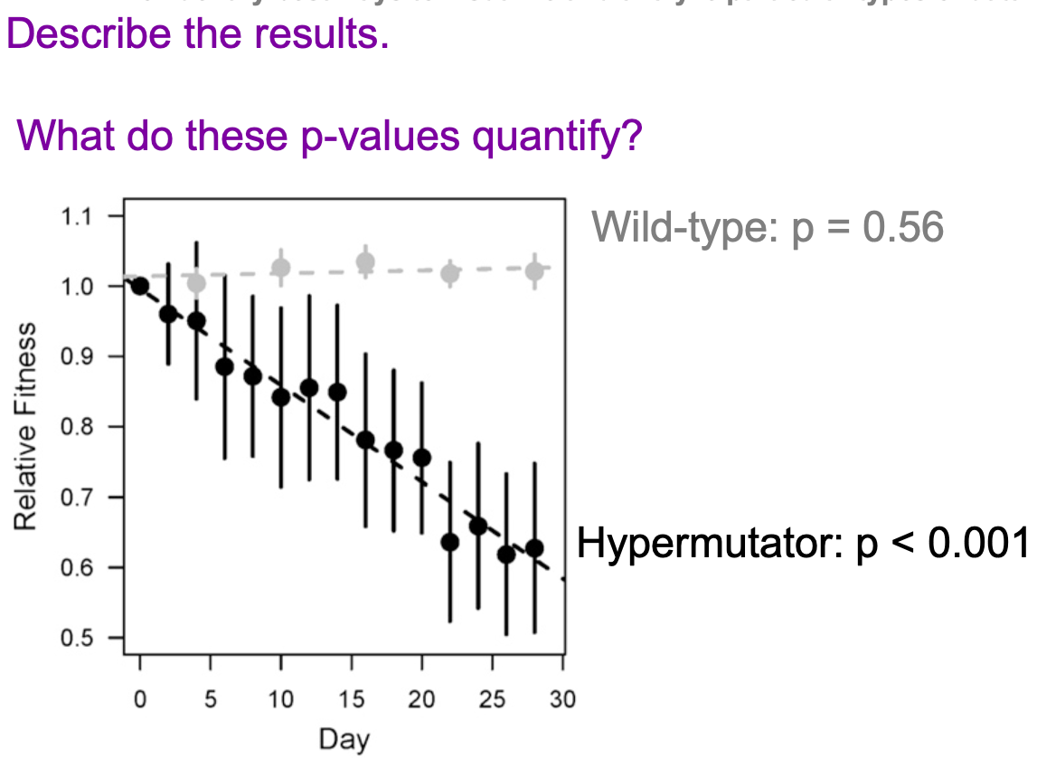



1. p-values are the chance of getting a slope this extreme if day has no effect on fitness.

2. grey

3. black

**Question** **7**.

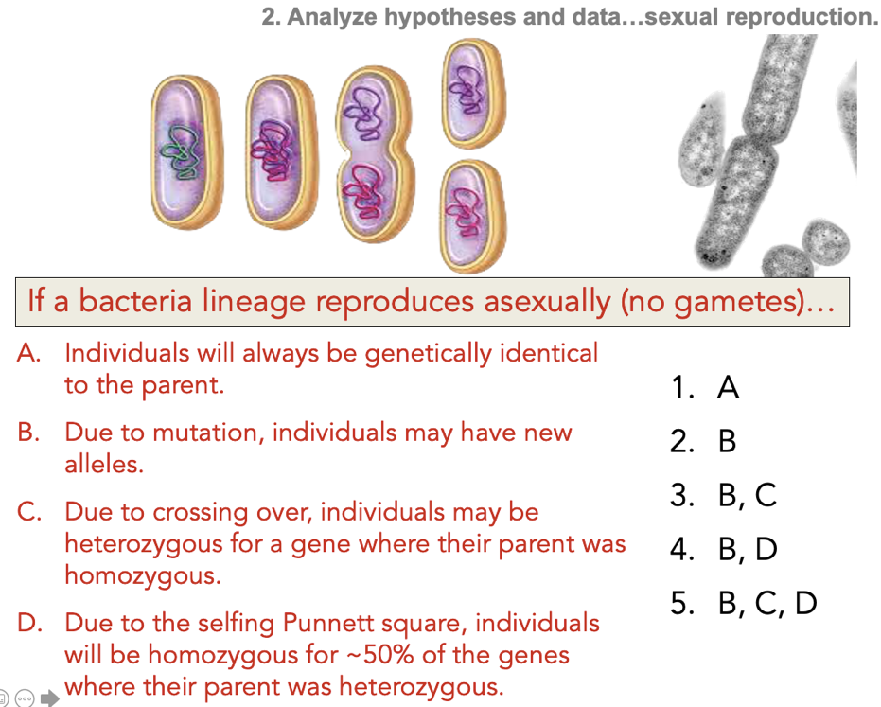

(answer: 2)—This is neither mitosis nor meiosis. It’s binary fission. But if you understand where genetic variation comes from, you can understand the effects of a novel reproductive scheme. (Corollary: The reproductive scheme of a population affects its genetic variation, which effects its evolution. This is important for conservation.)

D—There is no Punnett square, because no gametes are created in the first place.

**Question** **8a**.

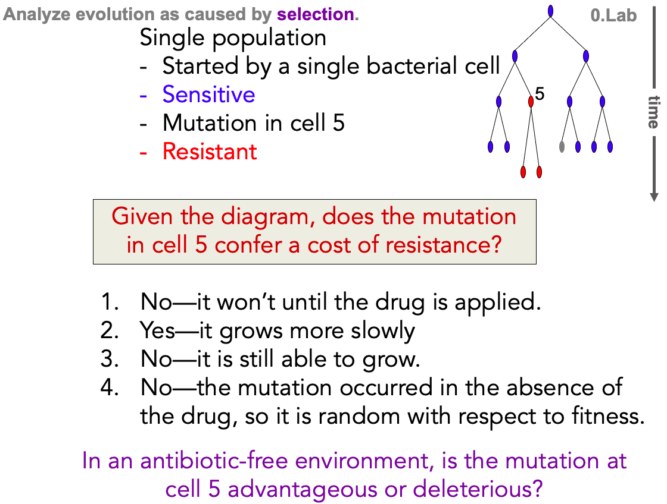

(answer: 2)

1: cost of resistance is observed in the absence of the drug, not the presence

3: this is not the criterion for a fitness cost—it’s all about relative growth rate in the absence of the drug

4: it’s true that the mutation is random with respect to fitness, but that doesn’t answer the question

**Question** **8b**.

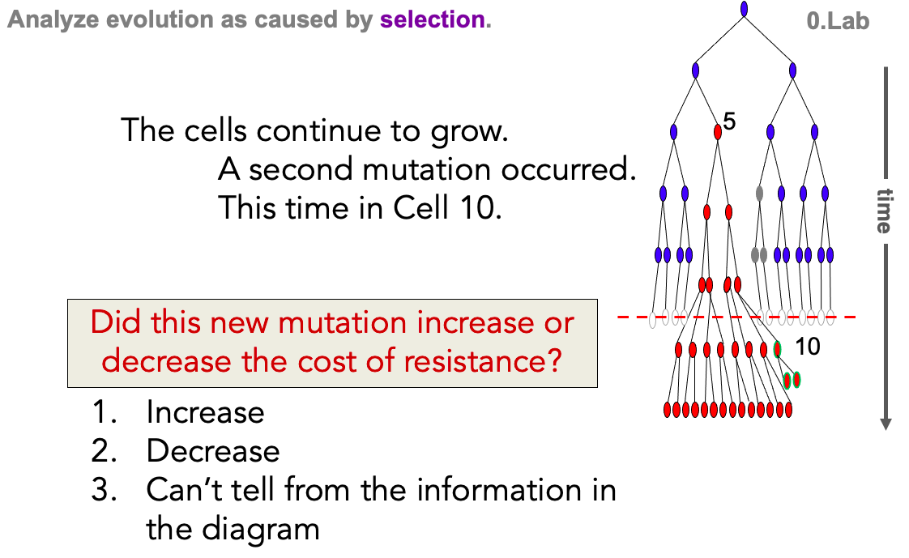

(answer: 2) It is now growing faster in the environment that lacks drug

**Question** **8c**.

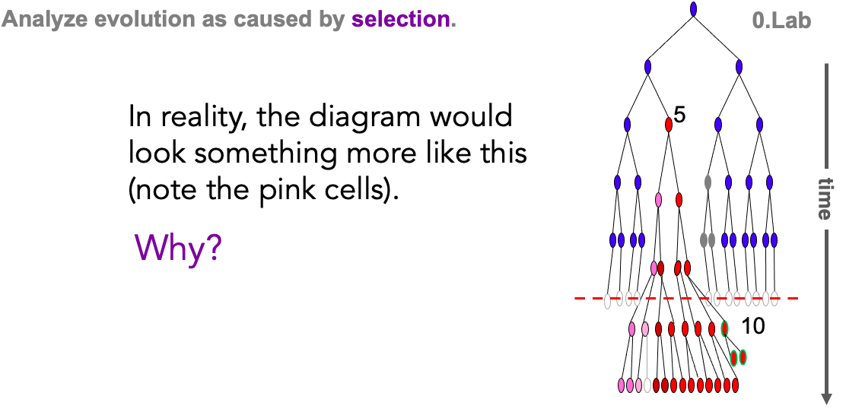

There is variation in resistance – it is a trait!

**Question** **8d**.

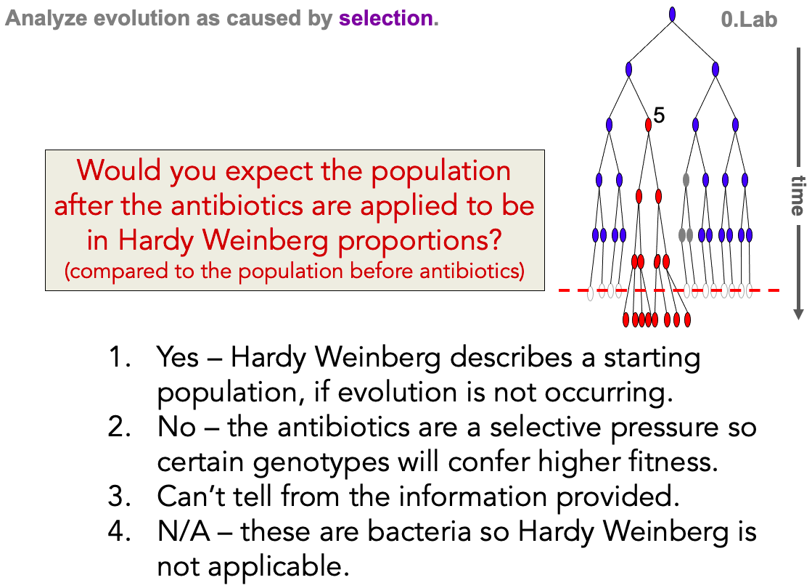

(answer:2) so there will be more of one genotype and less of the others

**Question 9**.



(answer: 1)—If a microbe was not “pre-resistant”, it would not survive! If there are resistant microbes after taking an antibiotic, there must have been resistant microbes before taking the antibiotic.

(4) is why these rare resistant alleles will increase in frequency, but not why they exist in the first place.

4x10^13 bacteria in adult human (Sender et al, 2016)

0.1% or less are E coli (Eckberg et al, 2005)

So ballpark 10^9 E coli in an adult human.

**Question** **10**.



40% lethal, 29% deleterious,

27% neutral, 4% beneficial

These data comes from a virus. Multi-cellular organisms have far far far more non-coding DNA, so mutations are far more likely to be neutral. Either way, very few mutations are beneficial.

**Question** **11**.

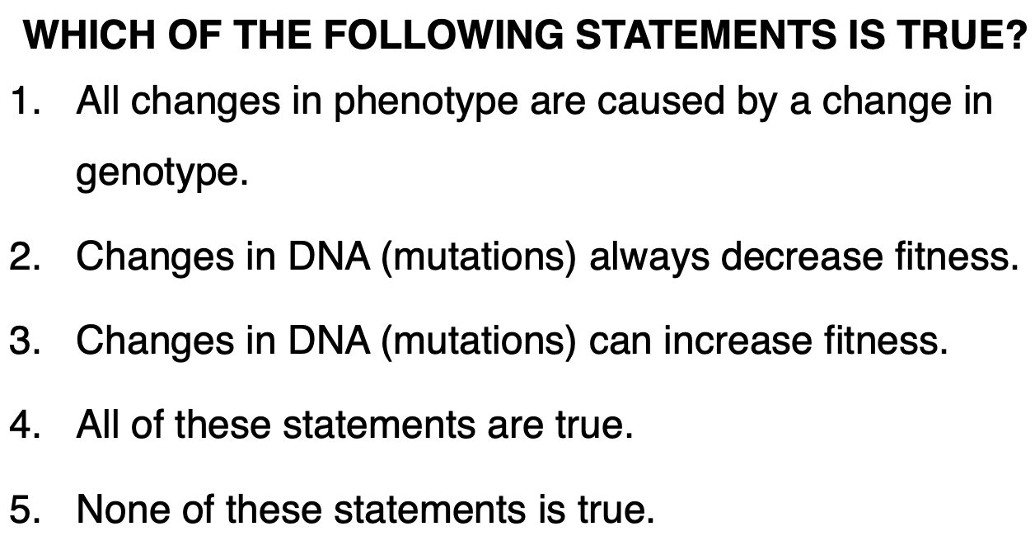

(answer: 3) Changes in DNA (mutations) can increase fitness

**Question** **12**.

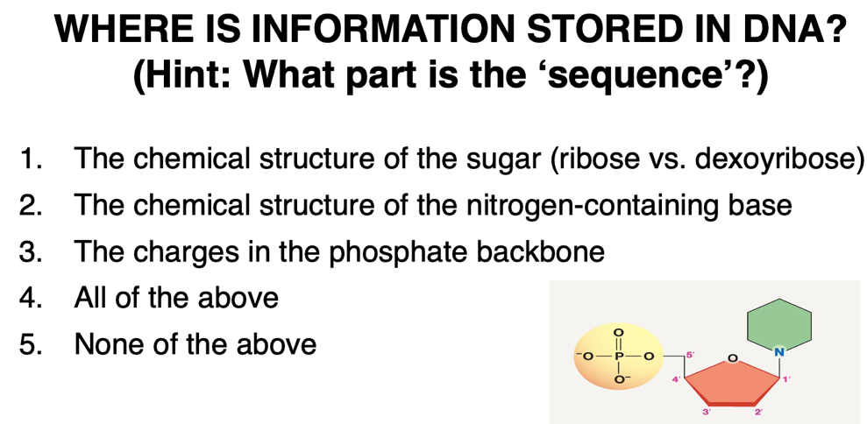

(answer: 2) Biological structures impact function

**Question** **13**.

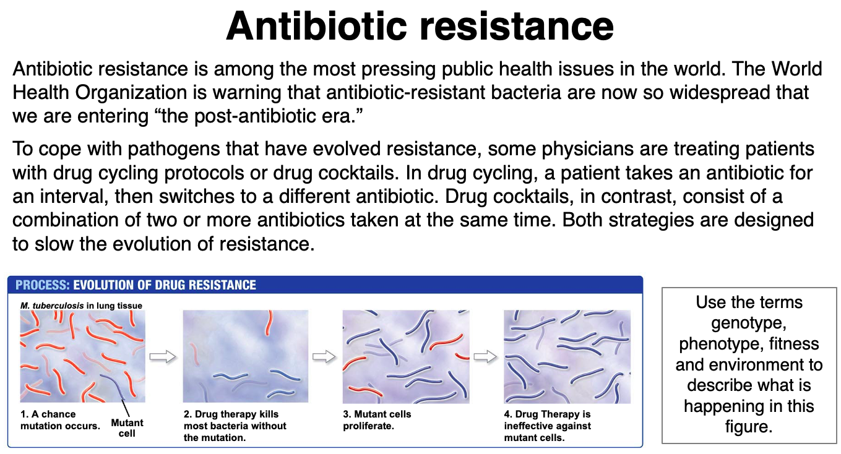

(answer: **GENOME=ALL GENES** Alleles That Confer Drug Resistance Increase in Frequency When Drugs Are Used)

**Question** **14**.

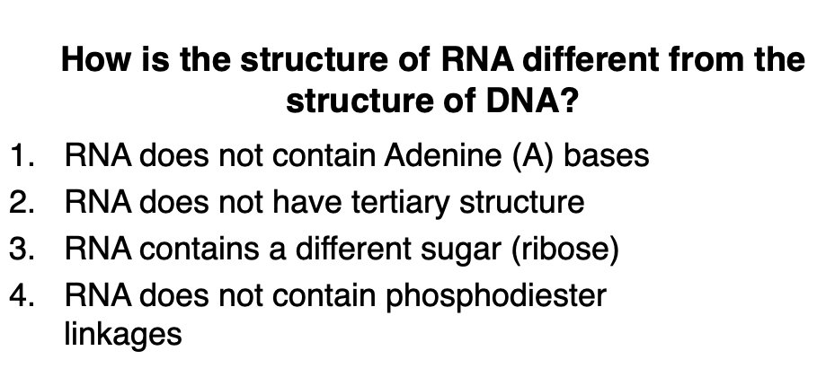

(answer: 3) How else different? RNA contains uracil instead of thymine, extensive tertiary structure to create shapes: makes RNA capable of being a ribozyme

NTP = adenosine

**Question** **15**.

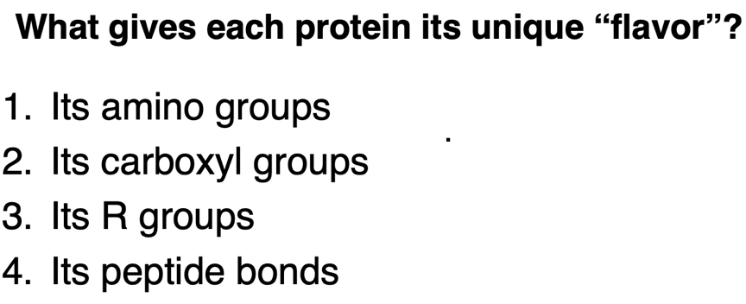

(answer: 3)

**Question** **16**.

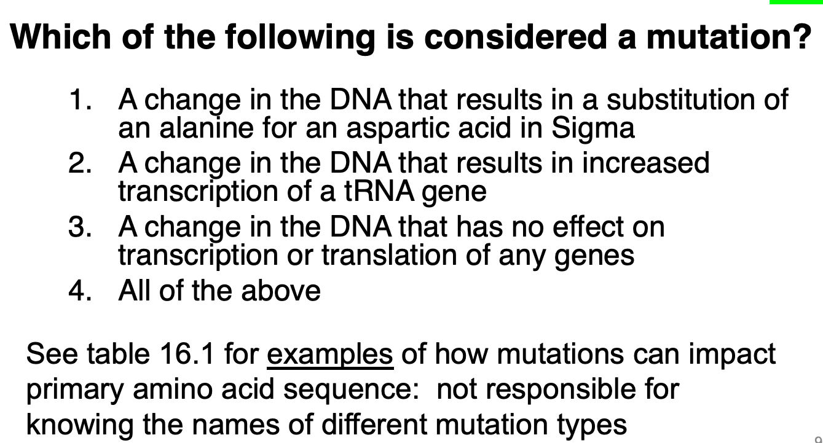

(answer: 4) **A mutation is any change in the DNA. Occurs randomly**

**Question** **17**.

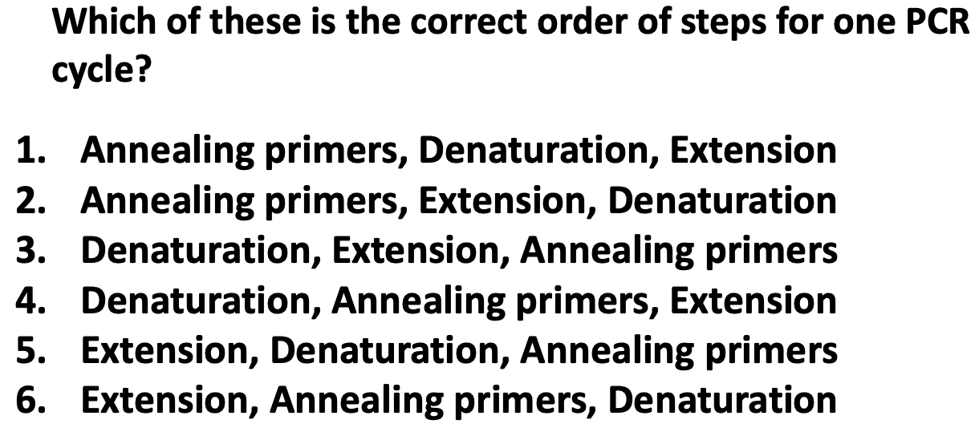

(answer: 4)

**Question** **18**.

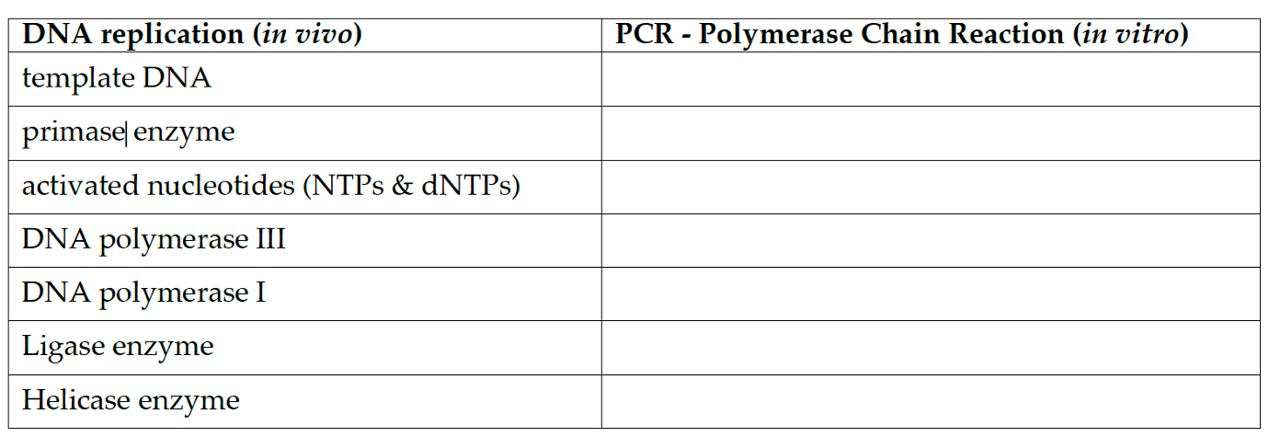

Template DNA = template DNA

Primase = primers

Activated dNTPs

Pol III = Taq polymerase

Pol I = not needed (no RNA primer to remove, no lagging strand

Ligase enzyme = not needed - no okazaki fragments in PCR to ligate together

Helicase = Heat -95°C

**Question** **19**.



(answer: 3)

**Question** **20.**

In lab, your sensitive and resistant cells will be evolving in an environment that lacks antibiotics. (*8 pts*)

Average resistance level

Time

High

0

Sensitive

Resistant

a. In the graph to the right, predict how the average level of resistance will change over time, as you do daily transfers for the descendants of both sensitive and resistant ancestors.

**+2: Sensitive low (1) and flat (1)**

**+2: Resistant starts high (1) and ends low (1)* see note below**

**NOTE ALTERNATE VERSION – swapped dashes**

1. Explain your reasoning for each, in 1 sentence or less.

* Sensitive population:

**+2: low resistance and it won’t change because there isn’t a cost**

* Resistant population:

**+2: resistance will decline because there is likely to be a cost of resistance (*it is possible that there would be an additional mutation that reduces that fitness cost – if this is the answer stated, the slope of the dashed line should not be as steep as shown.)**

**Question** **21**.

*E. coli* prefer to eat glucose (a sugar). When lactose (a different kind of sugar) is available and glucose is not, a gene called the lac operon is turned on (i.e., up-regulated) by a regulatory sequence of DNA. The lac operon product digests lactose. (*6 pts*)

a. From the bacteria’s perspective, why is it advantageous that lac operon is only up-regulated when lactose is available and not when just glucose is available?

**+2: so that energy isn’t expended making lac operon when lactose is not around.**

If a mutation occurs in the regulatory sequence of lac operon, and the lac operon product is no longer produced, how would the fitness of the wild-type bacteria compare to the fitness of the mutant, both in the presence of glucose and the presence of lactose. (Assume there are no other mutations.)

Only Lactose available

Glucose available

Wild-type Mutant

Wild-type Mutant

Fitness

Fitness

b. Plot your predictions on the figures below.

**+2**

**NOTE ALTERNATE VERSION: glucose and lactose**

**figure order swapped.**

c. Explain your reasoning.

**+1: same fitness in glucose because the mutation**

**does not affect fitness in that environment.**

**+1: decreased fitness in only lactose because it**

**can’t digest it**

**Question** **22**.

What is one new study strategy that you want to try? Why? (2 *pts*)

**+2 for good faith effort plus justification**

**Question 23**.

Consider the microtiter (MT) plates you set up in lab. This plate shows bacterial growth after 1 day. (*9 pts*)

1. Add an arrow to the left of the plate, showing the direction of the

antibiotic gradient in the wells. Label it to indicate “low” and “high” antibiotic.

**+2: arrow**

**+2: label**

1. Circle the wells with bacteria that have the highest resistance to STR. Label them HRS.

**+2: circle**

**+2: label – NOTE HRS (highest resistance to STR) vs. MRS (Maximum Resistance to STR)**

1. Do the data from this plate suggest that collateral resistance to STR might be occurring in these RIF-resistant strains? Explain why or why not.

**+2: yes;**

**(+3: explanation)**

**+3: RIF strains have higher growth (more resistance) than SEN strains in wells with some antibiotics**

**High**



**Low**

# APPENDIX 6: Learning Objectives

|  |  |  |  |  |  |  |  |  |  |  |  |  |  |
| --- | --- | --- | --- | --- | --- | --- | --- | --- | --- | --- | --- | --- | --- |
| **Lab #** | **Activity** | **Learning objective** | **Evolution** | **Structure & function** | **Information flow** | **Energy & matter** | **Systems** | **Process of science** | **Quantitative reasoning** | **Modeling & simulation** | **Interdisciplinary skills** | **Communicate & collaborate** | **Science & society** |
| 1 | Plate bacteria for selection; learn sterile technique | Explain why the evolution of antibiotic resistance is a health concern | X |  |  |  | X |  |  |  |  |  | X |
| Instruct another student on proper sterile technique |  |  |  |  |  | X |  |  |  |  |  |
| Explain how and why you performed each specific step in the start of this experiment | X |  |  |  |  | X |  |  |  |  |  |
| Diagram the week-to-week plan for this experiment over the course of the quarter | X |  |  |  |  | X |  |  |  |  |  |
| 2 | Pick mutants and start transfers | Why antibiotic resistance is a predictable consequence of natural selection | X |  |  |  |  |  |  |  |  |  |  |
| How changes in genotype can alter phenotype |  |  | X |  |  |  |  |  |  |  |  |
| Why resistance may have a fitness cost | X | X |  |  |  |  |  |  |  |  |  |
| Why you will be transferring bacteria daily | X |  |  |  |  | X |  |  |  | X |  |
| 3 | Practice using RStudio and performing t-tests | Explain why resistance is not all-or-none, but a phenotype with continuous variation from 0 to extremely high | X | X |  |  |  |  |  |  |  |  |  |
| Explain why resistance can be costly in the absence of an antibiotic, and analyze methods for measuring the cost of resistance | X | X |  |  |  |  |  |  |  |  |  |
| Understand why researchers perform statistical analyses |  |  |  |  |  |  | X |  |  |  |  |
| Navigate the interface of RStudio, load a practice data set, and run practice analyses |  |  |  |  |  |  | X |  |  | X |  |
| 4 | Practice using RStudio and running linear regressions | Explain what collateral sensitivity and collateral resistance are and how to measure them | X |  |  |  |  | X |  |  |  |  | X |
| Discuss how investigating collateral effects could help slow the evolution of antibiotic resistance | X |  |  |  |  |  |  |  |  |  | X |
| Use RStudio to graph, interpret and analyze data |  |  |  |  |  |  | X |  |  | X |  |
| 5 | Set-up MIC and fitness assays | Explain how data from your MIC assays will allow you to assess changes in antibiotic resistance over time and whether collateral resistance or sensitivity occurs | X |  |  |  |  | X | X |  |  | X | X |
| Explain how data from your competition assays will allow you to assess the cost of resistance in progenitors and descendants of each of your strains | X |  |  |  |  | X | X |  |  | X |  |
| **Lab #** | **Activity** | **Learning objective** | **Evolution** | **Structure & function** | **Information flow** | **Energy & matter** | **Systems** | **Process of science** | **Quantitative reasoning** | **Modeling & simulation** | **Interdisciplinary skills** | **Communicate & collaborate** | **Science & society** |
| 6 | Collect data from MIC and fitness assays | Explain how the MIC data you collected will allow you to address questions about variation in level of resistance, and changes in the level of resistance over time | X |  |  |  |  | X | X |  |  |  |  |
| Explain how the MIC data you collected will allow you to address questions about collateral resistance and collateral sensitivity | X |  |  |  |  | X | X |  |  |  | X |
| Explain how the fitness data you collected will allow you to address questions about the cost of resistance | X |  |  |  |  | X | X |  |  |  |  |
| 7 | Analyze data on costs of resistance and collateral effects | Use RStudio to graph, interpret and analyze data |  |  |  |  |  |  | X |  |  |  |  |
| Choose appropriate statistical tests to analyze experimental results |  |  |  |  |  |  | X |  |  |  |  |
| Discuss whether you are seeing evidence for collateral sensitivity, collateral resistance, or no collateral effects | X |  |  |  |  |  | X |  |  |  | X |
| Interpret any changes in fitness observed by your group or other groups | X |  |  |  |  |  |  |  |  |  |  |
| Suggest future experiments to follow up on your results |  |  |  |  |  | X |  |  |  | X |  |
| Connect our controlled laboratory experiment to the natural world and ecological dynamics |  |  |  |  | X |  |  |  |  |  | X |

|  |  |  |  |  |  |  |  |  |  |  |  |  |  |
| --- | --- | --- | --- | --- | --- | --- | --- | --- | --- | --- | --- | --- | --- |
| 8 | Run a PCR reaction; run products out on a gel | Complete POGIL / RNA polymerase activity to predict location of the antibiotic resistant conferring mutation | X | X | X |  |  | X |  | X |  |  |  |
| Summarize the purpose of a PCR reaction |  |  |  |  |  | X |  |  |  |  |  |
| Draw a figure explaining how gel electrophoresis works |  |  |  |  |  | X |  |  |  |  |  |
| 9 | Analyze sequence data from a subunit of the RNA polymerase gene in *E. coli* | Use software to create a sequence alignment |  |  | X |  |  |  |  |  |  |  |  |
| **Lab #** | **Activity** | **Learning objective** | **Evolution** | **Structure & function** | **Information flow** | **Energy & matter** | **Systems** | **Process of science** | **Quantitative reasoning** | **Modeling & simulation** | **Interdisciplinary skills** | **Communicate & collaborate** | **Science & society** |
| 9 | Analyze sequence data from a subunit of the RNA polymerase gene in *E. coli* | Use software to edit sequence data as needed |  |  | X |  |  | X |  |  |  |  |  |
| Identify mutations in the DNA sequences of a progenitor versus a descendant |  |  | X |  |  |  |  |  |  |  |  |
| Analyze whether mutations impact a protein’s primary structure |  | X | X |  |  |  |  |  |  |  |  |
| 10 | Visualize RNA polymerase structure and interpret the phenotypic consequences of mutations | Analyze the quaternary structure of RNA Polymerase in 3-D—especially the binding pocket where Rifampicin binds to the β subunit of RNA Polymerase (the protein coded by the RpoB gene) | X | X |  |  |  |  |  | X |  |  |  |
| Model and view rifampicin and how it binds to β subunit of RNA Polymerase (the protein coded by the RpoB gene) |  | X |  |  |  |  |  | X |  |  |  |
| Edit the *RpoB* DNA to produce a protein sequence that matches mutations found in Lab 2 | X | X | X |  |  |  |  |  |  |  |  |
| 11 | Connect genotype to phenotype to fitness; design a poster | Connect changes in the molecular structure of RNA Polymerase in the progenitor and descendant strains to changes in MIC | X | X | X |  |  |  |  | X |  |  |  |
| Propose a hypothesis to explain the molecular basis of fitness trade-offs | X | X | X |  |  |  |  |  |  |  |  |
| Connect changes in the molecular structure of RNA Polymerase in the progenitor and descendant strains to changes in relative fitness | X | X | X |  |  |  |  | X |  |  |  |
| Connect changes in the molecular structure of RNA Polymerase in RIF-resistant strains to data on collateral effects | X | X | X |  | X |  |  | X |  |  |  |
| 12 | Present at a poster session | Describe the question that your group was asking and the experimental methods you used, explain the nature of your data, summarize the conclusions that can be drawn from your data, and propose logical follow-on research |  |  |  |  |  | X |  |  |  | X | X |
| Use oral, graphical, and writing skills to communicate effectively with both a scientific and lay audience |  |  |  |  |  | X |  |  |  | X | X |

1. <https://doi.org/10.1187/cbe.14-06-0099>
2. **Compensatory Evolution in Rifampin-Resistant *Escherichia coli*,** Mary G. Reynolds

   GENETICS *December 1, 2000 vol. 156 no. 4 1471-1481*
3. Campbell, E. A. et al. Structural mechanism for rifampicin inhibition of bacterial RNA polymerase. *Cell* **104**, 901–912 (2001). **Describes the intricacies of binding between rifamycin, rifampicin and a DNA-engaged RNA polymerase, and provides a detailed mechanism for rifampicin action.**
4. Alternatively, a text console can be toggled on and off using [ESC].

  